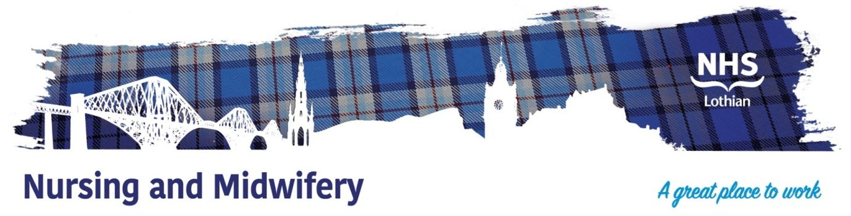**Ward 18 Plastic Surgery – Head & Neck Unit, St John’s Hospital**

Exciting opportunities are available to join Ward 18 Head & neck/Plastic Surgery Unit within one of the hospital sites across NHS Lothian. We have Band 3 Health Care Support Worker (HCSW) posts available and we are looking for passionate, caring, motivated people to join our highly skilled nursing teams.

**What We Can Offer You**

We have vacancies for HCSWs to join our innovative and dynamic team within NHS Lothian. We provide a robust staff induction to all new members of the team along with ongoing education and development.

As part of the multidisciplinary team the post holder shall contribute to the efficient service provision within the Regional Plastic surgery, head & Neck Unit.

For further information on the posts and informal visits, please contact –

Kirsty.Robertson12@nhs.scot OR louise.cunningham@nhs.scot

You can call the ward on 01506 524118

