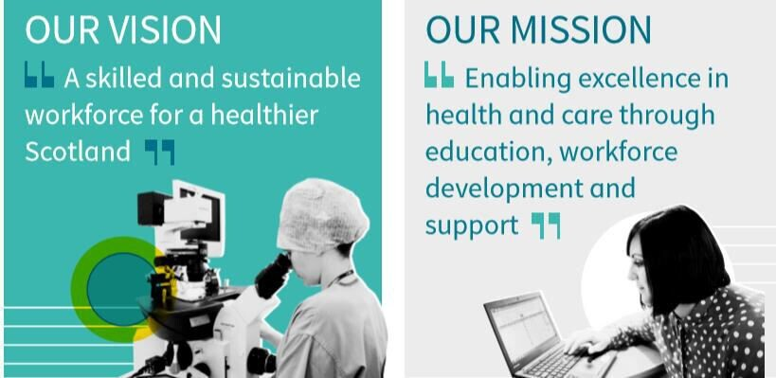

Programme Coordinator (Senior Officer)

Building Digital Skills and Leadership Programme

Workforce Directorate - Organisational Development Leadership and Learning

NHS Education for Scotland (NES)

2023

Location: Flexible Location

Grade: Agenda for Change Band 5

Salary: £30,229 - £37,664 per annum

Job Status: Permanent, Full Time, 37.5 hours per week.

*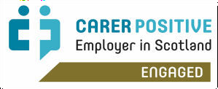NHS Education for Scotland is committed to creating a diverse and inclusive environment for all employees and is proud to be an equal opportunity employer. All qualified applicants will receive consideration for employment regardless of age, disability, gender identity, marital status, race, faith or belief, sexual orientation, socioeconomic background, and whether you’re pregnant or on family leave.*

# Candidate Brief About the Directorate

NHS Education for Scotland (NES) plays a critical role in supporting the health and care sector to have the right people, in the right place at the right time through education, training and workforce development. People are the lifeblood of the NHS and social care; NES is right at the heart of ensuring a future supply. We’re also central to delivering digital solutions which enable improvement in service to Scottish citizens and support our workforce to deliver it. Our organisation is full of talented, committed, specialists across health and care disciplines, backed up by excellent support functions. We are highly collegiate, innovative and delivery focussed.

The purpose of the Workforce Directorate, where this role sits, is wide-ranging and exciting. We not only enable NES to attract, recruit, support, train, develop, reward and recognise its own workforce, but also play a significant role in employing doctors and dentists in training across Scotland. Furthermore, we support recruitment of health and care professionals for the whole of Scotland. We support the management of change, providing organisational consultancy. We also play an active part in the organisation’s commitment to fulfilling its Equality and Diversity responsibilities, not just to its own staff but throughout all the activities of the organisation.

Nationally the Workforce Directorate acts as key strategic partner to Scottish Government in the

delivery of national Talent, Leadership and Management, Quality Improvement, and Learning &

Development ambitions. We also provide information, advice, educational solutions and support to the wider NHS through links with Health Boards, care providers and the Scottish Government.

**About the Role**

This is an exciting opportunity to be part of the Digitally Enabled Workforce (DEW) team, collectively responsible for the delivery of a programme of work aligned to Scotland’s Digital Health and Care Strategy, Data Strategy and Care in the Digital Age delivery plan.

The success of digital transformation is entirely reliant on people knowing when, why, and how to use technology, systems, and data. Workplace digital and data skills comprise the knowledge and confidence needed to undertake everyday activities whilst realising the full potential of technology and data relevant to the person’s role.

As Programme Coordinator (Senior Officer) you will lead and thrive on planning, and co-ordinating tasks associated to each of the workstreams in delivering the priorities aligned to Scotland’s Digital Health and Care Strategy, Data Strategy and Care in a Digital Age Delivery Plan. This will include negotiating with the DEW team and stakeholders to ensure associated tasks are completed within timescales and risks identified. You will be responsible for overseeing the planning, implementation, and evaluation of various projects related to the overall programme and consider broader strategic planning and goals.

As someone who enjoys working in a fast-paced innovative environment, you will be enthusiastic, focused, professional, with a high attention to accuracy and ability to coordinate and track a range of projects and competing priorities. You will work across multiple organisations as well as with Scottish Government colleagues and external stakeholders daily. The role provides an opportunity you to be innovative in finding solutions to issues along with a flexible approach to overcome issues and challenges. You will be part of a team but also able to work on your own initiative.

You will lead the administration support for the programme by coaching and developing direct reports. You will be a strong influencer and analytical problem solver who can translate information to a variety of audiences.

Key tasks will include but will not be limited to:

* Creating the overall programme plan and co-ordination of the activities to ensure delivery of priorities within agreed timescales
* Implementing and maintaining programme and project management standards, reports, and processes to identify and manage cross-project dependencies, risks, and constraints for the different workstreams
* Preparing all programme documentation, reports, communications and maintaining the programme within MS Project, MS Teams, and Microsoft 365
* Ensuring the overall programme and workstreams have the documented communication plans and co-ordinating the completion of associated tasks
* Working with the Programme Leads in setting performance outcomes, associated with each of the workstreams within the overall programme, ensuring performance is monitored and identifying milestones and targets to be achieved within set timescales
* Progressing actions and updates of the deliverables to Scottish Government, Governance Structure and Programme Board members
* Realigning the workstream activities as directed by the governance of the programme.
* Planning new workstream activities with documented project delivery plans with milestones
* Using innovation to develop and implement new processes and governance across the programme that will help improve delivery and act as a champion within the team for change

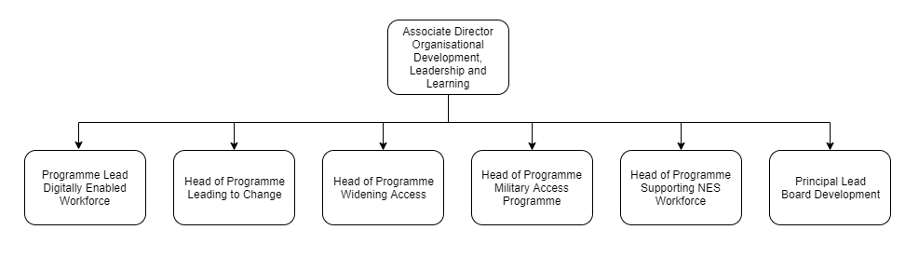

**Digitally Enabled Workforce Team**

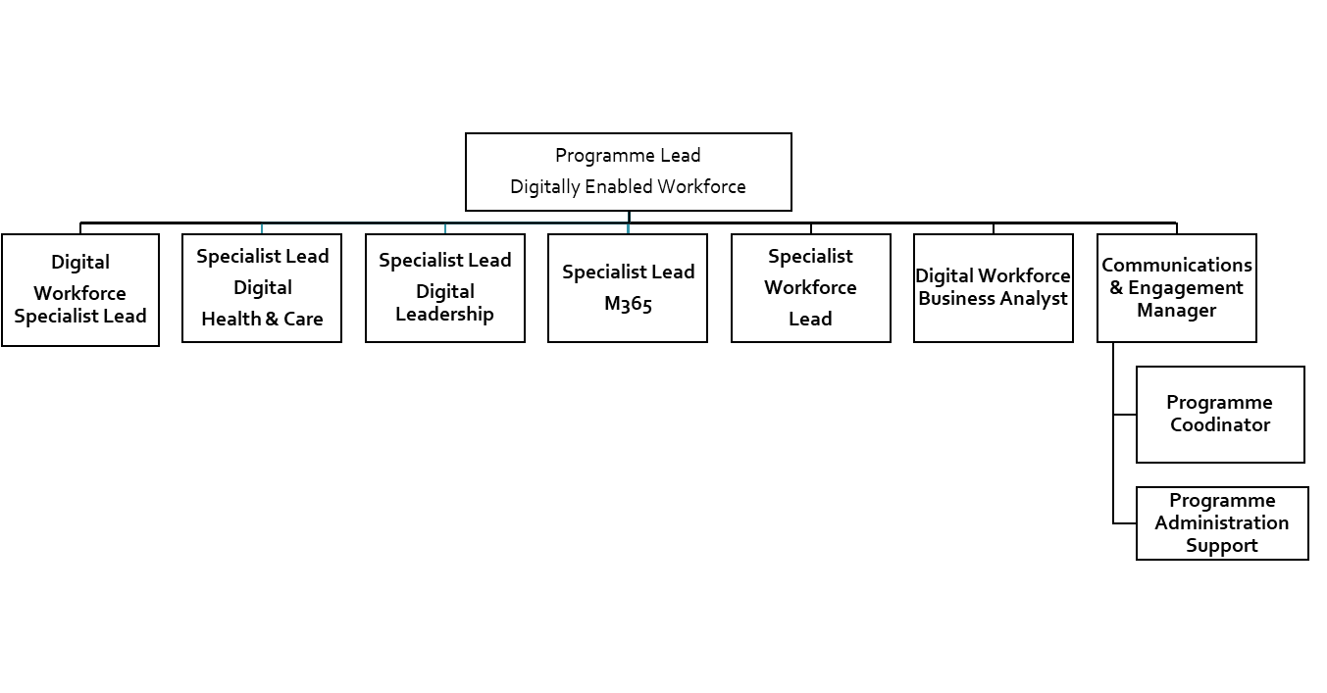

# Applying for the role

Complete the Assessment section of the online application form by referring to the Person Specification and NES Leadership Behaviours below.

* Complete Question 1 (‘Why do you think you are suitable for this role?’) by explaining how you meet the criteria in the Person Specification.
* Complete Question 2 (‘Why do you want to work for the NHS?’) by showing how your own values are aligned with each of the five NES Leadership Behaviours.

# Person Specification

### **Essential Criteria** These attributes are required for the role. Applicants who do not demonstrate the essential requirements in their application will normally not be considered.

### **Desirable Criteria** These attributes would be useful for the role. When shortlisting candidates, these criteria will be considered when more than one applicant meets the essential criteria.

| **Factor** | **Essential** | **Desirable** |
| --- | --- | --- |
| **Education and professional qualifications** |  | * HND/Advanced Diploma level qualification with in-depth experience   or   * SCQF Level 8 equivalence obtained via Professional Development Awards; Technical Apprenticeships; and SVQs |
| **Experience** | * Demonstrable experience in a project/programme support role or equivalent including creating project plans and coordinating completion of tasks * Experience of collaborative working, sharing knowledge and information across teams and large organisations * Ability to work both independently and as part of a team, whilst balancing a range of competing priorities * Experience of drafting reports and project documents related to reporting progress, risks and issues and governance * Experience working within a fast paced environment * Flexible approach to learning and problem solving * Commitment to personal and professional development, and that of your team * Ability to work with minimal supervision and to meet deadlines | * Experience of working within a health and social care context * Experience of project management * Experience of working flexibly in complex/sensitive environments where the parameters of the job are not necessarily clearly defined * Experience of tracking and coordinating actions across a large programme of work that overarches across organisations |
| **Specific skills, knowledge, and training** | * Strong working knowledge of standard Microsoft packages (e.g Word, Excel, PowerPoint) as well as confidence using MS Teams, MS Project and SharePoint * Advanced keyboard skills with proven speed and accuracy * Highly effective communicator(written and verbal) with the ability to understand the audience and adapt communication style accordingly * Ability to confidently facilitate team meetings online * Strong understanding of GDPR and data protection, plus appreciation of the need for discretion and confidentiality in the workplace * Ability to take a lead role with colleagues to ensure project documentation is maintained, updated and stored in an accessible and methodical way * Understanding of the need for accuracy and attention to detail * Highly developed customer service skills, with a helpful, flexible attitude * Line Management role including coaching and/or mentoring of team members * Values driven approach to practice, aligned with core NHS & NES values | * Experience and working knowledge of Microsoft 365 Apps: Sway; Planner; One Drive and OneNote * Expertise in using social media within a working/corporate environment (esp. Twitter) * Clear understanding of established project management principles (e.g. Prince 2; Prince 2 Agile) * An understanding of the wider combined health and social care system |

# NES Leadership Behaviours

The five NES Leadership Behaviours describe how we work at NES, and how we want colleagues to behave, whatever their role:

## Inspiring

* Passionate about our purpose and about excellence
* Communicating with enthusiasm
* Innovative and learning from success as well as setbacks

## Empowering

* Giving our colleagues space and authority to deliver outcomes
* Investing in learning and development
* Being approachable and open to constructive challenge

## Adaptive

* Responding flexibly to changing requirements and helping others to do the same
* Recognising that required expertise may not always sit at the top of the hierarchy
* Actively encourage innovative ideas/input from all levels

## Collaborative

* Committed to working together and across professional, clinical, and organisational boundaries internally and externally to achieve our objectives
* Sharing knowledge and skill for the benefit of the organisation as a whole
* Seeking feedback from colleagues to ensure quality

## Engaged and Engaging

* Committed to our values, agreed ways of working and our strategic and operational direction
* Visible to our stakeholders and to our teams
* Straightforward and honest in our communications