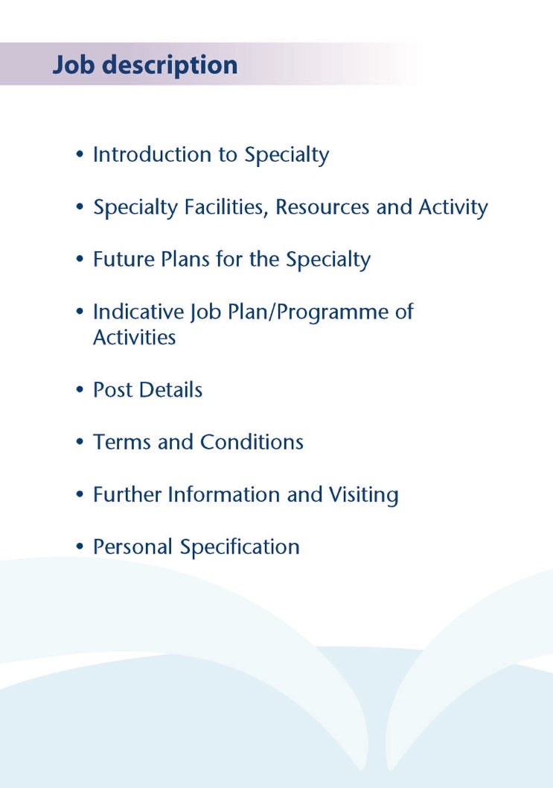



As part of ongoing incremental service improvements to Elderly Mental Health in NHS Ayrshire and Arran, we have a new post to advertise based at Ayrshire Central Hospital in Irvine. The service benefits from modernised service models involving a separate inpatient team and Hospital Liaison team. The Community Mental Health Team for the Elderly provides an excellent service, with nursing, OT and Psychology team members. The locality is suburban covering the Irvine and the surrounding areas. Ayrshire Central Hospital is within easy reach of Glasgow and the central belt of Scotland. Several Consultants are based here and as such there is peer support available. The post holder will share a secretary with the other Consultant for North Ayrshire.

The over 65s population of the catchment area advertised is approximately 16100, with an additional EPA available to cover the Island or Arran with a population of 1570. The post will be community only and the Consultant will be supported by a Trainee Doctor or a Clinical Development Fellow.

Inpatient wards are provided in the purpose built Woodland View facility in Ayrshire Central Hospital, where 15 organic beds (Ward 3) and 15 functional beds (Ward 4) are currently provided for Elderly Mental Health across Ayrshire and Arran. NHS Complex Clinical Care provision in North Ayrshire is currently under review and the Consultant in this post would not be expected to provide HBCCC cover. A degree of cross cover for colleagues who are on leave is expected, which may of course include inpatient cover.



**Medical Staff Resources**

**Consultant Grade:**

**ADULT**

**East Locality**

Dr Morag Henderson

Dr Aileen Guthrie (CD)

Dr Anna Ulanova

**North Locality**

Dr Everett Julyan (CD)

Dr Alison MacRae

Dr Ania Codona

Dr Alex McLean

Dr Eilidh Orr

**South Locality**

Dr Jacqui Scott (CD)

Dr Tim Johnston

Vacant post

Vacant posts (LTFT community)

Dr Adrian Nitu

**Liaison**

Dr Malcolm Cameron (Perinatal)

Dr Kim Newlands

Dr Ben Chetcuti

Dr Julie Langan-Martin

**Psychotherapy**

Dr Steve Moorhead

**Forensic and Inpatient**

Dr Dawn Carson (CD Inpatients and Forensic)

Dr Partha Gangopadhyay

Dr Gillian Howieson

Dr Ishbel MacFarlane

**Rehabilitation**

Dr Kris Tyczynski

**Elderly**

Dr Mark Luty (CD EMH Community)

Dr Susan Maxwell

Vacancy (this post)

Dr Joe Sharkey (inpatients)

Dr Stephanie Cowan

Dr Gillian Scott

Dr Debbie Brown (Deputy Medical Director)

Dr Alan Spratt (Liaison)

Vacant post (Liaison)

**CAMHS**

Dr Helen Smith (CD)

Dr Tahir Ali

Vacancy x2

**LDS**

Dr Claire Hughes (CD)

Dr Omer Rashid

Dr Douglas Paterson

**Addictions**

Dr Beinn Wilson (CD)

Dr Karthik Kessavalou

Dr Caroline Woolston

Dr Claire Duncan

Dr Moninder Saggar

Dr Rian O’Regan

**Non Consultant Grade:**

The 40 or so consultant posts are supported by 7 Specialty Grade Doctors, approx. 14 junior trainees (FY2/ST1-3) and around 6-7 Senior Psychiatric Trainees (ST4-6/SpRs)

**Admin Support**

The post holder will have Medical Secretarial support shared with the other Consultant for North Ayrshire Health and Social Care Partnership.

**CMHTE**

The post-holder will be one of two Consultants working with North Ayrshire CMHTE which consists of:

1 Team Leader, Band 7

8 Band 6 CPNs

1 Band 5 CPN

3 Post Diagnostic Support Workers (1 Full time, 2 less than full time)

1 PDS Team leader post (less than full time)

1 Named Clinical Psychologist for the team from the Older Adults Psychology service.

2 LTFT Occupational Therapists (one integrated within the team, the other working between the community and inpatient teams)

1 LFT Physio

Access to SALT and dietetics by referral.

The clinic on the Isle of Arran is at Arran War Memorial Hospital in Lamlash, which is also the base for the 1 x Adult CPN and 1 x Older Adults CPN and support worker are based.

**Education**

Woodland View has its own library and training facilities on site for local Postgraduate teaching.

University Hospital Crosshouse and University Hospital Ayr have the Alexander Fleming Education Centre and MacDonald Education Centre, respectively. These facilities have well stocked libraries with good electronic facilities, a lecture theatre with state-of-the-art equipment and meeting rooms.

The post holder will be expected to participate in the local postgraduate psychiatric training programme and to be involved in the teaching of medical undergraduates.



.

The Elderly Mental Health team in NHS Ayrshire and Arran is undergoing an exciting and fast moving development with four new appointments to substantive Consultant posts since 2020.

The inpatient wards at Woodland View were purpose built in 2016 and provide a high standard of accommodation in single rooms.



The post will consist of 10 programmed activities, but may be adapted to applicants wishing to work 8 or 9 sessions. The nature and timing of activities shown in the timetable are indicative and the precise nature of the duties will be agreed with the successful candidate at a job planning meeting with the Clinical Director. Timetables may be adapted in future to meet the changing needs of the service but any changes would be subject to discussion and job planning.

|  |  |  |  |  |  |
| --- | --- | --- | --- | --- | --- |
|  | Mon | Tues | Wed | Thur | Fri |
| am | Clinical admin /  Telephone reviews/  Monthly Arran Clinic (all day) | Clinical admin | Community Mental Health Team Meeting | SPA | OutpatientClinic  Woodland View / cross cover |
| pm | Home visits/ urgent reviews | Outpatient clinic  Woodland VIew | Clinical admin | Home Visits/ Clinical Admin/SPA | Cross cover/ urgent reviews |

**Proposed Weekly Programme**

The above timetable is indicative and subject to amendment through job planning.

Notes on the Programme

Travel: Any travel allocation will be included within the Total Programmed Activities and will be determined by location at which Direct Clinical Care and Supporting Professional Activities are carried out.

On call arrangements: The postholder will be part of the current rota. This rota is ~1 in 26 or less. The availability supplement is level 1 (currently 3%).

**Supporting Professional Activities**: NHS Ayrshire and Arran recognise the important role Job Planning has in ensuring consultants are supported in delivering high quality, safe, sustainable clinical care to patients. It is therefore important to ensure there is an adequate balance between direct clinical care activities and activities which support both the personal and professional development of the consultant workforce and facilitates agreed contribution to activities including:

* Undergraduate and postgraduate teaching/training
* Clinical Governance
* Quality and Patient Safety
* Research and Innovation
* Service management and planning
* Work with professional bodies

All consultants will have 1 SPA as a minimum to support job planning, appraisal and revalidation. However the final balance of SPA and DCC activity will be agreed between the appointee and clinical manager prior to contracts being agreed.

There may be a requirement to vary the DCC outlined in the indicative timetable at section 4 when the final balance of DCC and SPA is subsequently agreed. There may also be opportunities to contract for Extra Programmed activities Opportunities subject to service requirements and in accordance with national terms and conditions of service.

If the post-holder will be responsible for the formal training and supervision of post-graduates and under-graduates, a suitable additional allocation of SPA time will be made in accordance with national guidance.

**Job Plan Review**

New appointees will have an interim Job Plan review conducted at 3 months post commencement to review the balance previously agreed. The agreed job plan will include all the consultant’s professional duties and commitments, including agreed Supporting Professional Activities.    Thereafter Job Planning will be carried out annually as part of the Boards Job Planning process.

Research: Research is encouraged and supported by an active Research and Development Committee. The appointee will be encouraged to develop research interests associated with their specialist interest.

**Private Practice:** If the post-holder wishes to undertake any private practice, they are obliged to inform their employer at the time of appointment of their intentions to do so. This should be submitted in writing to the Clinical Director. The conduct of private practice will be in accordance with the Consultant Contract (Scotland) Terms and Conditions.

The post-holder shall be free to undertake private practice without approval provided such work is undertaken outside the time agreed in the job plan for programmed activities. (Refer Section 6 of the New Consultant Contract).



The main duties and responsibilities of the posts are:

* Medical responsibility for the provision of Elderly Mental Health Services within NHS Ayrshire and Arran into the North locality of the North Ayrshire Health and Social Care Partnership
* Lead diagnosis, treatment and management of older patients with mental health difficulties within this locality.
* Provide twice weekly outpatient clinics for patients from this locality
* Provide Consultant leadership to the multidisciplinary team through support, advice and guidance on clinical mental health issues to assure high quality patient interventions.
* To provide consultant input and supervision to the care home liaison nurse or CPN in order to, where possible, avoid inappropriate admission to both general hospital and mental health beds.
* Develop effective working relationships with partner organisations
* Maintain compliance with legal requirements covering all aspects of clinical management to support NHS Ayrshire and Arran to meet its statutory requirements in delivering safe, efficient patient services.
* The successful applicant will be encouraged to participate in research and to develop a relevant subspecialty interest, subject to resources and in line with local priorities.



Terms and Conditions of Service are those determined by the Terms and Conditions of the New Consultant Grade (Scotland) as amended from time to time. The distance that a consultant can reside from the principal base hospital, where travel time is seen as more important than mileage, is subject to the agreement of the Medical Director.



For further information or to arrange an informal visit please contact Dr Mark Luty Clinical Director on 01292 513981 or Dr Debbie Browne, Associate Medical Director on 01563 578646.



**POST OF : CONSULTANT IN OLD AGE PSYCHIATRY**

## LOCATION : Ayrshire Central Hospital, Irvine

## DURATION : Permanent

|  |  |  |
| --- | --- | --- |
| **Attributes** | **Essential** | **Desirable** |
| **Education and Qualifications:** | MRCPsych or equivalent.  Full GMC registration.  Section 22 approval or willingness to gain approval following appointment.  Inclusion on GMC Specialist Register for Old Age Psychiatry (or within 6 months CCT/CCST at date of interview). | MRCGP, MRCP or Diploma in Geriatric medicine |
| **Experience:**   * **Expertise in generalist field** * **Expertise in sub-specialty field** | Experience of working within and developing partnership structures within an elderly mental health environment.  Experience of working with stakeholders, patients and service users to develop and improve the patient journey.  Demonstrable record of professional achievements within a mental health environment, evidenced by specific examples throughout career. | Experience of working in area of Liaison Psychiatry |
| **Team Working** | Committed to working effectively within the multi-disciplinary team evidenced with examples throughout career. |  |
| **Teaching & Training** | Strong interest in teaching and research in psychiatry.  Demonstrate evidence of ongoing continuing professional development.  Dynamic and enthusiastic individual with good interpersonal skills.  Understand strategies for managing students and trainees in difficulty  Ability to train and supervise junior medical staff, medical students and other members of the multi-disciplinary team; demonstrating a flexible approach to reflect varied learning styles. | Formal training in educational supervision. |
| **Research & Publications** | Demonstrate interest to participate in research programmes and also to supervise research projects. | Evidence of published research within Psychiatry. |

|  |  |  |
| --- | --- | --- |
| **Clinical Governance** | Demonstrate breadth of knowledge and understanding of Clinical Governance agenda within Mental Health.  Experience of improving the quality (safety and effectiveness) of services or other clinical governance activities.  Evidence of audit cycle completion |  |
| **Service Management** | Experience of contributing to and supporting service modernisation and redesign programmes. | Embrace innovative solutions to deliver modern patient centred services. |
| **Personal and Interpersonal Skills** | To act as a positive role model and have the ability to influence and motivate.  Demonstrate effective leadership of multi-disciplinary team utilising effective contribution of all professionals. |  |