

**Specialty Doctor in**

**Old Age Psychiatry**

Recruitment Pack

Application Closing Date: 22nd December 2024

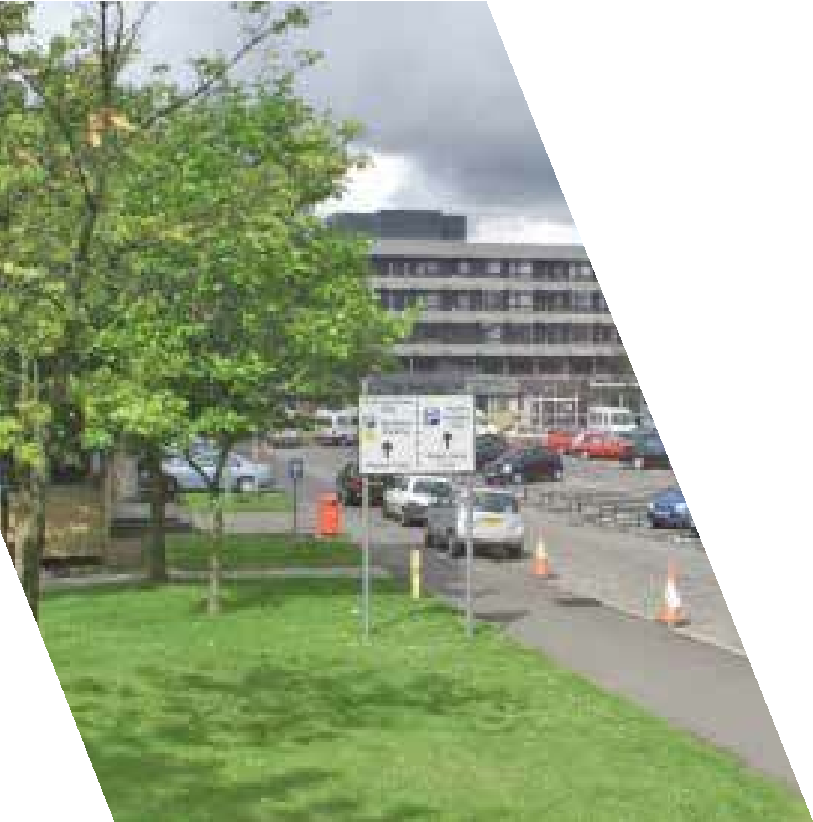

HR Medical & Dental

Law House

Airdrie Road

Carluke

ML8 5EP

  Carer Positive LEVELS LOGOS CMYK_engaged_linear.jpg

**Contents**

To assist you with your application for the post of Specialty Doctor in Old Age Psychiatry for NHS Lanarkshire, this pack will provide useful information about the posts, about NHS Lanarkshire and about Lanarkshire more generally.

|  |  |
| --- | --- |
| Advert 3  Job Description 6  Person Specification 11  Terms and Conditions 17  Selection Process 18  Lanarkshire – The Place 19  Our Vision 20  Our Context 23  Our Ambition 24  Useful Websites 28  Living in Lanarkshire 29 |  |
|  |  |

Specialty Doctor in Old Age Psychiatry



**Salary Range £58,198 - £90,688 per annum (based on 10 PAs per week)**

NHS Lanarkshire is innovative and forward thinking Health board with a commitment to excellent Mental Health Services. As part of this commitment, we are seeking to further strengthen our existing Old Age Psychiatry service by improving our Specialty Doctor workforce and welcome applications from enthusiastic individuals keen to join our dedicated team.

This post is a 5 PA Specialty Doctor post in Old Age Psychiatry, based in North Lanarkshire.

This post will be part of the Motherwell Older Adult Community Mental Health Team and also part of an active and vibrant Old Age Psychiatry Department. This is a community post with no inpatient responsibility or commitment and the successful applicant would work with the CMHT which is led by a consultant psychiatrist.

***NHS Lanarkshire are happy to consider requests for this publication to be in another accessible format i.e. large print, braille, etc.  Please contact us via either of the undernoted methods clearly stating which format is required:***

An informal discussion or visit would be welcomed and can be arranged through Dr Sowmya Munishankar, Clinical Director, Old Age Psychiatry on 01698 754420.

For any application queries, please contact Nicole Hetherington –

Senior HR Assistant on 01698 754 350 Medical.dentalSAS@lanarkshire.scot.nhs.uk

Interviews are scheduled for: TBC

|  |
| --- |
| **Integrated Health and Social Care Partnerships**  Legislation requiring the integration of health and social care came into effect in April 2016. This resulted in significant change to the way we care for and improve the health of our people in their community. NHS Lanarkshire has 2 Health and Social Care Partnerships one in the North and one in the South.  NHS Lanarkshire, our Local Authority Partners in North and South Lanarkshire Councils, our third sector partners and the people of Lanarkshire recognise the importance of a system of health and social care that is robust, effective and efficient and which reliably ensures a high quality of support and care which is the right of the people of Lanarkshire.  Further details on the Integration of Adult Health and Social Care are available at: www.scotland.gov.uk/publications/2012/07/5082/0  **The Monklands Replacement Project team welcome approval of Wester Moffat as preferred site for new hospital**  The Monklands Replacement Project (MRP) team are delighted that Wester Moffat has been selected as the preferred site for the new, state-of-the-art University Hospital Monklands. This will be Scotland’s first digital hospital and through the use of available technologies, we will enhance the patient journey and staff experience. The project team look forward to working with all stakeholders and will share our exciting plans in the coming months to ensure the public and our staff are fully aware of developments and can continue to provide input.  Exciting plans to replace University Hospital Monklands with a new landmark facility have taken a giant leap forward following Scottish Government approval of the outline business case.  The approval gives NHS Lanarkshire and the people of Lanarkshire an extra special reason to celebrate the NHS’s 75th Anniversary as they look to a future with a trailblazing fully-digital hospital set to be the most advanced in Scotland when it opens.  The new hospital is a hugely significant capital project with massive benefits for healthcare, the economy and local community across Lanarkshire and Scotland.  Following a thorough review at the highest levels, including support from the First Minister, the Scottish Government has invited NHS Lanarkshire to submit a full business case for the Monklands Replacement Project (MRP). The final programme timescales and cost will be agreed when the full business case is submitted in 2024. |

**Job Description**

1. **JOB PURPOSE**

The job is offered on a 5 PA basis (0.5 WTE) in Old Age Psychiatry.

The post holder would be joining the established Motherwell Older Adult Community Mental Health team in North Lanarkshire. The CMHT is led by a consultant and the successful candidate will work with a very experienced and enthusiastic consultant colleague and multidisciplinary team members within the CMHT-OP. The team usually has a trainee and medical students attached based on training requirements and supervision availability. There are no inpatient responsibilities nor on–call commitment attached to this post.

An important part of the post is flexibility and team working in order to work with the existing medical staff. The medical staff within the Old Age Psychiatry department in Lanarkshire are a very proactive and supportive group of colleagues who meet monthly, with additional peer group meetings, and internal teaching. Attendance at the West of Scotland Old Age Psychiatry teaching and Faculty of Old Age Psychiatry meetings is encouraged, as is study leave wider afield.

Old Age Psychiatry is managed strategically on a pan-Lanarkshire basis, through the Old Age Psychiatry Program Board, chaired by the General Manager, and with input from the Clinical Director, Service Manager, senior nurse and others. The service also benefits from an active clinical governance group and ward based clinical quality groups, with links to national programs such as Focus on Dementia.

Community services are organised by locality with operational responsibility falling to the Locality Manager. Each locality has a CMHT for older people with a remit for both dementia and functional patients. The service is largely community based. The Inpatient service is managed centrally by a dedicated management team. The acute mental health inpatient facilities for Older Adults for these localities are located at University Hospitals Monklands and Wishaw.

There are consultant led pan-Lanarkshire specialist services in Care home Liaison, Hospital based complex clinical care, functional and organic, Young onset Dementia, Acute hospital liaison and Huntington disease.

Old Age Psychiatry and Psychological Therapies teams are proud of their close working relationship. All localities including Older Adults Liaison and our inpatient wards have dedicated psychology input. All localities also have access to Occupational Therapy which also has dedicated personnel to develop and improve the service.

Staff across Old Age Psychiatry is well motivated and enthusiastic and despite some resource limitations have introduced many service innovations over the past few years. The Old Age Psychiatry department currently has 17 consultant posts with a total of 14.9 whole time equivalent staff. The department is supported by Associate specialists and Specialty doctors, and benefit from a steady stream of FY2, GP, core and higher trainee doctors, and are actively pursuing broad based trainees. The department also benefits from Clinical Fellow posts which are based on the Older Adults inpatient wards. We also welcome medical students from Edinburgh and Glasgow Medical Schools. Some of our Specialty doctors are also actively involved in undergraduate teaching/ supervision. There is also active departmental Quality improvement activity.

The precise details of the job plan will be dependent on the successful candidate’s subspecialty training and interests.

The job is offered as a 5 PA basis.

All new Specialty Doctors are initially offered a minimum of 1 PA for personal development in relation to appraisal and revalidation.

Candidates with a particular interest in a career path to the new Specialist grade and/or CESR and beyond will be welcomed.

NHS Lanarkshire is supportive of applications from individuals with well-developed ideas for improving services who are able to demonstrate a commitment to quality improvement, patient safety (including human factors training), Medical Education and Research & Development.

The Board has a well-established, bespoke Medical Education and Training Centre with simulation facilities and is developing a faculty for Human Factors training. We have a strong commitment to Patient Safety and Quality Improvement.

Specialty Doctors are initially offered 1 PA for SPA duties for a full time post. Candidates wishing to work less than full time would be offered pro rata SPA, dependant on the number of sessions worked.

|  |  |
| --- | --- |
| Number of PAs worked | SPA offer |
| 5 -10 PAs | 1 SPA |
| 3 - 4 PAs | 0.5 SPA |
| 1 – 2 PAs | 0.25 SPA |

1. **GENERAL PROVISION**

You will report to the Clinical Director, who will agree your job plan.

1. **HEALTH & SAFETY**

You are required to comply with NHS Lanarkshire Health and Safety Policies.

1. **MANAGEMENT STRUCTURE**

The supporting operational and clinical management structures are focused on enhancing patient safety, quality improvement and local delivery, with visibility of clinical leadership and support for individual professional accountability. Our Medical Managers will provide professional leadership to medical staff, ensuring that they are effectively developed, organised, integrated and managed to support the strategic aims of each Division and meet the needs of the patient.

**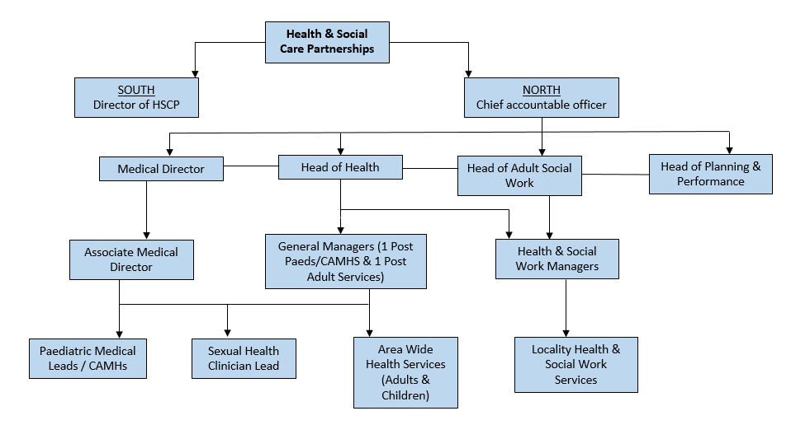**

1. **RESOURCES**

|  |  |  |
| --- | --- | --- |
| The following department resources are available:- | | |
|  | | |
| **Consultants** | **Special Interest** | |
| Dr Sowmya Munishankar | Young onset dementia and Management | |
| Dr Rajdeep Routh | Inpatients/Training | |
| Dr Susan Telfer | Community Psychiatry | |
| Dr Damian Lynch | Training/ Management | |
| Dr Martin Carlin | Education and training | |
| Dr Christine Carswell | Forensic | |
| Dr Alison Gordon | Movement Disorders | |
| Dr Andrew Donaldson | HBCCC/Clinical Gov/Research/Training | |
| Dr Sujatha Maiya ECT/HBCCC | | |
| Dr Stuart Gibson Sleep Disorders | | |
| Dr Adam Daly Management | | |
| Dr Rekha Hegde | Liaison/Deanery | |
| Dr Joanna Franz | Community Psychiatry/BMA | |
| Dr Karli Dempsey | Liaison Consultant/Education | |
| Dr Craig Patrick | Community Psychiatry/HBCCC/Care Home | |
| Dr Catriona Ingram | Community psychiatry | |
|  |  | |
| **Speciality Doctors inc Clinical Fellow** | **7** | |
| Specialist Registrars on rotation from the West of Scotland Training Scheme | 2 | |
| STRs/FY’s | 8 | |
|  | | |
|  | |  |
| **Secretarial Support:** | |  |
| WTE Secretaries (shared with other staff within the teams) | | 1 |

1. **OFFICE SPACE**

All Medical Staff have access to office space with IT facilities. Dedicated departmental secretaries provide administrative and secretarial support.

1. **JUNIOR MEDICAL STAFF/MEDICAL STUDENTS**

There are regular opportunities to be involved in the training and supervision of Junior Medical staff who work with you. In addition, you will be expected to ensure that staff have access to advice and counselling. If appropriate, you will be named in the contracts of Doctors in training grades as the person responsible for overseeing their training and as the initial source of advice to such Doctors on their career.

1. **WORK PROGRAMME**

As required under Section 4 of the Terms and Conditions of Service, the duties and responsibilities are supported by a job plan and work programme detailed as follows:

**Job Planning/Programmed Activities**

The job plan will be dependent on the successful candidate’s subspecialty training and interests. On taking up post a Job Plan will be agreed between the person appointed and the Clinical Director. This job plan is subject to review by the post holder and the Clinical Director as noted in the terms and conditions. The procedures set out in the ‘Terms & Conditions of Service’ must be followed if it is not possible to agree a job plan, either initially or at annual review.

The timetable is indicative and subject to negotiation with the Clinical Director. The core 10 PA working week will be based on 5 PA’s of Direct Clinical Care (DCC) duties and 1 PA of SPA time for a full-time post-holder.

|  |  |  |  |
| --- | --- | --- | --- |
| **Days** | **Hours** | **Type of Work** | **Location** |
| Monday | AM | Off | Off |
|  | PM | SPA (0.5) | Journal Club/Peer group/CPD (2/month) |
| Tuesday | AM | CMHT | Motherwell CMHT-OP |
|  | PM | CMHT | Motherwell CMHT-OP |
| Wednesday | AM | CMHT | Motherwell CMHT-OP |
|  | PM | CMHT | Motherwell CMHT-OP |
| Thursday | AM | SPA (0.5) | Teaching fortnightly |
|  | PM | CMHT | Off |
| Friday | AM | CMHT | Off |
|  | PM | CMHT | Off |

The indicative weekly timetable included in the work programme shows an example of the working week, which will be subject to change and negotiation with the Clinical Director depending on service needs on commencement.

**Main Duties**

To review patients referred to Old Age Psychiatry in community outpatient clinics.

Provide psychiatric input and support to the CMHT-OP. Attend MDT meetings. To support the Consultant Psychiatrists in the Motherwell locality in assessment and management of patients in the community and work closely with other members of the CMHT-OP multidisciplinary team in the management of patients in the community.

Liaise closely with clinicians from other specialties when necessary, and GPs in the community.

Roles include:

* Discussing referrals, inpatient and outpatient with colleagues.
* Discussing management/investigation of patients with colleagues in other appropriate clinical support services.
* Expeditious completion of patient administration duties e.g. verifying letters, signing off results etc.
* Speaking to GP’s and other doctors re: outpatient results.
* Vetting urgent clinic referrals / allocating appointments
* Covering fellow Specialty doctor/ Associate Specialist colleagues within Old Age Psychiatry service
* Work towards generic and specialty objectives.
* Attend peer group
* CPD and Appraisal
* Departmental audit and service evaluation.

Whilst there are some potentially fixed commitments in the job plan (as above), this is subject to negotiation and other clinical and non-clinical sessions will be subject to room availability (for example), but this can be discussed with the successful applicant to find a weekly timetable that suits for both the service and the successful applicant.

Clinical supervision will be provided by the Consultant Old Age Psychiatrist for Motherwell, Dr Roger Cable and managerial supervision provided by Dr Sowmya Munishankar, Clinical Director. The Specialty Doctor will be encouraged to participate in the local post-graduate teaching programme. The Specialty Doctor is expected to participate in audit/service evaluation. An interest in research will be supported. The post holder will participate in locality team meetings.

1. **AUDIT & RESEARCH**

The successful candidate will be expected to participate in audit processes and there is an active clinical audit department available to assist. NHS Lanarkshire is ambitious to build a portfolio of research projects backed by enthusiastic and dynamic individuals. It has an active Research and Development department and would welcome discussion regarding a potential research interest.

**10. CONTINUING PROFESSIONAL DEVELOPMENT**

Study leave is available within the terms and conditions of service with the approval of the Clinical Director. The appointee will be required to fulfill such demands for continuing professional development as the Royal College of Psychiatrists (or other relevant bodies) may make.

**11. HONORARY ACADEMIC STATUS**

If involved in undergraduate teaching, status can be applied for. Applications can be made via the Hospital Sub-dean and then to the appropriate academic department within the University.

**Specialty Doctor in Old Age Psychiatry**

**Person Specification**

|  |  |  |
| --- | --- | --- |
| **Demonstrated on Application** | | |
| Attributes | **Essential** | **Desirable** |
| Qualifications | MBChB or equivalent.  Current full registration with GMC with a licence to practice. | Membership of the Royal College of Psychiatrists or equivalent qualification (in accordance with Royal College of Psychiatrists guidelines).  Higher Degree or other Diploma. |
| Training | Completed at least four years’ full-time postgraduate training (or its equivalent gained on a less than full time or flexible basis) at least two of which will be in a Specialty Training Programme or specialty registrar locum appointment for training (LAT) : or shall have equivalent training, experience or competencies, either in the UK or overseas. | Further specialist training in psychiatry and old age psychiatry.  Training at ST/SPR level in communication teaching or management.  Experience within UK training establishments.  Human Factors Training. |
| Experience | Experience of working within a multi-disciplinary team in Old Age Psychiatry, in both inpatient and outpatient settings, and ability to work with relative independence.  Confident with indirect supervision of varying grades of doctors in training.  Working knowledge of Mental Health (Care & Treatment) Act Scotland. | Ability to supervise the clinical work of doctors in training and relevant staff in other disciplines.  Experience of actively contributing to innovative service development.  Experience of leading and/or involvement in change management.  Subspecialty interest.  Previous experience in organising NHS Services or equivalent.  Administrative / Management experience. |

|  |  |  |
| --- | --- | --- |
| **Demonstrated on Application** | | |
| Attributes | **Essential** | **Desirable** |
| Audit/Research | Understanding of the principles of medical audit.  Evidence of contribution to audit at least at local level. | Experience and interest in Audit of the practice and experience of design of audit.  Awareness of principles of research with an ability to critically analyse medical literature.  Research within the practice.  Involved in design of research relevant to the practice. |
| Publications | Not essential | Relevant presentations or publications to the specialty. |
| Teaching | Enthusiasm for undergraduate or postgraduate teaching. | Interest in and commitment to teaching and training.  Experience of providing supervision and or mentorship  Experience of providing problem-based teaching.  Experience of organising teaching programmes.  Formal training in educational/clinical supervision. |
| Managerial | Knowledge of service provision at a local level. | Involvement in service re-design.  Involvement in project delivery.  Involvement in NHS-related meetings. |

|  |  |  |
| --- | --- | --- |
| **Demonstrated at Interview** | | |
| Attributes | **Essential** | **Desirable** |
| Knowledge and  Skills | Be able to demonstrate a good knowledge of the range of psychiatric conditions and their management in a older adult population. Have knowledge of working in community settings and to have experience of MDT working.  A basic knowledge of recent clinical guidelines.  Established clinical skills.  Excellent communication skills both verbal and written.  Able to seek advice and support when required.  Good patient management / interactional skills. | Good IT Skills  Knowledge of specialist skills. |
| Disposition | Committed to Quality Patient Care.  Able to be understanding of and sensitive to the needs of patients.  Excellent communication skills (verbal and written)  Ability to work under pressure.  Ability to work effectively in a multidisciplinary team.  Responsive to change and innovation, promoting a culture for organisational development.  A flexible approach to duties, which satisfies the needs of the Service in a changing environment.  Ability to demonstrate reflective practice with evidence of regular appraisal with clear Personal Development Plan relating to Continuing Professional and Personal Development.  Good time management and organisation.  Demonstrates commitment and enthusiasm to service delivery. | Problem solver/diplomat/counsellor.  A natural leader. |
| **Demonstrated at Interview** | | |
| Attributes | **Essential** | **Desirable** |
| Disposition | Ability to demonstrate reflective practice with evidence of regular appraisal with clear Personal Development Plan relating to Continuing Professional and Personal Development.  Committed to Quality Patient Care.  Good time management and organisation.  Demonstrates commitment and enthusiasm to service delivery. |  |
| Managerial | Knowledge of service provision at a local level.  Awareness of the principles and core practices involved in service management, project management and effective meetings. |  |
| Leadership | Awareness of the principles of team leadership and effective people management.  Commitment to the Values of NHS Lanarkshire:- Fairness, Respect, Quality, Working Together. | Evidence of role as leader within groups. |
| Other | Fluent in medical English and evidence of ability to communicate in stressful situations. |  |

|  |  |  |  |  |
| --- | --- | --- | --- | --- |
| **PERSON PROFILE** | | | | |
| **Demonstrated at Pre-Employment Check** | | | | |
| Attributes | **Essential** | | | **Useful** |
| Other | Satisfactory medical clearance by NHS Lanarkshire Occupational Health Service.  Satisfactory PVG Check.  Current full driving licence and access to a vehicle (required for jobs where an immediate return to site or travel between sites is required) | | |  |
| If there is any reason why a disabled person should not be considered suitable for this post, please provide details: | | | **Uncorrected visual or hearing defect would be incompatible with the nature of the work**. | |
|  | | **Prepared By:-** | | **Approved By:-** |
| Name | | Dr Sowmya Munishankar | |  |
| Designation | | Clinical Director for Older People’s mental health services | |  |
| Date | | November 2024 | |  |

**Terms & Conditions**

1. This appointment is offered on the Terms and Conditions of the Specialty Doctor Contract (2022).
2. Our pension scheme is provided by Scottish Public Pensions Agency, and all benefits are explained on the SPPA website (http://www.sppa.gov.uk/). Here you can also access an annual statement showing how much service has built up in your pension. If you wish to opt out or have previous NHS Service, you should refer to the SPPA website for further information about any implications for your pension benefits.

Superannuable pay will include basic salary (up to 10 programmed activities, but not any extra programmed activities about this level), on-call availability supplements, discretionary points, distinction awards, and any other pay or allowances agreed by the Scottish Government, to be superannuable. Superannuable pay will be subject to HMRC legislation.

1. The employment is subject to 3 months’ notice on either side subject always to the appeal and other provisions of schedule 2 of the Terms and Conditions of the Specialty Doctor 2022 Contract (NHS Circular PCS (DD) 2022/2)
2. The successful candidate must be contactable throughout any on-call period. NHS Lanarkshire will provide the facility for this.
3. The successful candidate, if not already employed by the NHS Lanarkshire, will be required to complete a medical questionnaire to obtain medical clearance from the Occupational Health Physician. The successful candidate will be required to complete a Disclosure Scotland PVG (Protecting Vulnerable Groups Scheme) form. An e mail link will be sent to the successful candidate for completion. No approach will be made without written permission of the successful applicant who will be asked to sign and complete a disclosure PVG application, giving authorisation for the check to be undertaken. If you are a non EEA National and are currently based out with the UK a Country of Origin check/criminal records certificate will also be required from each country in which you have resided continuously or cumulatively for 12 months or more in the last 10 years.
4. NHS Lanarkshire does not negotiate salary placements. On commencement the salary will be in line with Schedule 10 of the Terms and Conditions of the Specialty Doctor Contract (2022). Appointees start on the scale minimum except in the circumstances of paragraphs 6 - 9 of Schedule 10 of the terms and conditions of service.

**Terms & Conditions (cont.)**

1. NHS Lanarkshire does not negotiate salary placements. On commencement the salary will be in line with Schedule 10 of the Terms and Conditions of the Specialty Doctor Contract (2022). Appointees start on the scale minimum except in the circumstances of paragraphs 6 - 9 of Schedule 10 of the terms and conditions of service.
2. From 1st April 2023, the starting salary for the post is £58,198 per annum (based on 10 Programmed Activities per week). The successful candidate’s total salary will be dependent on his/her previous service history. Remuneration for any extra programmed activities will be dependent upon the job plan agreed at the time of appointment.
3. Dependent upon present place of residence, NHS Lanarkshire may require the successful candidate to undertake to remove home to a distance acceptable to NHS Lanarkshire, normally within 10 miles of the base Hospital, in which case removal expenses will be payable in accordance with NHS Lanarkshire Policy. In some cases, however, a residence more than 10 miles distant from the base hospital will be acceptable and in this case removal expenses will be subject to the prior approval of the Associate Medical Director for such a residence. The position will be made clear to the successful candidate on application.

**Selection Process**

The Job Description and Person Specification is designed to inform potential applicants on the essential and desirable experience and personal attributes which are sought in the appointment of this post.

Assessment against this will feature throughout the recruitment and selection process for the appointment.

**Lanarkshire – The Place**

NHS Lanarkshire is the third largest health system in Scotland with around 12,500 staff and a baseline recurring budget of £1.4bn, serving a community of circa 655.000 people, through

* Three acute hospitals – University Hospital Hairmyres, University Hospital Monklands and University Hospital Wishaw
* Around 102 GP Practices with 367 wte GPs
* Spans two local authority areas – North Lanarkshire Council and South Lanarkshire Council with 2 Integration Joint Boards, North Lanarkshire IJB and South Lanarkshire IJB.

NHS Lanarkshire and North and South Lanarkshire Councils formed the North and South Lanarkshire Heath and Social Care Partnerships to develop a wide range of community facing health improvement, health and social care services with locality based planning and delivery.

The Partnerships include a range of community health and social care services, community hospitals (mainly for long term conditions and continuing care for older people), as well as a wide range of services for patients with mental health problems and learning disabilities. Services also include GP Practices providing many primary and community care services throughout Lanarkshire.

https://www.hscnorthlan.scot/

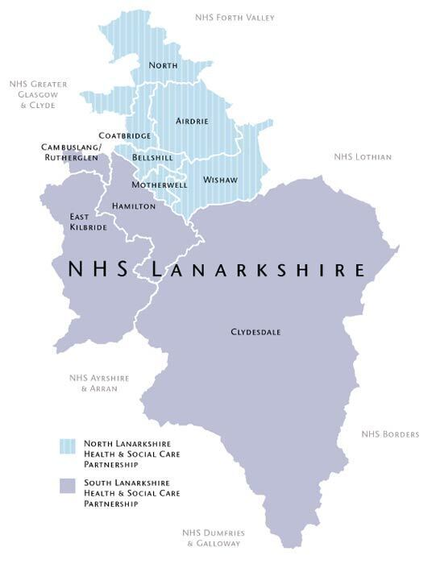https://www.southlanarkshire.gov.uk/slhscp/info/1/about\_us

**Our Vision**

**NHS Lanarkshire will:**

* Be an exemplar anchor institution in our own NHS care delivery work and in how we support and catalyse action with our local partners.
* Build upon the learning and collaboration that has been reinforced by the pandemic to ensure that we have a resilient healthcare system for the future.
* See addressing inequalities, promoting well-being and ensuring sustainability as core ways of working both in service delivery and in partnership working. We will continue to use the opportunity of remobilisation to redesign services to achieve a reduction in healthcare associated inequalities, promote well-being, ensure cost-effectiveness, and reduce unmet need rapidly across the system.

**Our Interim Corporate Objectives**

|  |  |
| --- | --- |
| 1 | **Pandemic Response & Corporate** **Resilience**  Respond to the pandemic to ensure resilience and provide a safe environment and interventions that minimise the risk of injury or harm to our patients and staff. |
| 2 | **Recovery of Services**  Remobilise and recover services to re-establish timely and accessible health and social care to all parts of the community we serve. |
| 3 | **Workforce**  Ensure we have a diverse, flexible and appropriately trained workforce in place that delivers high quality care that meets the needs of NHS Lanarkshire’s population |
| 4 | **Development of Our Health Together**  Work in partnership to deliver ‘Our Health Together’ realising our strategic ambition to modernise and continuously improve care, engaging with our patients, partners and workforce to ensure health and social care services are sustainable, focused on prevention and early intervention and continue to meet their needs |
| 5 | **Equalities & Inequalities**  Establish NHSL as an Anchor organisation, working with partners to tackle socio-economic disadvantage and reduce inequalities and ill health that are associated with being disadvantaged |
| 6 | **Maximising Staff Wellbeing**  Promote health and wellbeing, implementing programmes that impact positively on the lives of our workforce, reflect the value we place on them, enhance engagement, and build resilience |
| 7 | **Addressing the Challenges of Sustainability and Climate Change**  Work towards delivery of net zero health and social care services, responding to climate change while delivering efficient, low carbon patient focused care. |
| 8 | **Financial Sustainability**  Provide effective financial planning that supports financial sustainability, balances budgets and provides value. |

*The Board’s Interim Corporate Objectives for 2022/23 were approved by the NHS Board in March 2022 and reflect* *that many uncertainties remain with respect to the ongoing and future impact of the global Covid-19 pandemic. NHS Lanarkshire is committed to maximising a successful and sustained recovery of services as quickly as possible. However, the impact of Covid-19 and non-Covid demands on the service in recent months has contributed to a significant deterioration in our planning assumptions. As such, the scope of our Corporate Objectives is limited in terms of our ability to accurately assess how the whole system can address the ongoing challenges of responding to the pandemic and how quickly the remobilisation process can take effect.*

**Our Values**

The NHS Lanarkshire values of Fairness, Respect, Working Together and Quality underpin our purpose, providing local focus and context for the improvement of our services and guiding our individual and team behaviours. NHS Lanarkshire’s values represent the care our patients can expect, and how this care should be delivered by our staff.

|  |  |
| --- | --- |
| **Fairness**  Ensuring clear and considerate decision making at all levels | As a team, we are responsible for being consistent and open in making decisions  As an individual I am responsible for participating in decisions and seeking clarity whenever I am unsure |
| **Respect**  Valuing every individual and their contribution | As a team, we are responsible for being courteous and professional in fulfilling our individual and collective roles  As an individual, I am responsible for recognising that we are all different and appreciating the contribution that I and others make |
| **Quality**  Setting and maintaining standards in everything we do | As a team, we are responsible for upholding our high standards in every activity, for every person, everywhere  As an individual, I am responsible for ensuring I understand and deliver our standards every time |
| **Working Together**  Thinking, growing, delivering as a team | As a team, we are responsible for creating and sustaining an environment that allows team working and collaboration to flourish  As an individual, I am responsible for communicating effectively and working well with others at all times |

**Our Context**

**The Board**

Lanarkshire NHS Board (the Board) is a strategic body, accountable to the Scottish Government Health and Social Care Directorate and to Scottish Ministers for the functions and performance of NHS Lanarkshire. The Board consists of the Chair, Non-Executive Directors (who are publicly appointed by the Scottish Ministers), Stakeholder Non- Executive Directors including the Employee Director, Area Clinical Forum Chair, representatives of North and South Lanarkshire Councils and Executive Directors.

The NHS Board’s role is to improve the health and wellbeing of the people of Lanarkshire through robust, accountable and corporate governance systems. The Board’s role is to set strategic aims, hold the executives to account for the delivery of those aims, determine the level of risk the Board is willing to accept, influence the organisation’s culture and engage with stakeholders on the stewardship of public money and the priorities of the Board.

**Composition of the Board**

|  |  |
| --- | --- |
| Non-Executive Directors | Executive Directors |
| Chair  10 Non-Executive Lay Members (including 1 Whistleblowing Champion)  Chair - Area Clinical Forum  Chair - Area Partnership Forum  2 Local Authority Elected Members - 1 from North Lanarkshire Council and 1 from South Lanarkshire Council | Chief Executive  Director of Public Health and Health Policy  Director of Finance  Medical Director  Director for Nursing, Midwives and Allied Health Professionals |

**Our Ambition**

The NHS Lanarkshire Board has recently agreed that our overall healthcare strategy will be guided by:

* The Healthcare Strategy- Our Health Together; Living our best lives in Lanarkshire
* Focusing on service recovery through the triple lens of addressing inequalities, maximising wellbeing and addressing the challenges of sustainability and climate change,
* Capitalising on the new and innovative ways of working, particularly in the use of digital technology, brought about in our response to COVID-19;
* Delivering the Outline Business Case for the replacement of University Hospital Monklands;
* Being a leading partner in contributing to improving the exacerbated socioeconomic and health inequality challenges faced by Lanarkshire since the pandemic;
* Enhancing the Board’s reputation through exploiting the opportunities that arise through our strategic partnerships with three University partners as a leading teaching Board; and
* Continuing to provide high quality sustainable services and financial prudence in line with our Local Delivery Plan, agreed with Scottish Government.

**Our Health Together: Living our best lives in Lanarkshire**

The Healthcare Strategy “Our Health Together; Living our best lives in Lanarkshire” is developing from our previous strategy “Achieving Excellence” and reflects the significant achievements made already, and takes account of the post COVID-19 world we are adapting to.

Progress is driven by a series of action plans which are coordinated by a Strategic Delivery Team and reported to the NHS Board and Planning, Performance & Resources Committee on a regular basis.

Our Health Together will address:

* **Finishing what we’ve started** – shifting the balance of care and maintaining acute services within the current bed base: one hospital, three sites. This was a key element of Achieving Excellence: success has been achieved, but more needs to be done.
* **Recovery and resilience following COVID-19** – recovery/remobilisation plan over 18 months or so and resilience planning. Meet agreed (new) clinical priorities (national and local).
* **Making A Wider Impact** – through a whole-Lanarkshire approach to tackling both existing and COVID-19 driven health and socioeconomic inequalities, the strategy will consider inequalities, wellbeing and the challenges of sustainability and climate change. A Partnership approach with other public bodies, and third and independent sectors.

Workstreams have been established to develop the strategic ambitions for the following service areas:

* **Primary Care Redesign** – Continuation of Primary Care Improvement, adoption of post-COVID-19 service model with emphasis on reduction in physical attendance.
* **Redesigning Urgent Care** – Post-COVID-19 primary and secondary urgent care service model short, medium and long term redesign. Taking national directions of travel but creating local solutions, particularly in the short term.
* **Mental Health (incl CAMHS & Dementia)-** Delivering on the agreed Mental Health & Wellbeing Strategy and delivering a new service model for CAHMS based on the outcomes from a deep-dive exercise.
* **Frailty, Older People & Care Homes**
* **Planned Acute Care** – General Surgery, Robotic Assisted Surgery, Trauma & Orthopaedics and National Treatment & Diagnostic Centre workstreams, with a focus on post-COVID-19 recovery (backlog) and developing a service model capable of meeting future demand within the COVID-19 environment.
* **Monklands Replacement Project** – Learning the lessons from COVID-19 across services and engineering and preparing a business case for the new hospital.
* **Long Term Conditions (LTC)–** Building on the work of the LTC hub.
* **Public Health System Development**
* **Realistic Medicine**
* **Rehabilitation**
* **Staff Health & Wellbeing**
* **Unscheduled Care**

**COVID-19**

COVID-19 has undoubtedly proved to be the biggest challenge to public health and the organisation of health services in a generation. Our focus has been in supporting staff and patients during these first two years of the pandemic, and we are now moving into the remobilisation and living with Covid19 phase.

The Board has in place a Service Remobilisation Oversight Group which is chaired by the Executive Director of Nursing and Executive Medical Director. This is a whole-system oversight group established to support the operating divisions in the “standing-up” of services and the preparation of the Annual Delivery Plan (ADP).

In the recovery phase, we are working closely with our planning partners across the whole of Lanarkshire, and engagement with our planning partners is key to delivering our ambitions.

The Chief Executive, working closely with the NHS Board, will drive this agenda, working with all stakeholders across the wider Lanarkshire community and at regional and national level.

In NHS Lanarkshire we have a demonstrable track record of excellent partnership working, through meaningful and mature staff and stakeholder engagement.

**Net Zero Carbon Pathfinder Project**

The Energy Efficient Scotland Routemap requires public sector buildings to be zero carbon by 2050 and the Scottish Government has also called a Climate Emergency, committing to become a net zero carbon economy by 2045. The Net Zero Carbon Public Sector Buildings (NZCPSB) standard (“the Standard”) is a new voluntary standard which has been developed by Scottish Government to support the Public Sector in setting ambitious targets to achieve net zero outcomes for new buildings and major refurbishments.

The Standard supports a challenging, credible path to net zero carbon materials and energy supplies for all non-domestic buildings. By 2045, projects that adopt the Standard will achieve zero embodied carbon during construction and subsequently the whole life of projects, including operational energy. The Monklands Replacement Project has been selected as a pathfinder project for the new standard which has resulted in the requirement for an all-electric hospital. This demands innovative solutions and a substantial energy centre to accommodate all of the required technology.

**Scotland’s First Digital Hospital**

The construction of a new Monklands Hospital has also created the opportunity and ambition for the new Monklands University Hospital to be Scotland’s first digital hospital, directly benefitting its local community of patients, staff and visitors. Technology will be used to allow patients to access care advice and to navigate their way through the hospital easily and intuitively. The new hospital will ensure safer, better patient care and value for staff and for patients through the use of digital technology and real time information to support an efficient and effective patient journey. The hospital will have new digital systems to support patients and their clinical teams.

For further information, please visit to www.monklands.scot.nhs.uk

**Health Inequalities**

The Board is committed to addressing health inequalities throughout Lanarkshire and, working with our Community Planning Partners, there will be a renewed focus on improving the exacerbated socioeconomic and health inequality challenges faced by Lanarkshire since the pandemic.

The Board has adopted a ‘place based approach’ to regenerate what will be the vacant Monklands Hospital site, and the work we are taking forward with Strathclyde University and Professor Sir Harry Burns will form part of our wider triple lens strategic approach to tacking health inequalities in Lanarkshire.

**University Strategic Partnerships**

NHS Lanarkshire has entered into strategic partnerships with

* Glasgow Caledonian University in 2017
* the University of the West of Scotland in 2018; and
* most recently with Strathclyde University in 2019.

This resulted in the Board gaining University status from Glasgow Caledonian University and the University of the West of Scotland. Discussions are at an advanced stage for Strathclyde University to also award the NHS Board with University Status in late 2020.

**Useful Websites**

NHS Lanarkshire – https://www.nhslanarkshire.scot.nhs.uk/

Scotland’s Health on the Web (SHOW) – www.show.scot.nhs.uk

North Lanarkshire Council Website - www.northlanarkshire.gov.uk

South Lanarkshire Council Website - www.southlanarkshire.gov.uk

NHS Lanarkshire Finance –

https://www.nhslanarkshire.scot.nhs.uk/download/annual-report-and-accounts-for-year-ending-march-2019/

Link to the Interim Corporate Objectives 2002/22 (cover paper and template) https://www.nhslanarkshire.scot.nhs.uk/download/2022-march-30-board-papers/?ind=1648622978910&filename=2022-March-30-Board-13a.-Interim-Corporate-Objectives-Cover-Paper-30-March-2022-ver-18.03.22.pdf&wpdmdl=37902&refresh=628754be1902d1653036222

https://www.nhslanarkshire.scot.nhs.uk/download/2022-march-30-board-papers/?ind=1648622977160&filename=2022-March-30-Board-13b.-Interim-Corporate-Objectives-2022-23-Annex-1-Ver-22.03.22.pdf&wpdmdl=37902&refresh=628754be190b41653036222

Link to Strategy Map for Delivery of the Annual Operational Plan:

https://www.NHSLanarkshire Strategy Map for AOP 20-21

Link to Monklands Replacement Project

https://www.nhslanarkshire.scot.nhs.uk/get-involved/consult-engage/monklands-engagement/

 @NHSLanarkshire

15-157574_sme-youtube-blue-youtube-logo-transparent

youtube.com/nhslanarkshire

825-8255248_follow-us-on-facebook-light-blue-facebook-icon

facebook.com/nhslanarkshire

82-821814_transparent-ig-png-blue-instagram-icon-png-png

@nhslanarkshire

**Living in Lanarkshire**

***Living in the area***

Within the UK, Lanarkshire is situated in the heart of Scotland's central belt, the area offers an ideal combination of tranquil parks and market towns, with something for everyone.

Centrally located between Glasgow (c. 20 minutes) and Edinburgh (c. 40 minutes) you can easily commute or, should you wish to relocate, you can chose either a substantial Lanarkshire town or a more relaxed rural location and still have the attractions of two major cities on your doorstep. The county offers accessible links to major cities with easy access to major motorway/rail routes and international airports allowing you to travel across Scotland, the UK and beyond.

There are many attractions within Lanarkshire, including:-

* New Lanark World Heritage Site,
* Antonine Wall World Heritage Site,
* The Falls of Clyde,
* Summerlee - The Museum of Scottish Industrial Life,
* The National Museum of Rural Life,
* Strathclyde Country Park,
* Scottish Wildlife Reserves on the shores of the River Clyde,
* Various museums, galleries, castles, heritage centres,
* Numerous country parks.

## *Where Schools are Located*

The majority of Glasgow's independent schools are located just outside the city centre. https://www.mytopschools.co.uk/private-schools-glasgow/

St Aloysius’ College https://www.staloysius.org/

Hutchesons’ Grammar School https://www.hutchesons.org/

Hamilton College - https://www.hamiltoncollege.co.uk/

**To find more information about living and working in Scotland please visit:**

www.visitlanarkshire.com

www.visitscotland.com/destinations-maps/glasgow-clyde-valley/

www.southlanarkshire.gov.uk

www.northlanarkshire.gov.uk

https://www.scotland.org/

https://www.talentscotland.com/

https://moverdb.com/moving-to-glasgow/