JOB IDENTIFICATION
Job Title: Technical Specialist (Infrastructure)

Responsible to: Senior Technical Specialist (Infrastructure)

Department(s): Digital Services

Directorate: Infrastructure & Support Services

No of Job Holders: 7

Last Update: 06/2023

2. JOB PURPOSE
To plan, direct and co-ordinate the design, installation, connectivity and security of computer and network systems to ensure the stable operation of the organisations IT assets. To provide second line support and specialist advice for the resolution of all I.T. Infrastructure related issues and problems raised the I.T. Servicedesk

3. DIMENSIONS
- Client Group
- All NHS Ayrshire & Arran users of Information Technology
- Approximately 15,000 users across all hospital, GP Practice, Pharmacy, Dental, community clinic and health centre sites
- Technology
- In excess of 900 on premise servers
- In excess of 9,000 desktop PCs
- Local Area Network (LAN)
- Wide Area Network (WAN) and links to SWAN
- Distributed systems ranging from Radiology Information System to GP clinical systems within General Practice
- VMWare Virtulisation Technologies
- Cloud Hosting

4. ORGANISATIONAL POSITION
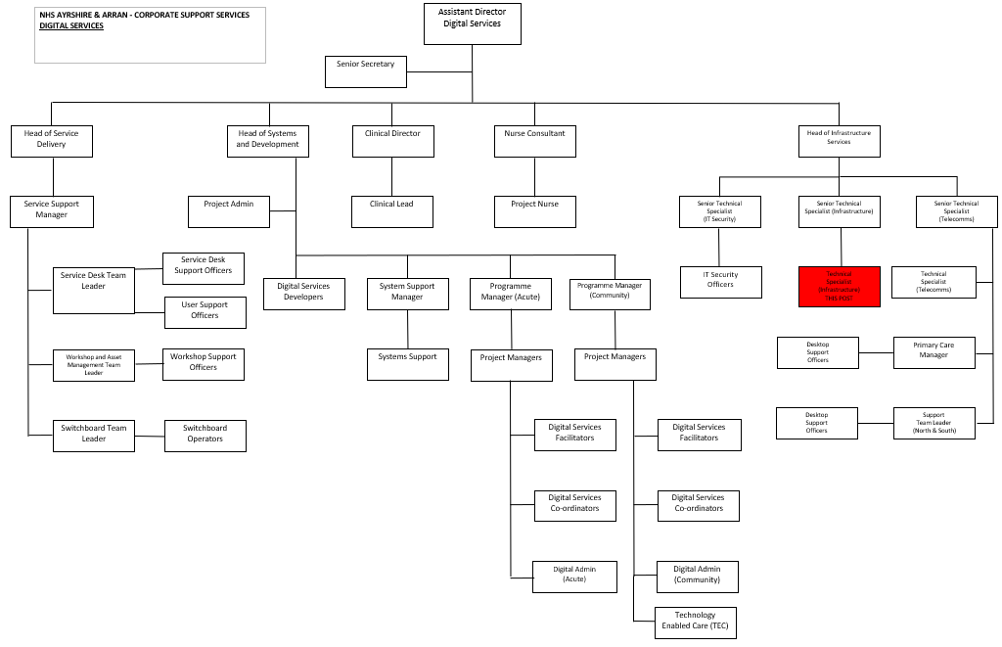

5. ROLE OF DEPARTMENT
Deliver effective operational Digital Services across NHS Ayrshire & Arran, based on the application of new technologies and effective ways of working, to support and enable the modernisation of services. Develop the technical infrastructure (servers, desktops, local and wide-area networks) to enable the sharing of information and knowledge across NHS Ayrshire & Arran in a secure managed environment. Define, promote and lead the development and deployment of a Digital strategy, within and beyond NHS Ayrshire & Arran. Develop and extend information literacy across the organisation by developing information sources, extending access. Provide support and professional advice on Information Technology.

6. KEY RESULT AREAS
- Technical management to ensure optimal operation of all network hardware and equipment including routers and switches
- Management of the IT technical network to ensure efficiency of IT security including firewalls, anti-virus solutions and intrusion detection systems.
- Management of servers including clinical systems, financial systems, e-mail, file and print and backup servers, their associated operating systems and application software.
- Implement strategic plans to ensure network capacity meets existing, future and national requirements.
- Develop, implement and maintain policies, procedures and associated training plans for network resource and system security administration and appropriate use.
- Develop and deploy methodologies for testing network performance and providing network performance statistics and reports.
- Assess, approve and administer all equipment, hardware and software upgrades.
- Establish best practices and policies for installing, configuring, maintaining and troubleshooting end user workstation hardware, software and peripheral devices.
- Approve and administer user accounts, permissions and access rights.
- Design and implement disaster recovery plans for operating systems, databases, networks, servers and software applications.
- Recommend, schedule and apply fixes and security patches and keep current with emerging security alerts and any other measures required in the event of a security breach.
- Develop, deploy and project manage specialised projects as and when required.
- Maintain and update all relevant documentation pertaining to the server and network infrastructure to support understanding and rapid resolution of problems and issues.
- Maintain an up to date knowledge of available technologies and recommend the introduction of new products.
- Participate in a 365x24 on-call rota to help provide support for the Infrastructure and maintain appropriate user access to systems.

7a. EQUIPMENT AND MACHINERY
- IT technical testing and maintenance equipment.
- Full range of Microsoft Office 365 suite and document management systems.
- Servers ,switches
- Backup systems.
- Data centre technologies.
- Testbed equipment
- PCs, laptops, printers and cabling
- Considerable daily use of many Microsoft products including o365 Exchange Online, MS Word, MS Excel, MS PowerPoint and MS Project. VMWare Technologies.
7b. SYSTEMS
- Those identified in sections 3 and 7a
- IT Helpdesk System (technical database) for logging and managing calls.
- Report writing software
- Presentational software
- All Microsoft systems – Outlook for day to day own use, all other relevant Microsoft 365 applications when dealing with users issues
- WAN/LAN network monitoring tools
- Software monitoring tools
- Firewall software tools
- Unix and other non Microsoft operating systems

8. ASSIGNMENT AND REVIEW OF WORK
Work is assigned by the Senior Technical Specialist (Infrastructure) in line with local and national Digital Strategies, although some work will be self initiated and therefore there is a high degree of autonomy.

The review of work is undertaken by the Senior Technical Specialist (Infrastructure) on a regular and informal basis, and formally through annual appraisal meetings.

9. DECISIONS AND JUDGEMENTS
- The postholder is expected to anticipate problems within their area of professional expertise and
resolve or escalate these accordingly. The decision as to whether the problem should be resolved in
house or by a third party maintenance contractor is made by the postholder.
- The postholder will proactively manage potential problems by using specialised knowledge relating
to security issues, network issues and storage and capacity issues amongst others.
- There will be occasions when national guidance is given regarding security or support issues which
the postholder will take responsibility for communicating or actioning.
- The jobholder is expected to anticipate issues and/or problems arising from factors as described in
section 8 and be able to work on their own initiative and resolve these independently.
- In relation to on call duty the post holder is responsible for prioritising calls if required and
working autonomously to manage I.T infrastructure related problems to resolution and escalating
where appropriate to third party suppliers.
- In delivering the majority of the key results previously listed, the post-holder has full discretion in
prioritising, scheduling and executing the many individual tasks involved, except where a task is
the subject of a documented procedure, this taking precedence.

10. MOST CHALLENGING/DIFFICULT PARTS OF THE JOB
- Working within a highly technical and changing environment.
- Working within a pressurised environment providing critical infrastructure and systems support where
risk management in paramount.
- Keeping abreast of new technologies and potentially competent to deal with new technical
environments.
- Dealing with end users in sometimes stressful situations in a patient, non-technical, helpful and
competent manner.
- Concentration required when analysing complex technical issues, writing technical reports and
assisting in the development of strategies.
- Constant telephone interruptions.
- The ability to “think on your feet” and re-prioritise tasks when necessary while remaining calm
under pressure.
- Analysing highly technically complex problems, data and information

11. COMMUNICATIONS AND RELATIONSHIPS
- Internal to department – Directors, Senior Management, colleagues and Project Managers about IT
issues, necessary escalation, service management issues.
- External to department – stakeholder user groups and end users ranging from secretarial staff to GPs
and Consultants about IT issues, impact on users working arrangements.
- External- Negotiate with external organisations over service issues e.g. 3rd party support SLA.
- National technical groups to ensure convergence of local strategies.
- Other technical managers within other NHS organisations.
- Establishing and maintaining regular written and in-person communications with all levels of staff.
- The post-holder is also required to communicate complex technical information in a user friendly
manner to non technical managers.
12. PHYSICAL, MENTAL, EMOTIONAL AND ENVIRONMENTAL DEMANDS OF THE JOB
PHYSICAL EFFORT/SKILLS:

- Able to lift and handle heavy technical hardware on a regular basis
- Full UK driving license
- Keyboard skills

MENTAL EFFORT/SKILLS:

- Ability to perform general mathematical calculations for the purpose of creating business cases, budgets, and so on.
- Intense concentration, occasionally prolonged for strategy and report writing and technical reading, problem solving and system breakdown
- Unpredictable work pattern
- Logical thinking
- Ability to effectively prioritise and execute tasks in a high-pressure environment.
- Proven analytical, evaluative, and problem-solving abilities
- Ability to prioritise
- Keen attention to detail
- Dealing with complex technical issues against deadlines

EMOTIONAL EFFORT/SKILLS:
- Excellent interpersonal skills.
- Exceptional customer service orientation.
- Informing users of issues which may affect their productivity
- Empathy with colleagues and users
- Dealing with stressful, angry users

ENVIRONMENTAL WORKING CONDITIONS:

- Mixed office / remote working
- Travelling to sites
- Occasionally unpleasant conditions, exposure to dust and noise
- Server rooms within hospitals and clinics

13. KNOWLEDGE, TRAINING AND EXPERIENCE REQUIRED TO DO THE JOB
- Relevant degree or evidence of equivalent experiential knowledge.

- Highly developed specialist knowledge underpinned by theory and experience.

- Microsoft Certification in Server technology and Azure.

- Certifications in network related equipment.

- In depth knowledge of Microsoft Active Directory / Azure Active Directory

- In depth knowledge of Microsoft Windows Server Update Services / System Centre Configration Manager / Intune.

- In depth knowledge of Microsoft Group Policy.

- In depth specialist knowledge of NHS IM&T systems.

- Professional qualifications, eg. ITIL certification.

- Strong technical knowledge of network and PC / server operating systems.

- Strong technical knowledge of current network hardware, protocols, and standards.

- Strong technical knowledge of Microsoft 365.

- Extensive application support experience.

- Proven experience in IT infrastructure support.

- Excellent understanding of the organisation’s goals and objectives.

- In-depth knowledge of applicable data privacy practices and laws.

- Strong understanding of project management principles.

- Full UK driving license

