|  |  |  |  |
| --- | --- | --- | --- |
| **Job Title** | Director of Regional Planning | | |
| **Immediate Line Manager**  **Hours** | Chair, North of Scotland Chief Executives Group  37.50 per week |  |  |
| **Salary** | Grade D (£77,851 - £100,791) per annum | | |

|  |  |
| --- | --- |
| **2** | **Job Purpose** |
|  | To lead the delivery of the regional work plan on behalf of the six North of Scotland NHS Boards and to provide a regional perspective for those Boards to support collaborative working. The post holder will lead and manage the process of regional working for the six North of Scotland NHS boards. ·  Co-ordinate and support the work of the NHS Scotland North Regional Team.  To ensure co-ordination between regional and national approaches to planning and delivery, including leading pan-Scotland and national initiatives, for the benefit of NHS Scotland as a whole.  Facilitate the development of pan-regional solutions, including the development of regional networks, including obligate networks, managed service networks and managed clinical networks. |

|  |  |
| --- | --- |
| **3** | **Dimensions** |
|  | NHS Board NRAC Shares by NoS Boards  Highland 25.29%  Grampian 36.88%  Orkney 1.70%  Tayside 31.20%  Western Isles 3.01%  Sheland 1.92%  NHS Scotland North Regional Team 100%  The 6 NHS Boards within NHS Scotland North employ more than 37000 staff across all disciplines.  The post-holder will also work at a national level to ensure achievement of national strategies regionally and where agreed, leading national work streams. |
|  |  |

|  |  |
| --- | --- |
| **4** | **Organisational Chart** |
|  | The work of the regonal team is supported by a number of sub-committees as detailed at Appendix 1.  The organisation chart of the NHS Scotland North regional team is attached at Appendix 2. |

|  |  |
| --- | --- |
| **5** | **Role of Department** |
|  | The Health Reform Act (Scotland) Act 2004, HDL (2004)46 and HDL (200S)52 place an explicit duty to 1: participate in effective and proactive regional and national service and workforce planning and implementation, of services that need to be provided for populations greater than those of individual health boards. This includes the redesign of services to develop more sustainable and patient-focused solutions for hospital services and the development and progression of managed networks of care which transcend NHS Board boundaries. The recent Review of Regional Planning, commissioned by the North Chief Executives Group has confirmed the ongoing value and requirement for a regional approach to the way that Boards deliver sustainable services for the benefit of their populations.  Within NHS Scotland North area it has been recognised that a regional resource would support the disparity in, size *of* NHS Boards within the area and would ensure a collaborative approach which will be essential to ensure the sustainability of services. Integration between regional workforce planning and development and the strategic service planning agenda are therefore essential to ensure cross-board services.  Regional working aims to:   1. Ensure that a more systematic approach to planning healthcare services is developed for those. 2. Services which are more ·appropriately provided at a level above individual NHS Board level. 3. Ensure that services, which require a population level in excess of the average, Board population (c400,000) to ensure clinical sustainability, are planned and delivered appropriately. 4. Ensure that the highest possible standard of specialist care, which can be provided within · available resources, is available to all residents in the North of Scotland and the Island NHS Boards within the Region. 5. Facilitate a pan-regional approach to planning and delivery of appropriate Services. 6. Ensure that Regional services are delivered by means of agreed protocols backed up by sustainable tertiary services. 7. Ensure that the particular geographic challenges within the Region are addressed in national direction of regional services. . 8. Facilitate improved financial flows between NHS Boards within the region to fund regionally designated services. 9. Assess the regional implications of constituent NHS Board service plans and work towards harmonisation of such Plans. 10. Regional working is underpinned by the concepts of subsidiarity and proportionality and may have two forms: collaboration within the region; or between regions to develop a national response, where the services require a co-ordinated approach but do not fulfil the criteria that require a national approach. The NHS Scotland North regional groups also have a Key role in supporting delivery of the NHS Scotland agenda for service redesign and sustainability. |

|  |  |
| --- | --- |
| **6** | **Key Result Areas** |
|  | 1. Lead and manage the process and organisation of regional planning to facilitate and enable NHS Scotland North Regional Team to function effectively at both regional and national level. 2. Lead the development and progression of a strategic work programme for NHS Scotland North Regional Team ensuring key stakeholder involvement, to identify key priorities which facilitate a pan-regional approach to the delivery of specialist services and the development of sustainable solutions to local delivery of care. 3. Ensure implementation of national strategies within the North and ensure that the particular challenges, faced by the North of Scotland, are understood and recognised in National strategies. 4. Lead the development of an integrated Regional service and workforce plan, linked to local, regional and national priorities, which supports the strategic objectives of NHS Scotland North Regional Team and constituent NHS Boards. · 5. Facilitate the delivery of pan-Scotland solutions that will ensure service sustainability on behalf of the joint North Chief Executive's Group and National Planning Forum, including participation in the development of national policy development. 6. Facilitate the development and growth of managed clinical networks through the establishment and ongoing management of a Network Support office, which supports pan­ regional solutions to improved patient care. 7. Maximise performance of directly managed staff through input into their selection, performance, development and appraisal. 8. Lead the development and progression of an involvement strategy for NHS Scotland North Regional Team, which seeks to engage the wider NHS community, local authorities, patients and the public in regional solutions to healthcare delivery. 9. Develop, propose and implement appropriate performance indicators for regional planning and the cross-Board services which enable NHS Scotland North Regional Team to discharge its responsibilities and demonstrate accountability. 10. Facilitate improved cross-regional-working between constituent Boards to ensure improved financial flows and funding arrangements. |

|  |  |
| --- | --- |
| **7** | **Assignment and Review Work** |
|  | Although the post-holder will remain within his/her current employing authority, he/she will report to and be appraised by the Chair of the north Chief Executives Group, who will be a Board Chief Executive, in collaboration with the-Board Chief Executive of the employing NHS Board.  The post-holder is expected to drive and deliver the work of NHS Scotland North Regional Team, and will have delegated authority from the group to act in an executive capacity to manage the workload. Regional working is not covered by clearly defined procedures and the post holder will be expected to develop procedures and determine now to achieve results, within the broad parameters, agreed with the planning group (RPG) to sustain a strategic approach to regional working. Won< will be generated through the work of the North regional Team and its sub-committees, the Regional Chairs and Chief Executives Group, the regional work plan and regional and national priorities. Work will also be directed through regional structures by the Joint North Chief Executives Group, the National Planning Forum, the Scottish Government Health & Social care Directorate and self-·: generated by the Director, through identification of need.  The post-holder will have responsibility for supporting and performance managing staff who report to the post-holder and input to the performance management of staff identified within NHS Boards to progress the work of NHS Scotland North Regional Team. · |

|  |  |
| --- | --- |
| **8** | **Communications and Working Relationships** |
|  | The post holder will work closely with Chief Executives, planning, clinical, finance and HR staff in all the North of Scotland NHS Board areas. Close liaison will also be required with other Directors of Regional Planning and Regional Workforce Directors, the Director of National Services, with SGHCD and with equivalent planning functions in other UK countries. The post-holder will also work closely with NSS and other national bodies including NES, NHS QIS, and academic institutions throughout the area. ·  The challenge of developing a team, leading and performance managing staff who 'are also likely to have competing demands on their time with local issues.  Co-ordinating and performance managing the .work of clinicians in relation to areas of planning and the development of managed clinical networks will require leadership and credibility, plus detailed knowledge gained from extensive experience.  . ·  The post-holder must be a self-starter, who is able to motivate both his/herself and others, to deliver the agenda in an environment of conflicting demands. Personal resilience and the ability to manage and deliver In a complex and often very diverse environment will be key to success. |

|  |  |
| --- | --- |
| **9** | **Most Challenging part of the job** |
|  | The most challenging part of the job is to establish credibility across the Region and to facilitate change in ways of working, moving from a pan-Board perspective to that of the Region. Other challenges include gaining a common understanding of the role of a regional approach and the underpinning concepts of subsidiarity and proportionality. Harnessing sufficient resources and  commitment to deliver the NHS Scotland North Regional Team agenda across NHS Boards will also pose challenges, especially achieving simplification i.n the flow of resources.  Progressing the concept of regional approaches can be a major challenge, despite the desire to develop of innovative solutions which challenge traditional models of care, implementation and delivery often presents significant challenges. .  Establishing working links/accountabilities across regional boundaries and current groups e.g., NoSCAN; deification of working relationships and responsibilities with National Advisory Groups will also require attention. |

|  |  |
| --- | --- |
| **10** | **Qualifications and/or Experience Specified for the Post by the Employing Authority** |
|  | Educated to degree level or equivalent, almost certainly with .evidence of post-graduate qualification.  A proven track record in formulating new approaches and experience in change management· at a senior level, over a minimum period of five years.  Excellent leadership, relationship development, facilitation, communication and presentational skills are also required.  The post holder will require significant experience of strategic planning and development of healthcare services within the NHS and a clear understanding of and commitment to delivery of the agenda and direction of NHS Scotland  This is a new and rapidly growing area of work within NHSScotland and will require a high level of credibility, diplomacy and influencing skills to generate the commitment and teamwork needed to impact on the development of care across organisational boundaries. |

Appendix 1

**NHS Scotland North**

**Chief Executive Group**

**Forensic**

**North Regional Thrombectomy**

**Pathway**

**North of Scotland Public Health Network (NOSPHN)**

**Planning Leads**

**Mental Health Collaborative**

**Child Health Commissioners**

**Workforce Planners Network**

**Child Health Clinical Planning Group**

**Digital Leads**

**NHS Scotland North Regional Team**

**MOHS Surgery Service**

**Forensic Medical Services & Custody Healthcare Alliance**

**Eating Disorders Network**

**Child Health Networks**

**- Child Protection**

**- NOSPGHANN**

**- NESCANN**

**- NOSPRN**

**- CAMHS Tier 4**

**Major Trauma Network**

**Medium Secure Care**

**Regional IP unit**

**North of Scotland**

**Chairs and Chief Executives Group**

**North Radiology Alliance**

**North Cancer Alliance**

**CAMHS Tier 4**

**In Patient Unit**

**Director Regional Planning**

**North of Scotland Clinical Collaborative**

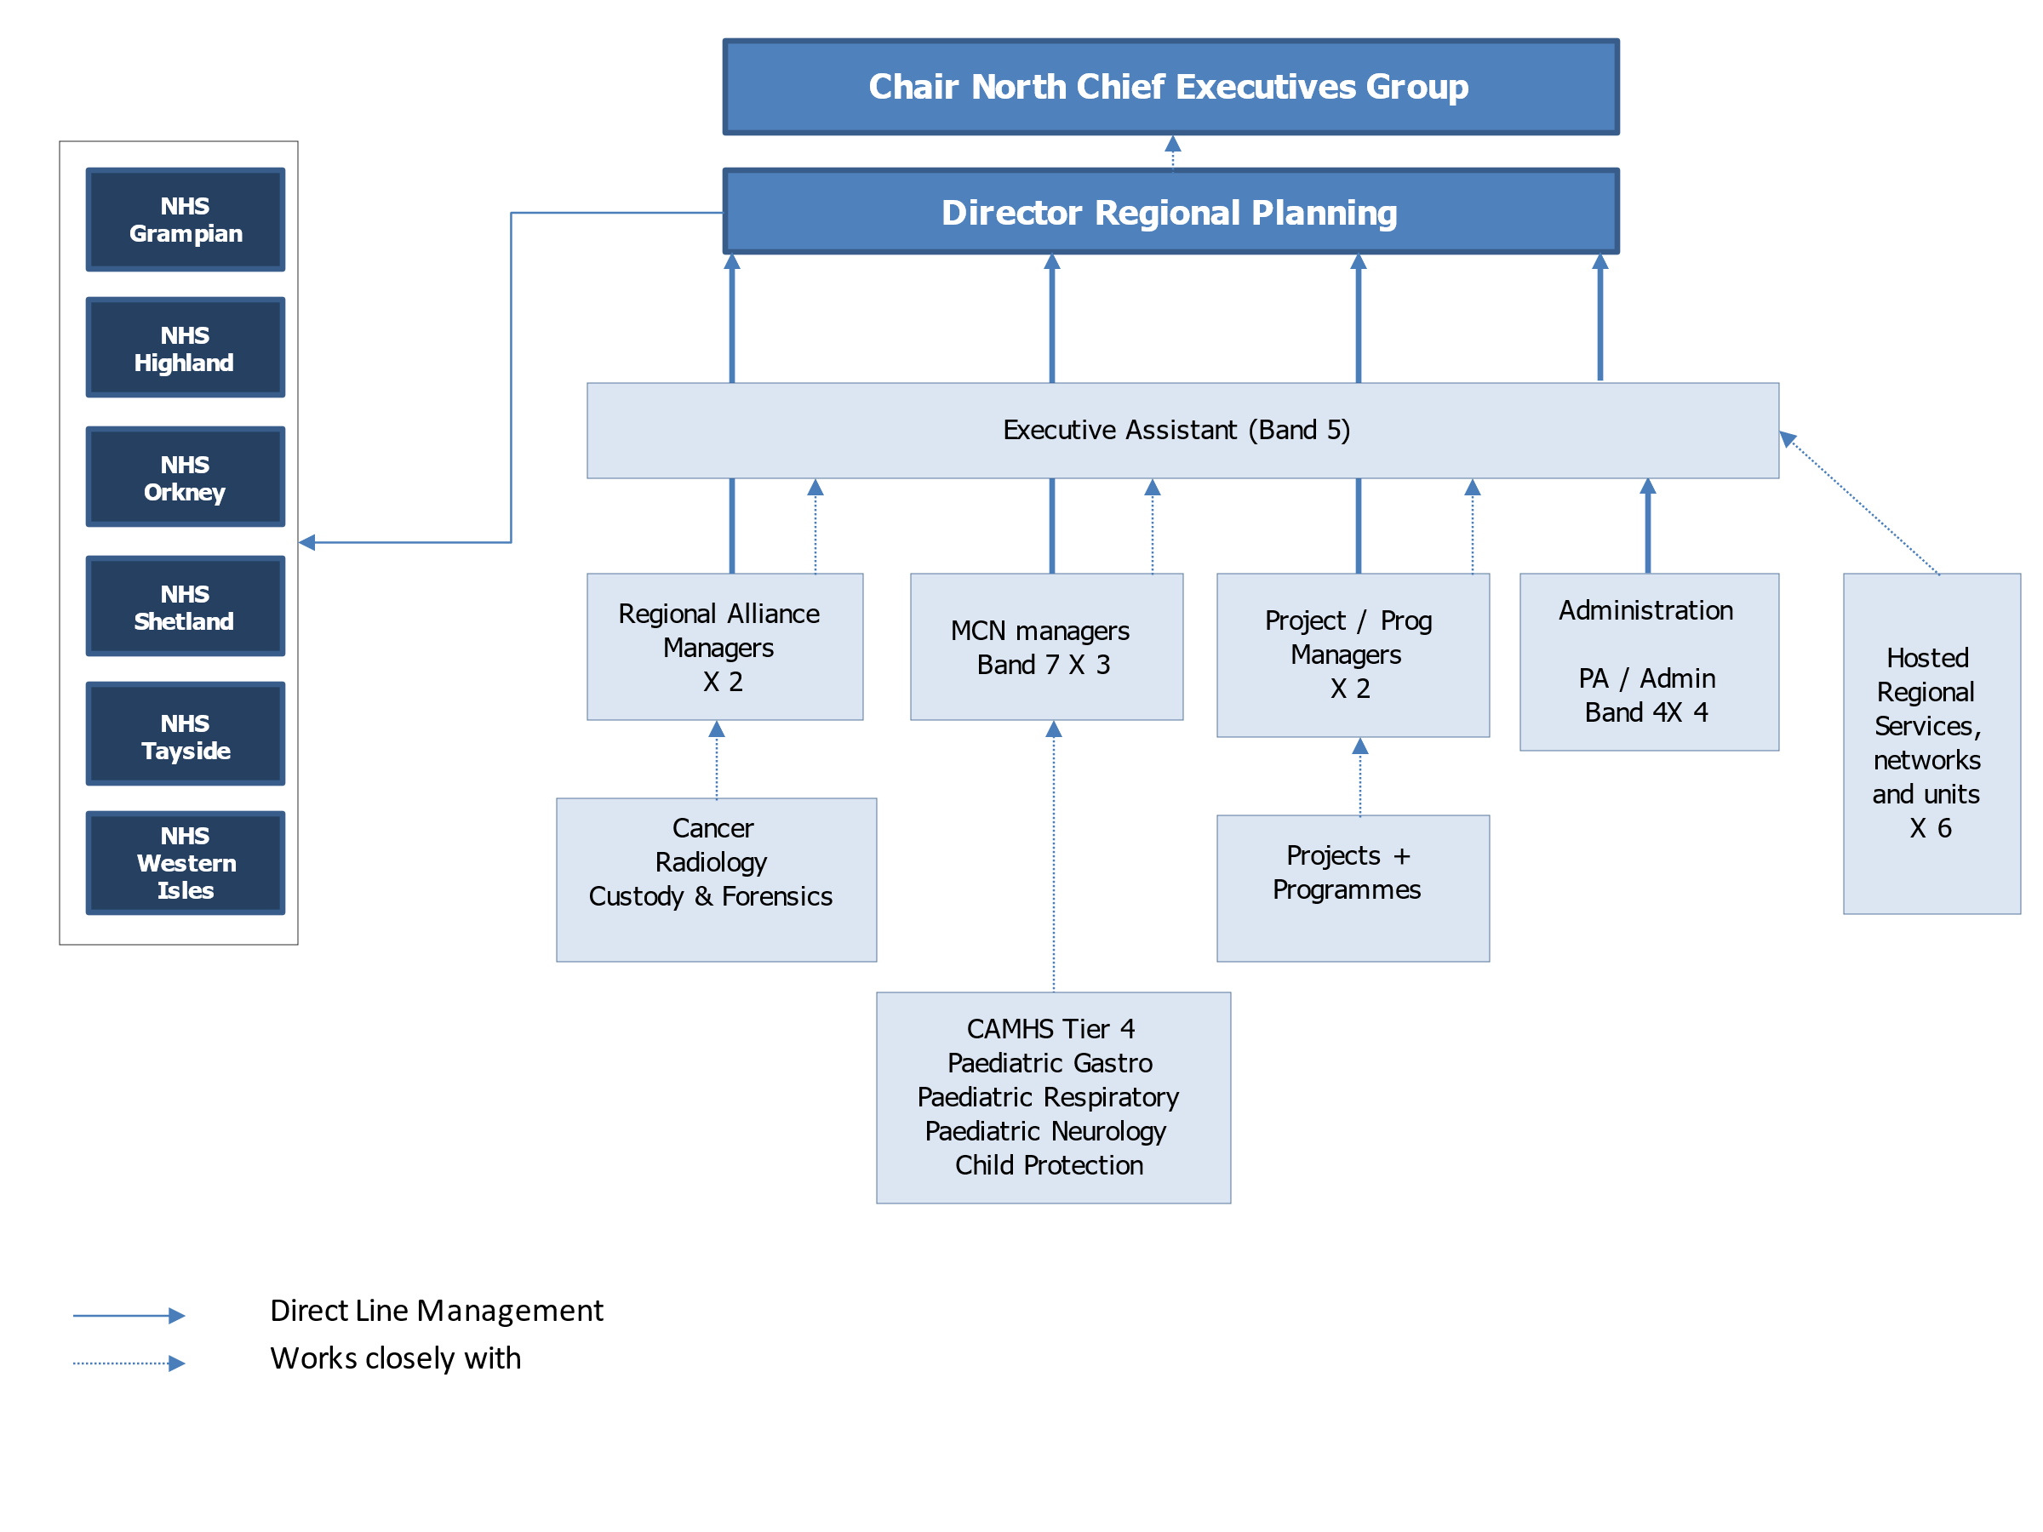Appendix 2

Appendix 2

NOSCAN

Public Health Network

Eating Disorders Network

NoS Restorative Dentistry Network

NoS Orthodontics Network

NoSOMFS Network