NHS TAYSIDE – AGENDA FOR CHANGE

JOB DESCRIPTION

- JOB IDENTIFICATION | Job Title | Project Support Officer
 | Department(s)/Location | Improvement Team, Ninewells Hospital
 | Number of job holders | 2

JOB PURPOSE

The role of the Support Officer is to support delivery on the agreed projects and priorities aligned to the corporate objectives of NHS Tayside.

The role is varied, working on a variety of service redesign projects. The role involves working with clinicians, staff, patients and carers to deliver high quality redesigned services

The role requires a high standard of Project Support activities including administrative, clerical and secretarial services ensuring the smooth running of the projects with the achievement of the desired outcomes.

The post holder supports data collection, analysis and presentation relevant to redesign projects. The role also covers a business support function with the team related to the project activities such as the organisation of events, meetings and group work.

The post holder will report to the Programme Manager but will work closely with the Improvement Academy Leadership Team within the division, taking direction and lead for the work from them.

ORGANISATIONAL POSITION

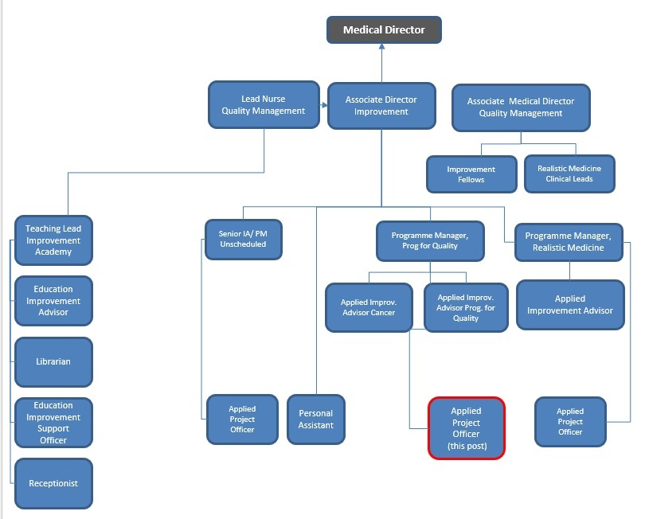

SCOPE AND RANGE

NHS Tayside is a teaching Board with annual expenditure of over £1Bn and serves a population of 389,000 people living in urban and rural parts of the region. In addition to the Board, three Integration Joint Boards are responsible for the provision of health and social care services in Tayside.

NHS Tayside management arrangements integrate support services at both strategic and operation levels, to better meet the needs of the organisation. This includes the development of a coordinated approach to identifying, organising and deploying expertise and resources to support the Improvement Team which provides an internal consultancy service to NHS Tayside.

Environment
- NHS Tayside
- NHS Scotland
- Public Sector
- External Consultancy
- Scottish Government
- Independent Contractors
- Education Providers

The post holder will:
- Support activity regarding the Improvement agenda including activities and learning from evaluations and reviews of commissioned work.
- Provide co-ordination support to the function of Improvement.
- Develop and manage systems for the co-ordination and delivery of service improvement commissioned interventions.
- Directly provide support to teams using improvement skills and teaching to build capability and capacity for improvement

The post holder is directly accountable to the Programme Manager. Work may also be delegated by the Improvement Academy Leadership Team.

MAIN DUTIES/RESPONSIBILITIES

Induction Standards and Code of Conduct
Your performance must comply with the national “mandatory Induction Standards for Healthcare Support
Workers in Scotland” 2009; and with the Code of Conduct for Healthcare Support Workers.

Data & Analytical Interpretation
Analyse and interpret complex information, including patient specific data to present service development options for consideration by key stakeholders and partners.
Monitor and report on implementation of project plans across a range of priorities.
Work collaboratively to assist with identifying the type and scope of data required to inform and monitor a wide range of projects and tests.
Work largely unsupervised using sound judgement and planning skills in order to evaluate options and develop innovative solutions.
Assist with the development and review of project management processes
Coordinate the implementation of data collection and project systems in collaboration with key stakeholders.
Provide a range of regular and ad-hoc reports including statistical analysis and interpretation of significant data and trends relevant to the various projects
Provide visual presentations relevant to the various projects that are appropriate for the intended audience

Planning and organisational
Provide administrative project support, to contribute to the effective organisation of the various projects delivery and achievement of specified outcomes.
Responsible for developing, organising and maintaining efficient and responsive project support systems utilising project management methodologies and templates
Plan and organise regular and ad hoc meetings; including venue, hospitality and travel arrangements as required, including set up of teleconferencing and video conferencing.
Using project management methodologies keep track of the various projects and escalate any variance from project plan timescales to the relevant project lead
Support the various projects workstreams/working groups by undertaking minutes and note taking of meetings and prepare, type and distribute minutes of meetings, agendas and other associated correspondence, specifying decisions made and follow up actions required, keeping track of progress

Governance
Assist in the review of systematic quality improvement within an agreed quality framework leading to the delivery of a safe, effective, patient centred service.
Ensure that any potential governance issues are raised timeously and that a system exists for monitoring that any such concerns are adequately addressed.
Provide support in the development and delivery of a clear and comprehensive Programme Plan taking account of local, regional and national priorities.
Work across traditional organisational and professional boundaries in collaboration with all relevant parties to achieve key strategic plans/objectives and help drive forward service improvement

Training and Educational
In collaboration with the project leads devise, develop and support training workshops and presentations to support the implementation of the various projects where required.

Information Resources
Lead the development of robust mechanisms which meet the project groups’ information needs (e.g. maintaining risk registers, managing data and information “feeds”, compiling and collating regular communications for stakeholders).

Finance
Assist with monitoring the resources allocated to projects

COMMUNICATIONS AND RELATIONSHIPS
DRAFT

The nature of this post necessitates a high standard of communication, interpersonal, influencing and negotiation skills.

Internal
The postholder is required to establish and maintain effective communication and productive working relationships with a wide variety of personnel and agencies. Internal relationships include providing the highest standard of communication, both written and verbally, face to face, video conference etiquette and telephone skills. Good communication skills and interpersonal skills are required when dealing with different internal stakeholders, which include but not exclusively the following: -

- Clinical Group Directors/Managers and their support teams
- NHS Tayside Board and Executive Teams
- Public Organisations
- Health & Social Care Partnerships
- Health & Business Intelligence Team
- Improvement Team

External
There is a need for well-developed inter-personal, communicative and presentation skills. These skills are necessary to support and facilitate the high quality, professional performance of the project team. The postholder will be required to identify the most appropriate and applicable communication method, which will require to be used. Communications can be to individuals, staff groups, and organisation-wide conferences and at public meetings. Communications are written and oral, formal and informal, and are both informative and authoritative both to staff and the public. Management of complex and sensitive information requires to be handled and delivered in a tactful and diplomatic way. The post holder should be open to the receipt of information and has the ability to share as appropriate.
- Education/Authority Bodies
- Scottish Government
- Scottish Government Health Directorate
- General Practitioners/Clinical Leads
- External Consultancy

The post holder will be required to:
- Generate information (sometimes highly complex) from a variety of sources, systems and cultures, and interpret and convey this in a form readily understood to a range of stakeholders
- Communicate with staff groups regarding issues relating to service re-design or by assisting/ delivering presentations and training and facilitating workshops and meetings

KNOWLEDGE, TRAINING AND EXPERIENCE REQUIRED TO DO THE JOB

- An HNC or HND or equivalent level qualification in administration/business management
- Previous administrative/clerical experience within the health service, or equivalent related service.
- Experience in using and delivering improvement tools and techniques to support quality improvement
- Experience of working with teams to support change/redesign
- An operational knowledge of a range of health services and related supporting policies and procedures.
- The post holder must support, through the Project Leads, the development and delivery of a strategy for redesign and improvement of NHS services.
- The ability to build effective professional relationships with a range of staff and public representatives.
- Can work effectively in a team and also the ability to work across professional and organisational boundaries.
- Has the ability to work with wide range of professions.
- The ability to participate and contribute to objectives to enable transformation, change and service improvement
- Proficient IT knowledge with specific experience in Word, Excel, Outlook and PowerPoint, MS Teams and bespoke databases
- Can self-generate work and use a high degree of initiative to achieve personal and organisational objectives
- The ability to work as a member of a team and independently
- It is essential that the work progresses and the postholder must be able to make appropriate level decisions
- A proactive attitude to work, actively seeking new ways of working.
- Ability to coordinate wide-ranging, Service Improvement activities in a constantly changing environment
- Ability to facilitate teams and large groups and the ability to work with a wide variety of individuals is essential
- Ability to act to improve performance across systems
- High level of written and verbal presentation skills
- Excellent communication skills, verbal and written
- Ability to work under pressure
- Accuracy skills and good attention to detail
- In-depth knowledge and experience of a range of administration duties
- An ability to follow written procedures (e.g. Standard Operating Procedures)
- The postholder will have knowledge of and adhere to all NHS Tayside policies and
- mandatory training including: Fire Safety, Appraisal, Induction, Load Handling, Health
- & Safety, Visual Display Unit, Security & IT Security, and Data Protection
- Awareness of legislation such as Freedom to Information Act, Data Protection Act, Health & Safety Acts

ESSENTIAL ADDITIONAL INFORMATION

- SYSTEMS AND EQUIPMENT

Computer based systems
A practical and working knowledge of the following systems:

- Microsoft Office
- Microsoft Teams
- Worldwide Web
- Email systems
- LCD presentational equipment

Equipment
- PC/Laptop
- Audio Equipment/Microphones
- Scanner/photocopier
- Projector (Multimedia, OHP, Slide)
- Display Boards
- Video/Tele Conferencing
- Telephone
- Interactive Boards
- Dictaphone
- Video Equipment/Digital Cameras

Responsibility for Records Management
All records created in the course of the business of NHS Tayside are corporate records and are public records under the terms of the Public Records (Scotland) Act 2011. This includes email messages and other electronic records. It is your responsibility to ensure that you keep appropriate records of your work in NHS Tayside and manage those records in keeping with the NHS Tayside Records Management Policy and with any guidance produced by NHS Tayside specific to your employment.

PHYSICAL DEMANDS OF THE JOB

Physical
- Keyboard and IT Skills – frequently
- Ability to travel – frequently
- Presentation Skills – frequently
- Facilitation skills – frequently
- Negotiating Skills – regularly
- Improvement skills - frequently
- Analytical and interpretation skills – regularly
- Project Management Skills – regularly

Physical Demands
- Travelling in adverse conditions i.e. bad weather, traffic congestion, rural roads etc – occasionally
- Sitting at computer and workstation – regularly
- Facilitation of groups some large
- Safely moving and handling bulky objects weighing less than 10kg

Mental Demands
- The post holder is expected to respond to unpredictable work demands on a daily basis including frequent interruptions which can lead to change of task whilst still being expected to complete tasks within given timescales e.g., managers may request high priority tasks to be completed at short notice on the same day thus requiring rearrangement of work timetable, which can create stress
- Need to adapt to different personalities (often unknown) within very short periods of time and adapt thinking processes/responses accordingly – regularly
- Requires considerable mental effort to manage all different facets of this job – regularly
- Act and take decisions quickly – regularly
- Multi-faceted to meet demands of all the complex services – regularly
- Ability to grasp developments in a professional manner – regularly
- Analytical and interpretation skills – regularly
- Intense concentration – frequently
- Travelling in varying weather conditions and traffic levels – occasionally
- Frequent interruptions – regularly
- Available to staff during working hours – constantly
- Review of workload required to ensure objectives met – constantly
- High levels of concentration required for the typing of lengthy reports, type ups and
- taking minutes etc, always ensuring a high level of accuracy – regularly

Emotional Demands
- Handling of confidential information – frequently
- Accommodating and responding to personal dynamics and the politics of working within a complex organisation – regularly
- Managing conflict – occasionally
- Team issues – regularly
- Verbal aggression – occasionally
- Expected to be able to cope with any situation with little or no support – occasionally
- Be associated with the implementation of unpalatable decisions –occasionally
- Coping with different styles/cultures of other organisations – frequently
- Working autonomously (under remote supervision) – regularly

Working Conditions
- Frequent use of computer equipment for long periods of time when analysing data or writing papers or reports - frequently
- Requirement to move and work between sites - regularly
- Travelling alone in remote and rural areas often for significant periods of time – occasionally
- Sitting or standing for long periods of time at work station or in meetings – frequently

DECISIONS AND JUDGEMENTS

- The post holder has the freedom to organise own workload on a day-to-day basis by negotiating priorities with the various project Leads
- The post holder reports directly to the Programme Manager and is expected to use their own initiative and work on a self-directed basis
- The post holder is an expert resource of advice and support to service managers and staff regarding the various projects they are supporting
- The post holder will support staff across NHS Tayside to use data to solve system problems and will support teams to implement action plans and monitor progress against those
- The post holder can deal with uncertainty and ambiguity professionally, and able to employ skills to address those in a way that still moves work forward with integrity
- Capture a range of disparate views on specific topics in an objective way, and support the use of improvement tools and techniques in converting those views into constructive plans that align with the projects objectives
- Ability to utilise reflective practice and make decisions based on knowledge and research
- Work will arise in line with the various projects objectives through a combination of self generated and supervised activities. Areas of work will include implementation of existing techniques and approaches, plus the testing of new and untried approaches, with support from the various project leads and the Programme Manager

MOST CHALLENGING/DIFFICULT PARTS OF THE JOB

- Prioritising of workload to ensure completing and conflicting deadlines are met.
- Managing time effectively and prioritising work to meet the various project demands
- Ensuring actions are followed up by agreed timescales and communicated with relevant project leads and working groups
- Manage the demands of large numbers of diverse key stakeholders whilst maintaining agreed priorities.
- Assist with delivering a new way of working through supporting the implementation of the project Plans designed to co-ordinate a major change to the way services are currently configured.
- Co-ordinating a wide range of activities requiring skilled time management and prioritisation often with competing demands requiring to be met
- Securing involvement and commitment to improvement and change with the organisation.
- Dealing with uncertainty and change
- Sustaining staff morale during change process whilst promoting a work culture and climate where quality of service is paramount

