Job Identification
Job Title: Primary Care Development Manager

Responsible to: Head of Service – Health and Community Care

Department(s): Health and Community Care

Directorate: North Ayrshire Health and Social Care Partnership

Operating Division: North Ayrshire Health and Social Care Partnership

Job Reference: C/386/16

No of Job Holders: 1

Last Update: 24 June 2022

2. Job Purpose
To sustain meaningful engagement and involvement of Primary Care Contractor Groups in the work of North Ayrshire Health and Social Care Partnership, with particular emphasis on delivering the Strategic Plan and responding to emerging priorities from Locality Planning.

This will involve actively engaging with individual Practitioners and Groups in a variety of fora that minimises adverse impact on their working day, as well as working with the Transformation Team to design and deliver of large scale planning events designed to create the time and space required to consider issues and priorities at length within a creative environment conducive to integrated solution development.

Key to this will be working closely with Primary Care Contractor Groups to identify, explore, define and deliver opportunities for new ways of working, ensuring a more holistic approach to assessing and responding to the needs of local people.

In doing so, the postholder will link with, engage and involve Senior Managers from Children, Families & Criminal Justice; Mental Health; and Health & Community Care to secure operational service input to the design process, ensuring services are configured in a complementary manner that removes duplication and gaps to derive maximum benefit from the available resources.

Further, the postholder will actively engage with the Planning and Performance Team to ensure all new service models are underpinned by a robust evaluation and performance management framework from the outset, establishing periodic review meetings to monitor progress and impact against plan and encouraging a continuous improvement approach to refinement and further development over time.

Working closely with the Clinical Director, the postholder will ensure all new service proposals and models are reviewed and assessed to determine potential unforeseen adverse impacts on wider services thereby mitigating the risk of conflicting emergent models.

3. Dimensions
The post holder will be required to work closely with:

22 General Medical Practices;
36 Community Pharmacies;
25 General Dental Practices; and
23 General Optical Practices.

In addition, the post holder will be required to work with all of the teams within the North Health and Social Care Partnership to explore and agree new ways of working designed build teams around Localities and General Medical Practices to better meet the needs of local people.

In doing so, the post holder will be influencing the use of a Primary Care budget totalling £20.082million

The post is funded from the Integrated Care Fund until 31 March 2018 and will be based at the Health & Social Care partnership headquarters at Cunninghame House in Irvine.

4. Organisational Position – Health & Community Care

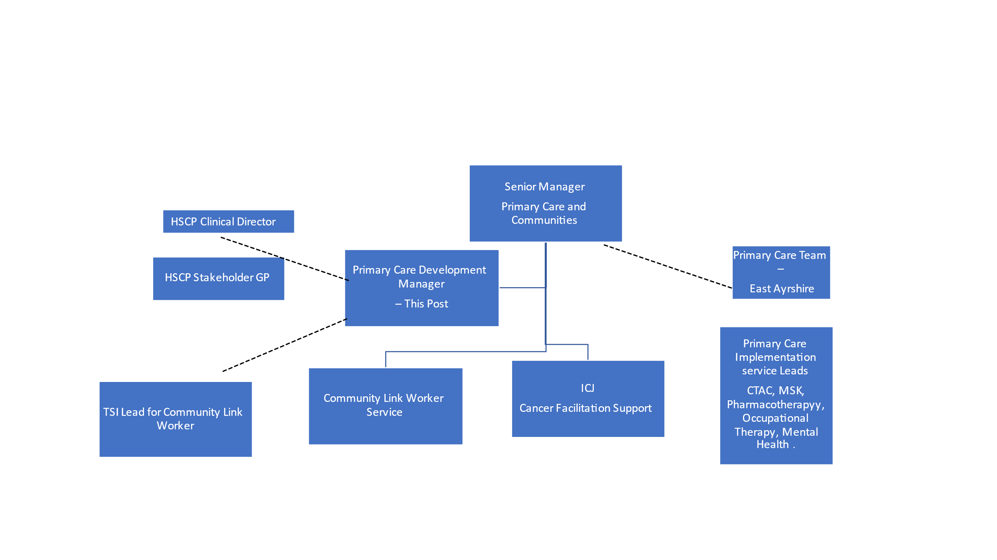

5. Role of Department
North Ayrshire Health and Social Care Partnership comprises all everyone involved in the delivery of community health and social care services within the local area to ensure:

- The health needs of the local population are fully assessed, and efforts targeted to improve health and close the inequalities gap;
- Local directly provided services are designed and managed effectively;
- Other services required to support individuals at home or in a homely setting are commissioned with a clear focus on desired outcomes;
- Services are fully integrated and seamless from the point of view of the people who use them;
- There is a sense of local ownership of the services being delivered with strong local accountability through involvement of the community, people who use services, family carers, community organisations and local councillors; and
- Local stakeholders are involved in the design of services and the allocation of resources to support their delivery to best meet the needs and preferences of local communities.

6. Key Result Areas
The post holder will develop and sustain a structured programme of engagement for Primary Care Contractors to:

- Delivery of management of community link worker and digital navigator service
- Ensure clarity of understanding in terms of the nature, purpose and goals of the Partnership;
- Secure intelligence on how each Contractor group can contribute to these;
- Develop an evidence base of local need from a Contractor perspective and examples of good practice in service delivery designed to meet local needs;
- Support ‘tests of change’ and the community connector pilot
- Provide a conduit for Contractors to influence decision-making and priority setting within the Partnership;
- Share knowledge and intelligence between Contractor Groups and Locality Planning Fora, ensuring opportunities for joint working and collaboration are maximised; and
- Collate data on the needs and expectations of Contractors in terms of how the Partnership can support them to meet local needs.

The post holder will work closely with the Transformation Team to ensure all major Programmes have access to intelligence from a Primary Care perspective to underpin their planning activities, as well as Primary Care representation at key points in the planning process to ensure a direct influence on future service provision.

Recognising the need for periodic inter-Contractor Group working, the postholder will engage with the transformation Team to design and deliver of large scale planning events designed to create a creative environment conducive to securing the input, advice and intelligence required to deliver major pieces of work such as the development of the Partnership Strategic Plan.

The postholder will support the Contractor Groups in service planning and redesign activities by:

- Working proactively with individual contractors and small groups to develop a clear understanding of local need and explore potential opportunities to redesign local services to meet these;
- Develop communication and information solutions to support the engagement and linkages between primary care and other community sectors
- Sharing these emerging opportunities with the Locality Planning Fora, the teams within the Partnership and the Third and Independent Sectors to test their viability, avoid duplication and reduce the likelihood of service gaps;
- Identifying where the emerging proposals would require services provided directly by the Partnership to be delivered in a different way and linking with Senior Managers from Children, Families & Criminal Justice; Mental Health; and Health & Community Care to secure operational service input to the design process, ensuring services are configured in a complementary manner that removes duplication and gaps to derive maximum benefit from the available resources;
- engaging with the Planning and Performance Team to ensure all new service models are underpinned by a robust evaluation and performance management framework from the outset, establishing periodic review meetings to monitor progress and impact against plan and encouraging a continuous improvement approach to refinement and further development over time; and
- Working closely with the Clinical Director, the postholder will ensure all new service proposals and models are reviewed and assessed to determine potential unforeseen adverse impacts on wider services thereby mitigating the risk of conflicting emergent models.

Based on these planning and redesign activities, the postholder will formulate and regularly update a work programme for the development of Primary Care in North Ayrshire with the explicit aim of developing teams around General Practice. This will include providing line management support of the Community Link Worker and Digital Navigator Service.

The postholder will work with key individuals within the Partnership design and deliver a range of communication and information tools specific to the needs to the Contractor Groups to ensure awareness of Partnership activities, as well as improved understanding and ease of accessibility to local services.

7a. Equipment and Machinery
Daily use of:
- Personal Computer
- Photocopier
- Scanner
- Shredder
- Telephone
- Fax machine
- Laptop
- Projector
- Frequent use of car to travel to practices

7b. Systems
- Use of Microsoft Word to create documents and reports
- Use of Microsoft Power point to create and deliver presentations
- Use of Microsoft Excel to analyse data, calculate funding, produce graphical displays of data and reports
- Use of Internet Explorer to maintain awareness of and access on line information sources
- Use of Lotus Notes for correspondence with internal and external correspondents, diary management and maintenance of contacts.
- e-Manager
- e-Expenses
- SSTS
- DATIX
- CM2000
- Carefirst

8. Assignment and Review of Work
- The post holder is expected to operate autonomously under broad direction from the Senior Manager of Primary Care & Communities, with a high degree of delegated decision-making combined with a significant degree of freedom in terms of management and assignation of their workload.
- Much of the work is self-generated through direct engagement with the Primary Care contractors, Partnership Management Teams and Locality Planning Fora.
- The postholder will be responsible for the identification, interpretation and application of national guidance and policies within their respective field(s).
- Objectives will be agreed annually with the Senior Manager for Primary Care & Communities – Health and Community Care, with progress being assessed formally at the six-month point and annually through the postholder’s year-end appraisal.
- Professional support will be provided by the Clinical Director Primary Care

9. Decisions and Judgements
- This post requires the interpretation and application of complex data, which may be hard or soft in nature, aligning this with advice and feedback from local communities to ensure a rounded view is available to inform work with the Primary Care Contractors
- The post holder is expected to exercise a significant degree of initiative and autonomy in relation to the management and assignation of their workload
- The post holder prioritises their own workload
- The post holder will line manage community connectors and ‘test of change’ projects
- Implementation of service developments within budgetary constraints, including working with budget holders to prioritise the developments where budget is limited
- The post holder will be required to manage and problem solve any issues faced by the Community Link Worker and Digital Navigator service

10. Most Challenging/Difficult Parts of the Job
- The development of positive working relationships with a diverse range of Primary Care Contractors.
- Securing and sustaining proactive, creative engagement with Primary Care Contractors to deliver the aspiration set out in the Strategic Plan and the priorities emerging from the Locality Planning Fora.
- Making connections between local communities, service users, Contractors, Partnership Teams and the Third and Independent Sectors to ensure an inclusive approach to service planning
- Ensuring that there is equitable service provision across North Ayrshire while ensuring services are targeted and tailored at a locality level to meet the specific needs of priority and hard to reach groups to reduce health inequalities.
- Provide and receive complex verbal and written communications. Communicate sensitive and or confidential information, often of a complex and highly sensitive nature in relation to service developments and service redesign requiring agreement or co-operation.
- Managing across a range of services where there are constantly competing demands and conflicting priorities.
- Developing evidenced outcomes from ‘tests of change’ e.g. Financial advice pilot in GP Practices
- Managing issues relating to sensitive and contentious information.

11. Communications and Relationships
Internal
- Partnership Director
- Clinical Director and Stakeholder GP
- Chair of the IJB
- Chair of the SPG
- Members of the IJB
- Senior Management Team
- Elected Members
- Members of Health Board
- Community Connector team

External
- Other Partnerships
- Scottish Government
- National Services Scotland
- SSSC
- Members of the Public
- General Practitioners and members of the practice team
- Third Sector
- Independent Sector

12. Physical, Mental, Emotional and Environmental Demands of the Job
Physical
- Accurate keyboard skills
- Excellent computer skills
- Excellent communication skills
- Excellent negotiation skills
- Presentation skills
- Car Driver essential

Mental
- The jobholder will frequently require long periods of concentration to produce reports and documents in relation to complex issues and to interrogate sensitive data and interpret complex Regulations
- Negotiation skills are necessary as is the need for diplomacy in relation to all aspects of the post
- Frequent interruptions
- Able to work under extreme pressure and be able to meet tight deadlines

Emotional
- Emotional effort during service redesign activities
- Exposure to difficult and sometimes confrontational situations
- Often exposed to long periods of driving alone to attend meetings with contractors and Locality Groups

13. Knowledge, Training and Experience Required to do the Job
- Educated to degree level and/or possession of relevant professional management qualification
- Significant experience in a managerial position, preferably in a Primary Care or healthcare setting is essential
- Able to deliver on initiatives
- Knowledge of the Data Protection Act and IT security policies
- Specialist knowledge and understanding of planning tools and approaches
- Specialist knowledge and understanding of project or programme management methodologies
- Willingness to see problems through to a satisfactory conclusion
- The ability to operate with high a degree diplomacy and tact
- Plans own work to meet given objectives and processes
- The ability to respond to changing demands is essential such that services are developed to meet current demand/focus
- Maintains awareness and responds to developing issues
- Able to time manage deadlines
- Effective management and development of staff
- Established management skills, including excellent inter-personal and communication skills
- Well-developed IT skills
- Experience of budget management
- Excellent presentational skills
- Excellent report writing skills are essential
- Evidence of Leadership and negotiating skills is essential
- A full current driving licence is essential for this post

