# 

# INFORMATION PACK

FOR THE POST OF

**CONSULTANT INTERVENTIONAL RADIOLOGIST (x1 post)**

Interested in applicants with an IR special interest who can  
contribute to a highly functioning team  
of Consultant Radiologists.

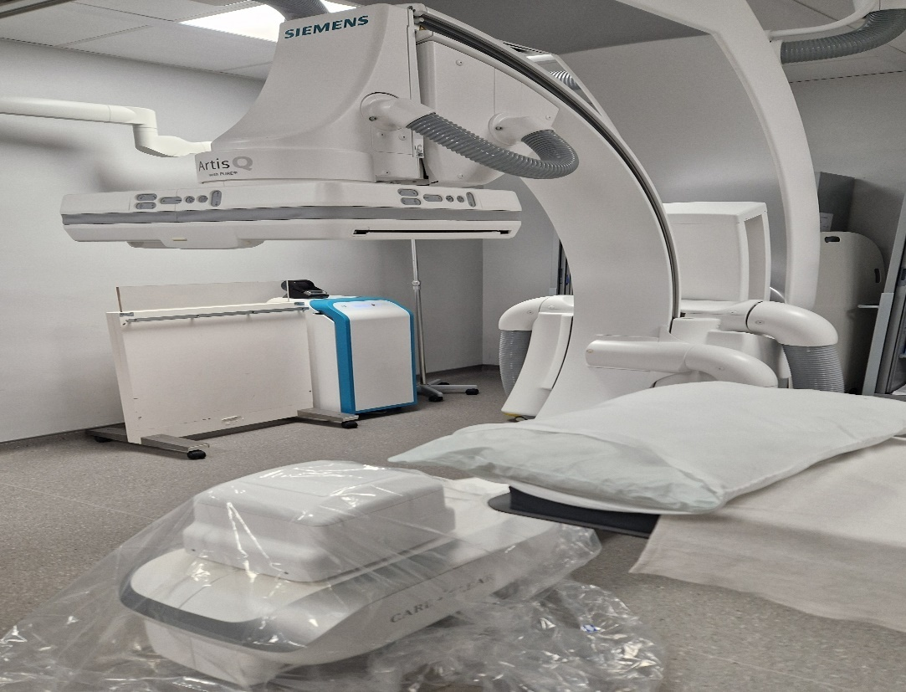

Aberdeen is a lively, cosmopolitan city located in the North East of Scotland. In the city, there are beautiful parks and gardens and superb beaches. Aberdeen city and surrounding towns across Aberdeenshire boast fantastic museums, theatres, galleries, bars and restaurants, and a variety of shopping, including unique family-run businesses.

*North East of Scotland – a great place to work and live*

There is a wide range of annual festivals across Grampian, from food and drink, music and arts and festivals celebrating local culture and traditions. There are excellent and varied schools within the city, Aberdeenshire and Moray, with a great range of housing to suit all tastes. There are strong public transport links and a modern comprehensive road network.

Aberdeen is a gateway to explore natural landscapes from the northeast coastline to beautiful Royal Deeside and the stunning Cairngorms National Park, with many Munros and Corbetts. The castle and whisky trails across the region make the northeast famous, and there is a wide range of outdoor leisure activities, such as hill walking, water sports and skiing. There are over 50 golf courses and excellent salmon and trout rivers.

Aberdeen's international airport is served by several major carriers providing an extensive network of routes throughout the UK, direct to Europe and worldwide through major hubs. There are good road and rail connections to the major Scottish cities of Edinburgh, Glasgow and Inverness.

***Patient care***

The multi-disciplinary teams in NHS Grampian Radiology Department and in Nuclear Medicine are very patient-centric. Our teams make all efforts to ensure that patients feel comfortable and confident, ensuring their care and dignity. We undertake patient satisfaction audits, which help with any service redesign and respect our patients' rights and responsibilities, underpinned by person-centred values.

We take all patient feedback seriously and consistently act on complaints and compliments, both within our department and through our Divisional Clinical Governance Group. This enables a drive towards service quality and improvement. This approach to our service provision is attractive to people who also carry these values and we are keen to appoint such individuals into our team.

*Future plans for NHS Grampian Radiology*

The Executive Team in Radiology are very ambitious. There is a common understanding that Radiology is at the heart of the hospital, and as such, we have a constant drive for further investment across all our staffing disciplines and capital. The major capital investment for a new Baird Family Hospital and ANCHOR Centre for Oncology and Haematology will improve patient care and augment patient imaging services.. In addition, the Interventional Radiology suite has recently been updated with state-of-the-art equipment with further significant investment to enable departmental redesign. Replacement plans to follow for all modalities.

Value-based care for our patients and staff requires collaboration across all modalities and work streams. We work closely with our eHealth and Health Intelligence colleagues to interrogate our data and activity, producing evidence for increased funding applications and future projections, working on the capacity gap and workflow efficiencies. We also value the contributions from our collective workforce and encourage participation in our strategic planning via the modality groups and participatory events.

A workforce plan is also in development to enhance our retention and recruitment plans. Staff development is a key driver for improving services, and all staff are encouraged to engage with the weekly CPD lecture programme and given time and space to pursue their professional interests.

A consortium between NHS Grampian, Aberdeen University, Scottish Government and industry partners was successful in the funding competition – *Creating a network of digital pathology, imaging and AI centres.* The iCAIRD (Industrial Centre for Artificial Intelligence Research in Digital Diagnostics) project was initiated in the autumn of 2018 to develop infrastructure to apply AI in digital diagnostics, pathology and radiology built upon existing national initiatives. iCAIRD is a significant platform for research and service development to which NHS Grampian is committed, and Radiology is playing a leading role.

The Radiology Department has representation around national and regional strategic programmes and ensures that NHS Grampian are part of the decision-making processes.

The plans for the radiology department are developed in conjunction with staff and underpinned by service needs and evidence to provide the best imaging service for our patients.

Potential candidates will be encouraged to identify areas within the IR department where they can lead and develop, acting as a conduit between contemporary thinking and local good practice.

# Picture

NHS Grampian is one of 10 principal Health Boards in Scotland. It provides healthcare services to approximately 600,000 people living in Grampian and additional provisions to 50,000 people living in Orkney and Shetland. The organisation employs around 17,000 staff.

A period of significant investment and modernisation began in 2013 with the opening of the Matthew Hay building, bringing emergency and urgent care services together into one building. NHS Grampian Board has recently approved plans for two new buildings on the Foresterhill site, the Baird Family Hospital and The ANCHOR Centre investing £120 million. The Baird Family Hospital will bring together maternity, gynaecology and breast services, while The ANCHOR Centre will provide outpatient and day-patient treatment for cancer and blood disorders. The Foresterhill site is novel in terms of the centralisation of all services, including university.

NHS Grampian has a status as the Major Trauma Centre for the North East of Scotland, and we expect significant investment to improve elective care within the National Treatment Centre programme with a new building and increased workforce. These are exciting times for Radiology as all these strategic local and national drivers will bring investment to the Radiology department, improving services for our patients. In particular, we are keen to develop the IR service in line with contemporary strategic drivers to provide the best service we can for our patients.

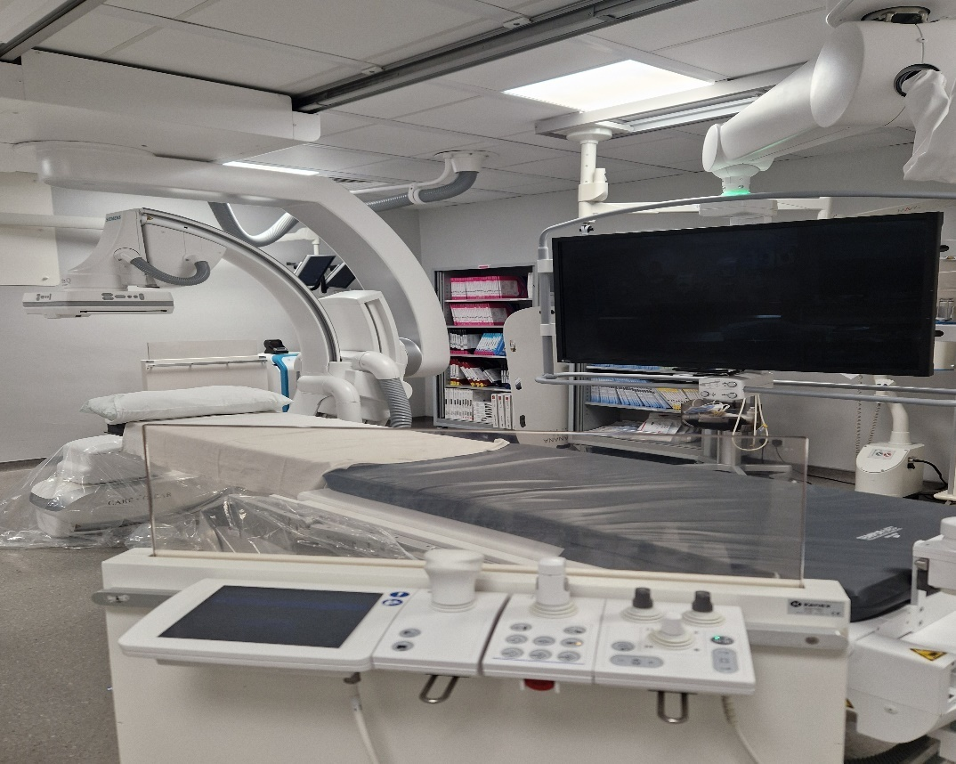

***NHS Grampian Radiology Department***

Radiology services are structured on a modality basis with Clinical Service Directors reporting to the Unit Clinical Director, Dr Natasha Rose (natasha.rose@nhs.scot) and the Unit Operational Manager, Mrs Sharon Jones (sharon.jones18@nhs.scot).

The primary radiology department is at Aberdeen Royal Infirmary on the Foresterhill site and is well equipped and includes a 128-slice Siemens Somatom X.cite and a dual-energy GE Discovery 750. Emergency and urgent cases are imaged on a 64 Slice GE Optima 660. The department also has a Siemens 1.5T Avanto MRI and has access to a Philips 3T University research MR scanner.

The **Interventional Radiology** suite has two state of the art Siemens Artis Qangiographic units with the most recent replacement completed in December 2022. Plans for phased expansion into the IR team are progressing with a future vision of providing a full range of vascular and non-vascular procedures. The department provides an in and out of hours service, both outpatient and inpatients. The IR Consultants are supported by a multi-disciplinary team who are dedicated to patient care and safety. This is supported by two weekly MDTs, a progressive M&M meeting for IR and also invitation to the Vascular M&M. In support of the clinical meetings, there is also a multidisciplinary service improvement group who are reviewing the broader scope of IR and where progress can be made, for example reviewing theatre utilisation data and booking and prioritisation of patients. The IR enjoy very good relationships with referring specialities, both vascular and non-vascular.

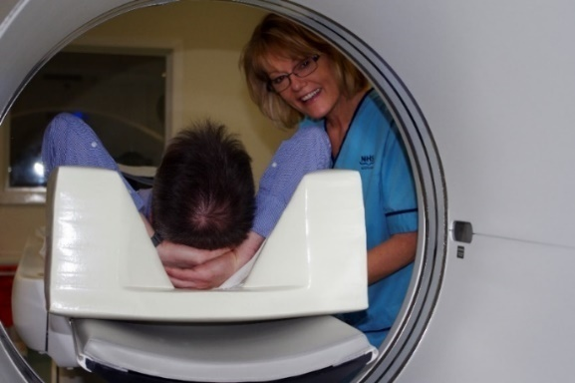**Nuclear medicine and PET-CT** have a long and illustrious history in Aberdeen, with numerous world and national firsts regarding service innovations and academic achievements.   The department performs around 8500 examinations annually and is equipped with 2 SPECT/CT gamma cameras and 1 SPECT, PET/CT system, a full isotope laboratory and a new PETtrace 800 cyclotron, which includes a Zn target to produce 68Ga.

Grampian is part of the Scottish breast screening service in addition to the symptomatic service and hosts two Hologic mammography rooms within the Radiology department with tomosynthesis and vacuum biopsy and excision services and provides MRI-guided biopsy and family history screening.

Aberdeen Royal Infirmary is a teaching hospital affiliated with the University of Aberdeen, the oldest medical faculty in the English-speaking world, home to one of the top Undergraduate teaching programmes in the UK. NHSG Radiology has a well-established and successful teaching programme for UG trainees. We also have strong links to Aberdeen University via the imaging research wing (www.abdn.ac.uk/abic) and Robert Gordons University, encouraging links to the UK and European academic settings for collaborative research. There is a robust audit and research component to the department for all staff members, both independently and as part of the RADIANT group at the Royal College of Radiologists.

NHS Grampian is also the base for the North of Scotland training scheme, and currently, it supports radiology training for 27 trainees across Grampian and the Highlands. Successful candidates will participate in teaching trainee radiologists and wider clinical teams and will be encouraged to take on recognised trainer roles.

The department is fully integrated with Carestream RIS/PACS/electronic requesting and uses a Soliton Voice Recognition System across all sites.

**Consultant Radiologists, NHS Grampian**

Dr Natasha Rose Unit Clinical Director

natasha.rose@nhs.scot MSK radiologist

Dr D McAteer Chair - Radiology Senior Staff Committee

dympna.mcateer@nhs.scot Gastrointestinal and Head and Neck Radiology

Prof A Denison Dean of Postgraduate Medicine, NHS Education for Scotland

alan.denison2@nhs.scot PET, Chest Radiology

Dr S Olson Nuclear Medicine Service Director

Shona.olson@nhs.scot Neuroradiology, Nuclear Medicine & PET

Dr E Ramage CT Service Director

emma.ramage@nhs.scot Gastrointestinal & Gynaecology Radiology

Dr J Harper MRI Service Director

james.harper2@nhs.scot Musculoskeletal Radiology

Dr B Winter Consultant Radiologist

benjamin.winter@nhs.scot Ultrasound Service Director

Musculoskeletal Radiology

Dr G Lip Clinical Director, North of Scotland Breast Screening Programme

gerald.lip@nhs.scot Breast Radiology

Dr L Narayanan Ass. Postgrad Dean for Medicine & Diagnostics, North of Scotland

leela.narayanan@nhs.scot Neuroradiology and Gastrointestinal radiology

Dr R Mitchell-Hay Training Programme Director

rosalind.mitchell-hay@nhs.scot Gastrointestinal and Hepatobiliary Radiology

Dr S Wilkie NHS Grampian Clinical Lead for Radiology IT

struan.wilkie@nhs.scot Unit Clinical Director DGH Medicine and Unscheduled Care

Training Programme Director

Musculoskeletal Radiology,Chest & Cardiac Radiology

Dr D Reynolds IRMER Lead

daniel.reynolds@nhs.scot Muskuloskeletal Radiologist

Dr A Nandakumar Audits and Quality Improvement Lead

anjali.nandakumar@nhs.scot Breast and Uroradiology

Dr J Brodie Clinical Lead for First Imaging

jonathan.brodie@nhs.scot Head and Neck, Chest and Cardiac Radiology, Dr Gray’s

Dr R Hamdy Clinical Lead – Dr Grays Radiology Department

rafik.hamdy@nhs.scot Musculoskeletal Radiology, Paediatric

Dr A Thompson Area Medical Committee diagnostic representative

angus.thompson@nhs.scot Musculoskeletal Radiology

Dr A Sethi Clinical Lead for Interventional Radiology

akshay.sethi@nhs.scot Interventional Radiology

Dr V Akondi Consultant Radiologist

raghavendra.akondi@nhs.scot Interventional Radiology

Dr D McGowan Consultant Radiologist

dominic.mcgowan@nhs.scot Interventional Radiology

Dr S Ragupathy Consultant Radiologist

senthilkumar.arcotragupathy@nhs.scot Breast and Uroradiology

Dr D Basko Consultant Radiologist

daina.basko@nhs.scot Breast Radiology

Dr K Lim Consultant Radiologist

kimhoung.lim@nhs.scot Breast Radiology

Dr M Mahmoud Specialty Doctor in Radiology

maha.mahmoud@nhs.scot Breast Radiology

Dr F Caswell Consultant Radiologist

fiona.caswell@nhs.scot Chest and Oncoradiology

Dr S Dubios-Marshall Consultant Radiologist

sylvie.dubois-marshall@nhs.scot Chest and Cardiac Radiology

Dr A Beaumont Consultant Radiologist

alex.beaumont1@nhs.scot Chest Radiology

Dr M Gandhi Consultant Radiologist

mark.gandhi@nhs.scot Uroradiology, Gastrointestinal & Haematology Radiology

Dr L Saraswat Consultant Radiologist

lokesh.saraswat@nhs.scot Gastrointestinal & Hepatobiliary Radiology

Dr H OBrien Consultant Radiologist

helen.obrien@nhs.scot Gastrointestinal & Hepatobiliary and Gynaecology Radiology

Dr D Morgan Consultant Radiologist

deniz.moragn Paediatric Radiology

Dr B Sethi Consultant Radiologist

bilal.sethi@nhs.scot Paediatric Radiology

Dr E Houghton Consultant Radiologist

eilidh.houghton@nhs.scot Paediatric Radiology

Dr Shonagh Walker Consultant Radiologist

shonagh.walker@nhs.scot Paediatric Radiology

Dr N Muhammad Gowdh Consultant Radiologist

nazleen.muhammadgowdh@nhs.scot Breast and Gynaecological Radiology

Dr A Rana Consultant Radiologist

arnab.rana@nhs.scot Neuroradiology

Dr A Neelakantan Consultant Radiologist

asha.neelakantan@nhs.scot Neuroradiology

Dr S Somasundaram Consultant Radiologist

somasundaram.sivaraman@nhs.scot Neuroradiology

Dr J Watts Chair of Radiology REALM

jessica.watts@nhs.scot Neuroradiology

5 **Description of Post**

Consultant Radiology with Special Interest

Interventional:

This post is designed for a motivated individual to complement and enhance existing services, and as such, we are open to hearing from anyone who can bring their talent to the department. This post is advertised as 10 PA job in Interventional Radiology, although we would welcome applicants wishing to work part-time. This post is advertising for Radiologists with special interests in Interventional Radiology.

The basic contract is negotiable, and EPAs can only be awarded above contracted 10 PAs and would be the subject of detailed job planning discussions. This additional activity is separate from the main contract and variable at three month notice period from either employee or employer.

There is the opportunity for home reporting workstations if additional reporting capacity is provided and depending upon availability of work stations. It can also be negotiated that home workstations can be used for reporting sessions and some SPA. The workstations have full RIS and PACS and access to the NHS Board systems. Office space is largely shared, with shared secretarial support.

Applicants would be expected to have a wide experience in IR, both vascular and non-vascular responding to increasing demand for Interventional Radiology services. The department would be flexible in accommodating any secondary areas of interest. The candidate would be expected to participate with colleagues in a 1:5 out of hour’s emergency IR rota. The multi-disciplinary IR team work closely together to ensure the best patient care. The team work very closely with vascular surgical and other colleagues’ to provide a wide spectrum of procedures. The department also supports a nurse-led vascular access team inserting PICCs and mid-lines.

The successful candidate will be expected to participate in strategic discussions regarding the planning and future vision for the NHS Grampian Intervention service.

**On call**

Any out of hour’s activity will be undertaken on the basis of the terms and conditions set out in the new consultant contract (Scotland).

**Clinical Commitments**

Job plans will be discussed individually but an indication on the bases of a 10PA contract will usually be based around:

3 Radiology Sessions in your Specialist Area

1 Flexible radiology session/prospective cover

1 MDT session

1 on call Session

2 Reporting sessions

2 SPA sessions

This contract would be negotiable for candidates who wish to work part time. Candidates for this post will be expected to have proficiency in vascular aspects of diagnostic imaging including CT and MR and also US and CT guided procedures. It would be preferable if they also have proficiency in general radiological examinations including CT, MRI and plain films.

**MODEL JOB PLAN FORMAT**

**a) Consultant Contract Details**

|  |  |  |  |  |  |  |
| --- | --- | --- | --- | --- | --- | --- |
| **Name:** | | | | **Specialty:** Interventional Radiology | | |
| **Principal Place of Work:** ARI | | | |  | | |
| **Contract :** | Full Time | |  | Honorary | **PAs** __10_____ | **EPA** _2 ______ |
| **Availability Supplement**: | | | 8% | Level 1 |  | **(Delete as appt )** |
| **OOH at Premium Rate worked :** | | | |  | | |
| **Managerially Accountable to:** Unit Clinical Director | | | | | | |
| **Responsible for :** | | Radiology | | | | |

**b) Timetable of activities which have a specific location and time**

**NB: *A detailed Job Plan will be agreed with the successful candidate at the time of the appointment, taking account of the experience, skills and interests of the candidate and how they can best be used within the Consultant team.***

|  |  |  |
| --- | --- | --- |
| **DAY** | **HOSPITAL/ LOCATION** | **TYPE OF WORK** |
| **Monday**  **From / To** | Aberdeen Royal Infirmary | 0900 – 1300 Specialist session (4 hours DCC)  1300 – 1700 MDT Prep/participation (4 hours DCC) |
| **Tuesday**  **From / To** | 0800 – 0900 MDT (1 hour)  0900 – 1300 General imaging (4 hours DCC)  1300 - 1600 Specialist session (3 hours DCC) |
| **Wednesday**  **From / To** | 0900 – 1300 General imaging (4 hours DCC)  1300 – 1700 SPA ( 4 Hours SPA) |
| **Thursday**  **From / To** | 0800 – 0900 MDT (1 hour DCC)  0900 - 1300 SPA ( 4 hours SPA)  1300 - 1600 Specialist session (3 hours DCC) |
| **Friday**  **From / To** | 0900 – 1100 – Flexible session (2 hours DCC)  1100 – 1700 – On Call (6 Hours DCC) |
| **Saturday**  **From / To** |  |
| **Sunday**  **From / To** |  |

|  |  |
| --- | --- |
| **NHS GRAMPIAN**  **PERSON SPECIFICATION** | |
| The Person Specification should meet the demands of the job and comply with current legislation. Setting unnecessary standards may, for example, unfairly discriminate against one sex, the disabled or minority racial groups. Applicants should be assessed in relation to their ability to meet the real requirements of the job as laid down in the job description. Shortlisted candidates **MUST** possess all the essential components as detailed below. |

# POST/GRADE: Consultant Radiologist

**LOCATION/HOSPITALS: Aberdeen Royal Infirmary**

**WARD/DEPARTMENT: Interventional Radiology**

|  |  |  |  |
| --- | --- | --- | --- |
| **Requirements** |  | **Essential** | **Desirable** |
| **Qualifications/Training** | Full Registration with the General Medical Council*, a licence to practice, and be eligible for inclusion in the GMC Speciality Register. | Yes |  |
|  | Those trained in the UK should have evidence of higher specialist training leading to CCT in Clinical Radiology or eligibility within 6 months of confirmed entry from date of interview. | Yes |  |
|  | Candidates should either be on the GMC Specialist Register, be within 6 months of CCT or be in possession of CESR. | Yes |  |
| **Ability/Knowledge** | Ability to perform as an independent Clinical Consultant. | Yes |  |
| **Experience** | Sub-speciality training and experience in the following: | Yes |  |
|  | * Vascular & non-vascular Interventional Radiology | Yes |  |
|  | * Vascular related CT and MRI | Yes |  |
|  | * Body CT/MRI |  | Yes |
|  | * Audit and research | Yes |  |
|  | * Multi-disciplinary team working | Yes |  |
| **Teaching** | Experience in post graduate teaching |  | Yes |
| **Special Aptitude and Abilities** | Ability to work flexibly to meet the needs of the service, with particular patient focussed approach | Yes |  |
| **Deposition** | Team player | Yes |  |
| **Physical requirements** | Good General Health | Yes |  |
| **Management Ability** | Working knowledge of the NHS management system and current developments.  Ability to develop and lead new areas of service development | Yes  Yes |  |

*GMC Requirements:

* GMC accredited Primary Medical Qualification (PMQ)
* English language knowledge –
  + PMQ delivered in English
  + IELTS, PLAB 1 or PLAB 2
  + References from previous English-language employers covering 2 years.
  + Written offer and English Language Form from Responsible Offer of Designated Body
* Proof of identity
* Certificate(s) of Good Standing
* Activities over the past 5 years.
* Declaration of Fitness to Practice
* English-translated documents
* Payment of GMC fee

**NHS GRAMPIAN**

**CONSULTANT RADIOLOGIST**

CONDITIONS OF APPOINTMENT

1. The appointment will be made by the Board on the recommendation of an Advisory Appointments Committee, constituted in terms of the National Health Service (Appointment of Consultants) (Scotland) Regulations, 1993 - NHS Circular 1993 No 994 (S.140) which will include University representatives. Any person suitably qualified and experienced who is unable for personal reasons to work full-time, will be eligible to be considered for the post.

2. (a) The whole-time salary, exclusive of any distinction award, will be a starting salary of £107,144 - £142,369 progression of salary is related to experience.

Appendix 8 of the contract sets out the code of conduct for private practice which applies to all interested parties. In general consultants will be free to undertake private practice as long as this is undertaken out with the agreed job plan and employers are informed, in writing, of private commitments. While employers have discretion to allow some private practice to be undertaken alongside a consultant’s NHS duties, such provisions of private service should not prejudice the interests of NHS patients or disrupt NHS services.

(b) Job plans must be agreed in association with the appropriate General Manager and Clinical Managers; for signature on behalf of the Chief Operating Officer. Changes will be discussed and agreed by these officers and yourself in line with Clinical Grouping service needs and changes in service requirements as well as at annual review.

3. The person appointed will be expected to take part in undergraduate and postgraduate teaching programmes. You will therefore be awarded appropriate Aberdeen University Honorary Status. As a teaching hospital, the postholder will be expected to engage in undergraduate and postgraduate teaching and learning activities, and also support both quality improvement and research within the service and wider organisation.

4. Consultants are expected to undertake research and development in their own field and to link with the University research areas.

5. Day to day arrangements for undertaking the specified duties of the post will be made in consultation with the Head of Service, other consultants in the department and with the Board.

6. The person appointed will have a continuing responsibility for the care of patients in his or her charge and will undertake the administrative duties associated with the care of his or her patients and an appropriate share in the running of the clinical department.

7. The person appointed will act as an adviser to the Board in Rdiology.

8. The person appointed will be expected to undertake domiciliary consultations as may be required by the Board.

9. The person appointed will be expected to undertake advisory ("pastoral") visits to hospitals in the Area.

10. You may exceptionally be required to undertake duties at other hospitals in the Grampian Area or other Health Board areas and at hospitals in Orkney, Shetland and elsewhere for which service agreements would be arranged.

11. The person appointed may undertake the diagnosis and treatment of patients occupying accommodation made available under Sections 57(1), 57(2) and 58 of the National Health Service (Scotland) Act 1978 at the above hospitals insofar as the patients have not made private arrangements for such treatment.

12. The Board, in partnership with the BMA Local Negotiating Committee has a study leave policy for all Career Grade Medical and Dental staff Policy available on request from the Human Resources Department.

13. The appointment will be superannuable if the person appointed so chooses. He or she will be subject to the regulations of the National Health Service Superannuation Scheme and the remuneration will be subject to deduction of contributions accordingly, unless he or she opts out of the Scheme.

14. The private residence of the person appointed should not normally be more than 10 miles by road from their principal place of work unless otherwise agreed locally. They must be contactable by phone.

15. NHS Grampian is legally liable for the negligent acts or omissions of employees in the course of their NHS employment. Medical staff are however advised to ensure that they have defence cover for activities not covered by the Board’s indemnity.

16. The officer appointed will be required to be registered on the General Medical Council’s Specialist Register.

17. As a result of guidance issued by the Scottish Office on "Protecting Health Care Workers and Patients from Hepatitis B" NHS Grampian is required to:-

Ensure health care workers who may be at risk of acquiring hepatitis B from a patient are protected by immunisation.

Protect patients against the risk of acquiring hepatitis B from an infected health care worker. Due to the nature of this post, any offer of appointment will be conditional upon the successful applicant either:-

* Undergoing a process of screening/immunisation/monitoring in accordance with the Board's Policy and Procedure, or
* Producing acceptable documentary evidence that he/she is not an infective risk to others.

In the event that he/she is an infective risk to others or if he/she fails to comply with the above requirements, the conditional offer of appointment will be withdrawn.

As a condition of his/her subsequent employment in this post he/she is also required to undergo further immunisation and monitoring at the intervals specified by the Board's Occupational Health Service in order to boost/maintain his/her level of immunity. Should he/she become hepatitis B e antigen positive and therefore an infective risk to others at any stage in the future the appointment will be subject to review in accordance with the Board's agreed Procedure for dealing with such situations where the postholder is involved in "Exposure Prone Procedures". This review may result in the postholder having to alter his/her clinical exposure to remove risk to patients and others. In circumstances where this is not a practical option, it will be necessary to provide industrial compensation for this prescribed industrial disease prior to the postholder leaving the Board's employment.

18. The appointment is made subject to satisfactory fitness for employment. The candidate will therefore be required to complete a pre-employment health screening questionnaire and may/will subsequently be required to attend for health screening.

19. Termination of the appointment is subject to three months' notice on either side

20. The Board is required to instigate a PVG (Protecting Vulnerable Groups) Scheme Check, to be made with Disclosure Scotland, for any convictions recorded before an offer of appointment can be made (Rehabilitation of Offenders Act 1974 (Exclusions and Exceptions) (Scotland) Amendment Order 2015)

**NOTES TO CANDIDATES**

Canvassing in connection with appointments is not permitted but this does not debar candidates who wish from visiting the hospitals concerned.

Further information can be obtained and an appointment to view the Department arranged by contacting Dr Natasha Rose, Unit Clinical Director or Mrs Sharon Jones Unit Operational Manager for Radiology on 01224 553517 (Sharon.jones18@nhs.scot).

Mr Paul Bachoo Dr Hugh Bishop

Medical Director – Acute Services Medical Director

NHS Grampian NHS Grampian

3rd Floor West Wing, Ashgrove House Summerfield House

Aberdeen Royal Infirmary Eday Road,

Aberdeen Aberdeen

PA Ann-Marie Park Lyndsay Cassie

Direct Line: 01224 551051 Direct Line: 01224 558577

Closing date 17th August 2025

NHS Grampian has a process of induction for all newly appointed Consultants. You will have a local department induction and orientation led by the Unit Clinical Director. In addition we believe it important that you have an opportunity to meet with key personnel in NHS Grampian. This allows them to explain their role in the organisation and to discuss key information on the organisation and strategic planning processes we operate. We believe it important that all newly appointed Consultants even if they have previously worked in Grampian should have this opportunity once appointed to a Consultant post. Your Clinical Director along with you will be responsible for ensuring this is undertaken. Heads of Service are supplied with the names of those you should meet.

NHS Grampian are obliged to bring to your notice that the Rehabilitation of Offenders Act 1974 provides for many people who have been convicted of certain criminal offences, the opportunity to have no need to refer to any conviction or circumstances relating to it in the course of daily lives. Certain convictions can, therefore, be regarded as "spent” " after the lapse of a period of years under the terms of the Act. The National Health Service employment for which you are applying, however, has been excluded from the provisions of the Act and you are, therefore, required no withhold information about convictions which for other purposes are "spent" under the provisions of the Act. In the event of employment, any failure to disclose such convictions could result in dismissal or disciplinary action by the Board. Any information given, however, will be completely confidential and will be considered only in relation to the post to which this job description refers.

There is a Day Nursing facility for children of staff employed by NHS Grampian in Aberdeen. 'Little Acorns Day Nursery' which has been specially designed can accommodate 24 children between the ages of 6 months and 5 years. Please contact the Nursery Manager on (01224) 557828 for further details.

There is no accommodation provided for medical staff attached to the hospital. However, support can be provided to candidates moving to the area in finding accommodation and relocation expenses are available as per policy.

In the interest of Health Promotion we operate a **No Smoking Policy.**