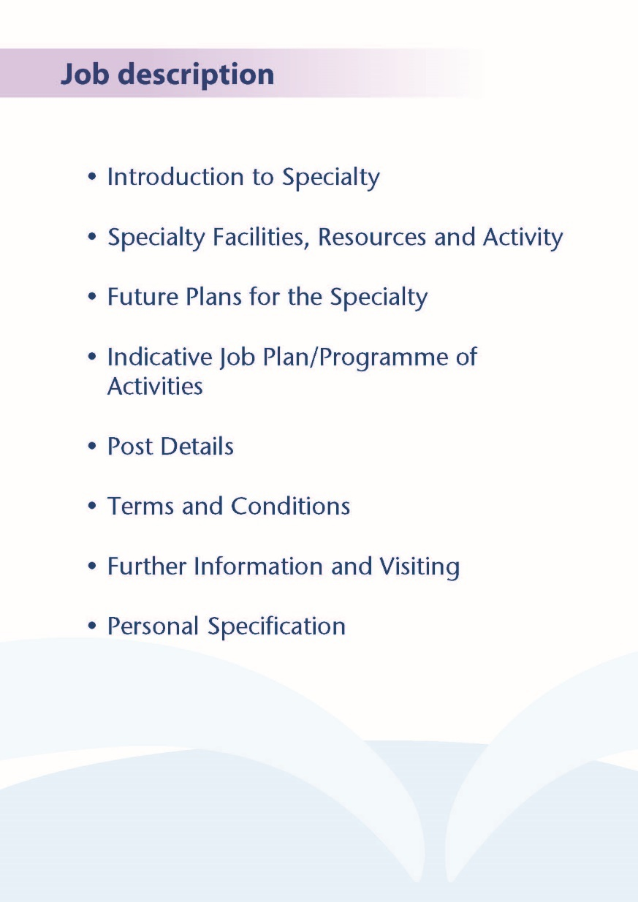



**CONSULTANT RADIOLOGIST**

NHS Ayrshire & Arran are pleased to invite applicants for the post of Consultant Radiologist. The successful applicant will join a friendly and dynamic team of 26 Consultant Radiologists based at University Hospital Crosshouse, University Hospital Ayr and Ayrshire Central hospitals. The successful candidates will be encouraged to take on a Specialist Interest(s) which complements the existing department.  Sub-speciality interest in Musculoskeletal Radiology, Urology, and Breast radiology will be welcome.

**THE REGION OF AYRSHIRE & ARRAN**

Ayrshire is a large county in southwest Scotland located on the shores of the Firth of Clyde. The overall population is approximately 370,000 with principal towns including Ayr, Kilmarnock and Irvine. Geographically the area is chiefly characterised by agriculture (with much of the inland county devoted to farming), but Ayrshire also has a beautiful coastline with the coastal Islands of Arran, Great Cumbrae and Little Cumbrae easily reachable. Most of Ayrshire is within easy reach of Greater Glasgow via the M77 and by rail. An international airport is also situated at Prestwick.

A wide variety of leisure activities are available in Ayrshire. The area is renowned for outdoor pursuits including fishing, cycling and hill-walking. Despite its relatively small area, more than a dozen golf courses are available including the prestigious Dundonald Links, Old Course at Royal Troon and Turnberry. The wider Greater Glasgow area affords further opportunities for travel and a wealth of culture, art, music, dining and sport.

Excellent Schooling is available within Ayrshire and the wider Greater Glasgow area with various highly-rated State and Independent Schools. University Hospital Ayr benefits from an on-site nursery with discounted staff rates.

**THE HOSPITALS**

Acute services are split between University Hospitals Crosshouse and Ayr, with Ayrshire Central Hospital home to the Ayrshire Breast Screening Unit.

University Hospital Crosshouse is situated on the outskirts of Kilmarnock, approximately 25 miles from Glasgow. Approximate journey times of 30 minutes each way from Glasgow are often faster than typical journeys to hospitals within Glasgow. The hospital is a large 500-bedded DGH serving a population of around 250,000, incorporating a diverse socioeconomic mix across urban, semi-rural, rural and island areas.

Numerous services are on offer at University Hospital Crosshouse. In addition to emergency medicine and the major medical and surgical specialities, the hospital also provides inpatient maternity, gynaecology and paediatric services, stroke, cardiology, renal medicine and respiratory services, breast surgery, and ENT/maxillofacial surgery. The Scottish Cochlear Implant Programme is based at University Hospital Crosshouse presenting a unique opportunity in Scotland for ENT radiologist involvement.

University Hospital Ayr and Ayrshire Central Hospital are located more peripherally but still remain easily accessible by car from Greater Glasgow in around 45 minutes. University Hospital Ayr provides local services in the major specialities, and is the site of urological and vascular surgery and vascular interventional radiology for NHS Ayrshire & Arran. The radiology department in Ayr is one of the few departments in Scotland to provide multiparametric MR prostate imaging.

Ayrshire Central Hospital is the county’s largest community hospital. NHS continuing care services are provided on-site along with a wide range of outpatient clinics and therapy services. Ayrshire Central Hospital is also home to the South West of Scotland Breast Screening Unit and the area-wide DEXA scanning service.

At each hospital there are large car parks with ample free parking for all staff and no private parking company management.

**WORKING AS A RADIOLOGIST IN NHS AYRSHIRE & ARRAN**

Both acute hospitals boast departments with a friendly outlook and collaborative, collegial atmosphere. Both departments have excellent integration with clinical teams and there is frequent direct consultation with clinical colleagues face-to-instead of remotely by telephone.

NHS Ayrshire & Arran has a commitment to flexible working which is reflected within Consultant Radiologist job planning. We encourage Radiologist involvement in management, service development, quality improvement and research. Education, teaching, training and trainee supervision are also encouraged.

NHS Ayrshire & Arran is accredited with the West of Scotland Deanery and receives Speciality Trainees on a rotational basis (ST1-ST5 level) for general and speciality attachments, with consistently high scores achieved on the annual GMC training survey. Medical students from University of Glasgow also rotate through the NHS Ayrshire & Arran hospitals for general and speciality attachments.

Cross-sectional modality reporting sessions are capped in order to maintain appropriate work intensity. Reductions are made to list sizes to accommodate interventional work. Interruptions are minimised through the use of a sessional duty radiologist system and work is being progressed to establish a true “sterile reporting environment” as recommended by the Royal College of Radiologists.

On-call commitments can be delivered flexibly with remote reporting available for out-of-hours work. Flexible remote daytime reporting is available for the local Radiologists.

The post will be based at either University Hospital Ayr, University Hospital Crosshouse, Ayrshire Central Hospital or can be split across the sites. The appointee will share, with the existing radiologists, in the full range of general radiology services provided by the directorate. These include in-patient reporting, out-patient reporting, Accident and Emergency reporting, fluoroscopy studies, CT and MR examinations, ultrasound examinations, and other specialist examinations within the overall service provision of the directorate. The appointee would also undertake duties in line with their areas of special interest and will have the opportunity to participate in clinico-pathological conferences, clinical audit, and contribute to Managed Clinical Networks.

At present both sites operate separate on-call rotas, currently 1:11 on weekends and 1 :22 on weekdays at both sites. The delivery of on-call radiology services is under review.

The CT and MRI departments in both hospitals work extended days and are open to 8pm during the week.



**Facilities**

Both departments have 1.5T MR scanners, 128-slice CT, fluoroscopy, nuclear medicine, mammography, dental and general purpose radiology rooms. There are four ultrasound rooms within the main department at University Hospital Crosshouse and two in Ayr. There is an active programme for purchase of new and replacement equipment. The current CT scanner in Ayr is due for replacement. In addition there is additional scanning is done on MR van and CT POD.

Radiologists generally report from PACS workstations within their own offices. The Soliton RIS and Philips PACS are used across Ayrshire with electronic examination requesting in use within the hospitals. A voice-recognition dictation system is used for most radiology reports.

Both hospitals offer a comprehensive range of acute services. Area services for Maternity, Gynaecology, ENT and Maxillo-Facial work are currently based at Crosshouse. Paediatric care is centralised at Crosshouse. Area services for Urology, Vascular Surgery and Ophthalmology are based at Ayr.

**Medical Staff Resources**

The staffing of the Medical Imaging Directorate is as follows:

|  |  |
| --- | --- |
| **Consultant Staff** | **Specialist Interest** |
| **Dr Sudhakar Unnam** Clinical Director Medical Imaging | General Radiology, GI and MSK |
| **Ashley Monagahan** | Uroradiology and Cross Sectional Imaging |
| **Dr Steven Henderson** | Breast and cross sectional imaging |
| **Dr Hazel Halbert** | Gynaecology and General Radiology |
| **Dr Alan Ogg** | ENT, General Radiology |
| **Dr Bappa Sarkar** | Gynaecological Radiology |
| **Dr Calum Nicolson** | GI Radiology and General Radiology |
| **Dr Henna Singh** | GI Radiology and General Radiology |
| **Dr Iain Cameron** | Cross sectional, Interventional Radiology |
| **Dr Magdalena Nowak** | Cross sectional Imaging, ENT |
| **Dr Shahid Rasul** | General Radiology, Nuclear Medicine |
| **Dr Maret McHardy** | Breast imaging |
| **Dr Catriona Turbet** | Uro-gynaecology and General radiology |
| **Dr Mark Ablett** | Interventional Radiology |
| **Dr Jean Pierre Charon** | Interventional Radiology |
| **Dr Olivia Thomas** | General Radiology, Paediatrics |
| **Dr John Maguire** | Cross Sectional Imaging and Chest |
| **Dr Leanne Alexander** | General Radiology and Neuro radiology |
| **Dr Olalekan Abudu** | General and Uroradiology |
| **Dr George McLaughlin** | General and Uroradiology |
| **Dr Liam Peng** | Cross Sectional Imaging and Chest |
| **Dr Tricia Yeoh** | Cross Sectional Imaging and NM |
| **Locum Consultants** | |
| **Dr Stephen Cooper** | Cross Sectional Imaging and Chest and Oncology |
| **Dr Rida Khan** | General Radiology and GIT |
| **Dr Sehrish Rubab** | General Radiology |
| **Dr Olubukola Ajiboye** | General and MSK radiology |

**2.3 Activity : 2022 figures**

|  |
| --- |
|  |
| General Examinations (inc. Bariums, IVU, Fluoroscopy, Specials)155179 |
| MRI20677 |
| CT 50787 |
| Ultrasound1997445670 |
| Mammography |
| Nuclear Medicine 1851 |

On average, the department has recorded a 7.5% increase in activity over the previous two years.

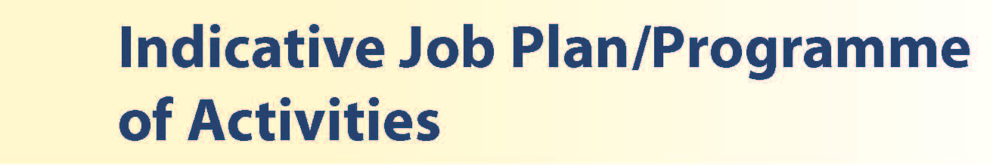

# Proposed Weekly Programme

The proposed weekly programme is shown below. Activities with current fixed time commitments will be carried out as detailed in the work programme e.g. clinics. Other DCC and SPA activities are shown with indicative timings within the weekly programme and will be discussed with the appointee.

**Notes on the Programme**

**Patient Administration**. This activity covers the management of individual patients including, radiology reporting, letters/phone calls to, GP’S and members of the wider multidisciplinary team involved in the patients care.

Adhoc interventions: These include drainages and biopsies.

**Travel:** Any travel allocation will be included within the Total Programmed Activities and will be determined by location at which Direct Clinical Care and Supporting Professional activities are carried out.

**On call arrangements:** At University Hospital Crosshouse and University Hospital Ayr the successful applicant will join the existing Radiologists on the on-call rota. Fixed on-site sessions are worked on Saturday and Sunday when on-call. On-call availability is paid at Category A rate. The time required for on-call is averaged and allocated within the standard weekly rota. There is teleradiology support for on-call CT.

**Supporting Professional Activities**: NHS Ayrshire and Arran recognise the important role Job Planning has in ensuring consultants are supported in delivering high quality, safe, sustainable clinical care to patients. It is therefore important to ensure there is an adequate balance between direct clinical care activities and activities which support both the personal and professional development of the consultant workforce and facilitates agreed contribution to activities including:

* Under and post graduate teaching/training
* Clinical Governance
* Quality and Patient Safety
* Research and Innovation
* Service management and planning
* Work with professional bodies

All consultants will have 1 SPA as a minimum to support appraisal and revalidation. However the final balance of SPA and DCC activity will be agreed between the appointee and clinical manager prior to contracts being agreed.

There may be a requirement to vary the DCC outlined in the indicative timetable below when the final balance of DCC and SPA is subsequently agreed. There may also be opportunities to contract for Extra Programmed activities subject to service requirements and in accordance with national terms and conditions of service.

**Proposed Weekly Programme**

|  |  |  |  |  |  |  |  |  |
| --- | --- | --- | --- | --- | --- | --- | --- | --- |
| **Work Timetable** | | **Direct Clinical Care (hours)** | **Supporting Professional Activities (hours)** | | | | | |
|  | Description | **Total** | Teaching | Audit | CPD | Research | Other | **Total** |
| Mon am | CT | 4 |  |  |  |  |  | **0** |
| Mon pm | Duty | 4 |  |  |  |  |  | **0** |
| Tues am | Reporting | 4 |  |  |  |  |  | **0** |
| Tues pm | TOIL FOR ONCALL | 4 |  |  |  |  | 4 | **4** |
| Wed am | MR | 0 |  |  |  |  |  |  |
| Wed pm | SPA | 0 |  |  |  |  |  | **4** |
| Thurs am | US | 4 |  |  |  |  |  | **0** |
| Thurs pm | CT | 4 |  |  |  |  |  | **0** |
| Fri am | MR | 4 |  |  |  |  |  |  |
| Fri pm | CT | 4 |  |  |  |  |  | **0** |

(Please note this is an example weekly programme which will be discussed with the successful candidate taking into account any special interests)

Some activities will be undertaken which may not occur at fixed times.

These include:

* Preparation for and attending MDT meetings and clinico-radiological meetings
* Providing radiological advice to hospital clinicians and General Practitioners
* Dealing with clinical correspondence. Dealing with special interest requests which arise outside normal sessional commitments

1 PA of DCC time is credited for on-call work.



The post holder will be accountable to the Clinical Director who will agree the Job Plan.

He/she will be expected to work with local managers and professional colleagues in the efficient running of services and will share with Consultant colleagues in the medical contribution to management. Subject to the provisions of the Terms and Conditions of Service, he/she is expected to observe the NHS Ayrshire and Arran’s agreed policies and procedures, drawn up in consultation with the profession on clinical matters, and to follow the standing orders and financial instructions of NHS Ayrshire & Arran.

In particular, where he/she formally manages employees of the Division, the post holder will be expected to follow the Local and National Employment and Personnel Policies and Procedures.

He/she will be expected to make sure that there are adequate arrangements for hospital staff involved in the care of patients to be able to make contact with the post holder when necessary.

The post holder is required to comply with NHS Ayrshire and Arran’s Health and Safety Policies.

He/she will be responsible for the training and supervision of Junior Medical Staff who work with the post holder and will be expected to devote time to this activity on a regular basis. In addition, he/she will be expected to ensure that Junior Staff have access to advice and counselling. If appropriate, the post holder will be named in the Contracts of Doctors in training grades as the person responsible for overseeing their training, and as the initial source of advice to such Doctors on their career.

**Resources**

The staff resources of the Directorate are listed elsewhere. The post holder will have access to such general administrative support as is required for the discharge of his/her duties and responsibilities.

This will include the provision of adequate secretarial and clerical support and the availability of accommodation, equipment etc.

The post holder will receive support from such other professional staff as are employed within the organisation and are deployed to his/her area of patient care.

**Duties and Responsibilities**

The main duties and responsibilities of the post include:

* Responsible to the Clinical Director in matters concerning service provision.
* Undertaking and reporting of imaging procedures and examinations.
* Participation in the on-call and duty radiologist rotas.
* Provision of cover for consultant colleagues during periods of annual and study leave.
* Professional supervision of radiographers.
* Participation in mutli-disciplinary team working as appropriate, including multi-disciplinary meetings.
* Responsibilities for carrying out teaching, accreditation and examination duties as required, and for contributing to undergraduate andpostgraduate medical education. The postholder will be expected to comply with College recommendations on Continuing Medical Education.
* The postholder will be required to comply with NHS Ayrshire and Arran’s Policies on Clinical Governance.
* The successful applicant will be encouraged to participate in research and to develop a relevant subspecialty interest, subject to resources and local priorities. In particular an interest in falls prevention would be welcomed.
* Requirements to participate in medical audit and in continuing medical

education.

* Managerial, including budgetary, responsibilities (where appropriate).

**Annual Appraisal & Job Planning**

You shall also be required to participate in annual appraisal. Job planning is linked closely with, but is separate to, the agreed appraisal scheme for consultants. The job plan review will take into account the outcome of the appraisal discussion and reflect the agreed personal development plan.

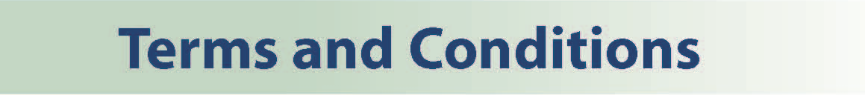

The Terms and Conditions of Service are those determined by the Terms and Conditions of the New Consultant Grade (Scotland) as amended from time to time. The distance that a consultant can reside from the principal base hospital, where travel time is seen as more important than mileage, is subject to the agreement of the Executive Medical Director, but it is usually anticipated that a journey that takes no more than 30 minutes for any emergency situation would be acceptable.



Interested applicants are invited to visit the departments and/or discuss the posts further with Dr Sudhakar Unnam, Clinical Director for Radiology, Tel. 01563 826141, email: sudhakar.unnam@aapct.scot.nhs.uk or Dr Suzzane MacKenzie, Associate Medical Director, Woman, Children and Diagnostic Services, 01563 827401, email: suzanne.mackenzie@aapct.scot.nhs.uk

.



**Post of**: **Consultant Radiologist**

**Location**: **University Hospital Crosshouse /**

**University Hospital Ayr/ Ayrshire Central Hospital**

## Qualifications:

|  |  |
| --- | --- |
| Essential | Desirable |
| Full GMC Registration with current Licence to Practice | Royal College Membership |
| FRCR (or equivalent) |  |
| Existing Consultants: Inclusion on the GMC Specialist  Register New Consultants: Be within 6 months of the  anticipated award of CCT or  CESR at the time of interview. |  |

**Skills/Knowledge/Competence**

|  |  |  |
| --- | --- | --- |
| **Requirements** | **Essential** | **Desirable** |
| **General Experience:**   * Expertise in generalist field * Expertise in sub-specialty field | * Knowledge of and skill relevant to the management of patients. * Ability to communicate effectively with all levels of staff and patients * Ability to work efficiently and timeously * IT literacy | * Ability to develop and maintain a   database of clinical practice |
| **Team Working** | * Effective Team Player * Ability to lead others, think strategically |  |
| **Development** | * Evidence of relevant Continuing Professional Development * Evidence of satisfactory compliance with appraisal requirements |  |
| **Teaching & Training** |  | * Proven ability to deliver high quality teaching * Interest in and knowledge of advances in medical education and training. |
| **Research & Publications** |  | * Evidence of publications of a high standard relating to specialty |
| **Clinical Audit** | Evidence of recent clinical Audits | * Evidence of interest and depth of experience in medical audit |
| **Management and Administration** |  | * Proven ability to lead a clinical team * Proven management experience * Understanding of resource   management and quality  assurance. |
| **Personal and Interpersonal Skills** | * A willingness to accept flexibility to meet the changing needs of the NHS in Scotland * Effective communicator and negotiator * Demonstrate effective leadership * A willingness to develop special interests which conform to the needs of NHS Ayrshire and Arran * Ability to operate on a variety of different levels * Open and non-confrontational | * Knowledge of recent changes in   the NHS in Scotland |