

|  |  |
| --- | --- |
| 1. **JOB IDENTIFICATION** | |
| Job Title:  Responsible to:  Agenda for Change:  Department:  Sector/ Division :  Base:    Number of post holders  Date last reviewed: | Specialist Rotation Dietitian  Dietetic Clinical Team Lead  Band 5 - 1.0 WTE (37.5 hours per week)  Adult Acute Dietetic Service (AADSNHS Greater Glasgow & Clyde (Hosted in Older Peoples Service) and Pharmacy Services Prescribing Support Team  North Acute  Gartnavel General Hospital (GGH), Beatson West of Scotland Cancer Centre (BWOSCC), Glasgow Royal Infirmary(GRI), Royal Alexandra Hospital (RAH) , Queen Elizabeth University Hospital (QEUH), and Clarkston Court.  10  April 2023 |
| 1. **JOB PURPOSE** | |
| To provide and contribute to the delivery and development of a clinically effective dietetic service in a specialist clinical rotation within Greater Glasgow and Clyde Acute Division Adult Service and the Pharmacy Services Prescribing Support Unit. Delivering care in accordance with Service Standards, National Professional Standards of Practice and the Health and Care Professions Council Standard of Conduct Performance and Ethics. Key Roles and Responsibilities  * To nutritionally, clinically and socially assess patients referred for nutritional care. * To act on analysis of assessment, plan, advise and communicate to patients/carers (lay or professional) on an appropriate nutritional care plan. * Monitor and evaluate the effectiveness of therapeutic dietary interventions employed in a range of complex pathophysiologies. * Participate in the delivery of and contribute to the development of the services education and training programmes. * Clinical Support for Band 5 graduate Dietitians and Dietetic Support Workers.      * Provide absence cover for the Specialist Dietitians, other team members and sites as required within GG&C. * To actively contribute to the services clinical effectiveness programme through supported investigative practise. * Actively contribute to MDT working. * Dietetic Student Practice Placement supervisor, up to six student weeks per year, between 4-8 students. | |
| 1. **ROLE OF DEPARTMENT** | |
| The Adult Acute Dietetic Service provides in and out-patient services in two Clyde Acute Hospitals, (RAH, IRH) and three Glasgow Adult Acute Hospitals, (QEUH, GRI, GGH), the Beatson West of Scotland Cancer Centre (BWOSCC) , Lightburn Hospital and Glasgow’s two Ambulatory Care Hospitals at New Victoria Infirmary and Stobhill Hospital . The 67 WTE Dietitians work across four Directorates (Surgery, Emergency care and Medical, Older People and Regional) and are hosted within the North Acute Division, Older People Services. The primary focus is to provide safe and effective nutritional care to the Adult Acute hospital population served by NHSGGC.  The function of the Pharmacy Prescribing Support Unit (PPSU) is to promote safe, effective and economic use of medicines. To facilitate integrated patient-focused care that meets the present and anticipated needs of the population of NHSGGC, in accordance with local and national strategies. The focus is on active participation in, and contribution to, multi-disciplinary and multi-professional teams in a fully integrated manner. | |

**4. ORGANISATIONAL POSITION**

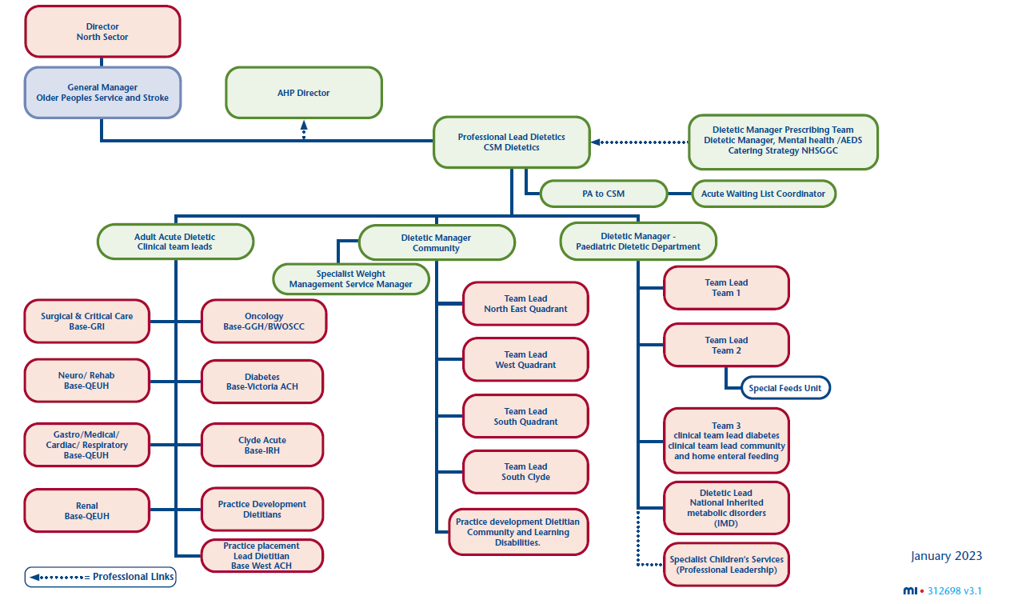

The specialist rotations are based in adult acute and prescribing teams

|  |  |  |  |  |  |  |  |  |  |  |  |  |  |  |  |  |  |  |  |  |  |  |  |  |  |  |  |  |  |  |
| --- | --- | --- | --- | --- | --- | --- | --- | --- | --- | --- | --- | --- | --- | --- | --- | --- | --- | --- | --- | --- | --- | --- | --- | --- | --- | --- | --- | --- | --- | --- |
| * **SCOPE AND RANGE**   Each specialist rotation is for **twelve months** across Greater Glasgow and Clyde Adult Acute Division and the Pharmacy Services Prescribing Support team. These rotations focus on a defined clinical speciality working across both in and out patient locations.   |  |  |  | | --- | --- | --- | | **Rotation A** | **A1** Oncology Surgical Head and Neck /Haemato-oncology  & non surgical oncology | QEUH/ BWOSCC | |  | **A2** Older Adult Rehabilitation , Neurosciences & Stroke | GRI/GGH & QEUH | |  | **A3** Medicine & Gastroenterology | RAH/ QEUH | |  | **A4** Surgical & Critical care | RAH/ QEUH | |  | **A5** Respiratory Medicine, Cardiac & Infectious diseases | QEUH | | **Rotation B** | **B1** Oncology Surgical Head and Neck /Haemato-oncology  & non surgical oncology | QEUH / BWOSCC | |  | **B2** Older Adult Rehabilitation & Neurosciences and Stroke | GRI/GGH & QEUH | |  | **B3** Medicine & Gastroenterology | RAH/ QEUH | |  | **B4** Surgical & Critical care | QEUH/ RAH | |  | **B5** Pharmacy prescribing Support | Clarkston court |   Posts 1-4 in both rotation A&B will be for 6 months in each of two different hospital  sites covered by speciality team to enable dietitians to gain experience across disease  trajectory in the clinical area.  A5 & B5 will be 12 months in one location.  SPRs will move through both Rotation A&B, once completing A6 will move to B1and upon completion of B5 will move to A1, to enable them to gain experience in all specialities.  **Oncology**  **Non surgical Oncology Beatson West of Scotland Cancer Centre (BWOSCC)** Work integrally via a shared caseload with Specialist Oncology team dietitians to provide an inpatient service to:-   * Non surgical oncology patients in this regional unit covering West of Scotland. * Provide absence cover for the specialist Dietitians, other team members and sites as required within GG&C   **Head and Neck Surgical Oncology/ Haematology (QEUH)**  Work integrally via shared caseload with Specialist Oncology team dietitians to provide  an in-patient service to:-   * Head and Neck Cancer Unit and post operatively on Neuro HDU/ITU.      * National Haemopoietic Stem Cell Transplant unit and Haemato-oncology ward. * Provide absence cover for the specialist Dietitians, other team members and sites as required within GG&C   **Older Adult Rehabilitation, Neurosciences & Stroke**  **Older Adult, Stroke and Rehabilitation (North Team)**  Work integrally via a shared caseload with Older Adult, Stroke and Rehabilitation Specialist Dietitians providing a in-patient service to:   * GGH - Older adult and orthopaedic rehabilitation wards. * Stobhill Hospital ACH - Older adult and Stroke rehabilitation wards. * Lightburn Hospital - Older adult rehabilitation. * GRI Acute older adult and Stroke.   **Neuroscience/Spinal Injuries(QEUH)/Older Adult,Stroke and Rehabilitation (SouthTeam)**  Work integrally via a shared caseload with Neurosciences Specialist Dietitian to provide  an in-patient service to:     * Regional West of Scotland Neuroscience Unit : Neurosurgery And Neurology Critical Care Unit ,High Dependency Unit, Neurosurgery Wards, Neurology Wards, Neurology 5-Day Assessment Unit ., * National Spinal Injuries Unit (rehabilitation and acute care beds) and * Stroke - acute and rehabilitation wards, Older adult - acute and rehabilitation , Neuro Rehabilitation Unit (NRU) wards including specialist Dementia unit. * Provide absence cover for the Specialist Dietitians, other team members and sites as required within GG&C   **Surgery and Critical Care (QEUH and RAH)**  Work integrally via shared caseload with specialist Surgical and Critical Care Dietitians to  Provide a service to:     * In- patients service to General Surgery, Vascular, Orthopedic, Urology,   Gynaecology, Maternity wards and Critical Care Units on QUEH/ RAH site.   * Out-patients surgical service at RAH and QEUH sites as required.   **Gastroenterology and Medicine (QEUH and RAH)**  Work integrally via shared caseload with specialist Gastroenterology & Medicine Dietitians to provide a service to:   * In-patient service to gastroenterology including liver, IBD and general medicine wards on QEUH and RAH sites. * Out patients gastroenterology and general medicine service at RAH and QEUH sites as required.   **Respiratory Medicine and Infectious Diseases (QEUH).**  Work integrally via shared caseload with Respiratory medicine, cardiac and infectious diseases Specialist Dietitian to provide   * In patient service to Respiratory, General Medical, Infectious Disease and cardiac ward at QEUH site.   **Pharmacy Services Prescribing Support DieteticTeam (Clarkston Court)**  This post will be for 12 months based in Clarkston Court and will involve travelling to community clinics in other health centres and home visits.   * GP Practices across GGC,  working autonomously and taking responsibility for own caseload providing nutrition support dietetic reviews to outpatient client groups   in a clinic 7 sessions weekly   * Liaise with GP’s and practice staff, primary care pharmacists, technicians and support workers, community pharmacists as well as community, mental health and acute Dietitians * Feedback to Prescribing Support Pharmacists and Prescribing Support Technicians of work and cost savings undertaken by attending area team meetings * Contribute to monthly Dietetic team meetings * Contribute to development work of the team |
| 1. **MAIN DUTIES/RESPONSIBILITIES**   **Clinical:**   * Assess and diagnose the nutritional status of patients with complex pathophysiologies  and based on clinical judgement develop an appropriate nutritional care plan. This will  be achieved by contributing to and working within established protocols. * Monitor and review nutritional care plans against outcome measures and adjust care plans to facilitate the achievement of treatment goals. * Understanding and awareness of the ethical and legal implications associated with  dietetic interventions. * Ensure the safe and timely transfer or discharge of patients from a dietetic episode of  care.   **Professional:**   * Remain current in terms of HCPC registration and professional organisation’s   guidelines and standards of proficiency and practice.   * Work within the service’s policies and procedures. * Engage in CPD activities that meet the needs of the service and HCPC and through   TURAS demonstrate this at annual performance appraisal.   * Undertake audit and/or investigation that will contribute to the service’s clinical  effectiveness programme which impacts on Division Clinical Services. * Participate in the delivery of the service’s clinical governance programme. * Ensure all patient activity data is current, accurately documented and in accordance   with professional and service standards. Educational:Educate and counsel patients and/or their carers on individual nutritional care plans. Participate in delivery of education to groups of patients in order to positively impact  on diet and lifestyle.  * Contributes to the development of appropriate education resources that are researched and evidence based to use in the education and counselling of patients and their carers. * Contribute to the planning and delivery of the service’s formal education programme for healthcare staff, undergraduate students and new graduate career progression programme.   **Managerial:**   * Allocate tasks and evaluate work of assistant grade staff and supervise new graduate dietitians providing feedback as appropriate to designated line manager.   **Organisational:**   * Plan and decide priorities for own work area, balancing caseload with other patient related activities and professional demands. * Contribute as a member of the multi-disciplinary team by attending case conferences and complying with multi-disciplinary discharge policy. |
| 1. **SYSTEMS AND EQUIPMENT** |
| |  |  | | --- | --- | | Equipment/System | Use/Purpose | | *IT:*   * Computers | * Accessing and recording of clinical  information and patient consultations on Electronic Patient Record (EPR), Clinical Portal, Trakcare * Data Collection and Analysis * Nutritional Analysis package * Correspondence, report writing (Word) * Presentation Development (PowerPoint/info-graphics) * Internet and intranet for accessing clinical information * Use of research data bases e,g PubMed, Embase, MedLine Cinahl. * Email for internal/external communication * Microsoft teams | | Audio – Visual Equipment  * Telehealth, WebEx | * Presentations, education and training of patients / carers and health care staff. * Microsoft Teams | | *Telecommunications: (telephone,*  *scanning, paging system)* | * Internal and external communication. | | *Nutritional Assessment and Support Equipment*:   * Scales * Stadiometer * Skinfold Callipers * Handgrip * Enteral Feeding Pumps and systems | * Weighing patients * Measuring heights * Measurement of body fat stores * Measurement of lean body mass stores * Administration of Nutritional Support | | *Administration:*   * Electronic patient record/Medical Notes/Nursing Notes/Care Plans * Written Dietary Information Resources * Statistic proforma * Referral and Discharge documentation | * Recording dietetic intervention * Source of patient/clinical information and communication of treatment * Patient Education Tool * To record patient contact * To inform other health professionals for ongoing care. | |
| 1. **DECISIONS AND JUDGMENTS** |
| Decisions and judgements will be guided and achieved by working within established protocols and procedures. The post holder will independently make clinical, operational judgements and decisions relating to evidence based patient care within their defined clinical caseload and scope of practice. The post-holder is charged with articulating to their clinical line manager capacity and/or capability issues. They are responsible for effective caseload management such that it conforms with the service’s clinical governance framework. |
| **8.COMMUNICATIONS AND RELATIONSHIPS** |
| * Receive, communicate and evaluate complex / sensitive medical, social, biochemical and behavioural information. Apply a high level of interpersonal and counselling skills to facilitate patients’ and carers understanding of dietetic intervention and recognise physical, emotional, cultural and educational barriers to change and take appropriate action. * Effectively network and communicate with healthcare professionals and multi-disciplinary teams within GG&C such that it will contribute to the quality of patient care. * Present the finding of audit / research work undertaken, using appropriate technology, at a local level. * Use information technology to assist in achieving the main duties and responsibilities of  the post. |
| **9. PHYSICAL DEMANDS OF THE JOB** |
| This practitioner will spend the majority of time moving between clinical areas and may  require to carry lap tops and anthropometric equipments to where appropriate manoeuvre patients to be weighed and scales (up 7kg) . |
| **10. MOST CHALLENGING/DIFFICULT PARTS OF THE JOB**   * Developing strategies to deal with distressed patients and their carers. * Engender change with patients and healthcare professionals resistant to change. * Take responsibility in working as an independent practitioner. * Developing appropriate strategies for meeting the emotional demands inherent with  working with acutely ill patients. |
| **11. KNOWLEDGE, TRAINING AND EXPERIENCE REQUIRED TO DO THE JOB**   |  |  | | --- | --- | | **FACTOR** | **ESSENTIAL** | | **Qualifications** | BSc Human Nutrition &Dietetics  Registered Dietitian ( Health and Care Professions Council) | | **Experience** | Normally 18 months of practice and relevant Continuing Professional Development. | | **Knowledge & Skills** | Organisational, communication and reflective skills.  Counselling and supervisory skills  Practice based audit.  Self-directed practitioner.  PC literate in the use of Word, Excel and PowerPoint. | | **Work Style** | Enquiring, Initiative, Flexible and Participative | | **Disposition** | Confidence to deal with staff at all levels  Team player  Questioning  Reasoning  Tactful | | **FACTOR** | **DESIRABLE** | | **Travel access** | Current driving license for Pharmacy Prescribing Support post | | **Membership Professional Bodies** | Member British Dietetic Association | |

|  |
| --- |
|  |
| **12. JOB DESCRIPTION AGREEMENT**   |  |  | | --- | --- | | A separate job description will need to be signed off by each jobholder to whom the job description applies.  **Job Holder’s Signature:**  **Head of Department Signature** | **Date:**  **Date:** | |