**Scottish Ambulance Service**

**Job Description**

**1. JOB IDENTIFICATION**

Job Title: Driver/Handyperson   
Department(s): ICT Department   
Job Holder Reference: TBA

No of Job Holders: 2

Driver / Handyperson Job Description November 2020 1

**2. JOB PURPOSE**

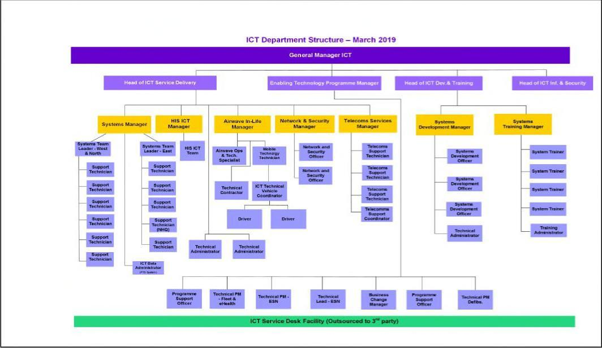

**1. ORGANISATIONAL POSITION** - See Organisation chart below

2

To assist the Airwave In Life Team in relation to the audit, maintenance, verification, installation and de-installation of all relevant Airwave Radio Assets across Scotland

The role may also involve working with any other technical / ICT equipment installed in Service vehicles e.g. mobile phones, tracking devices or other cab-based technology.

Given that this is a national role it may involve a significant amount of vehicle collections & deliveries to minimise the impact that planned ICT works have on the operational availability of Service vehicles.

**1. DIMENSIONS**

Drives Service vehicles between locations as instructed

Assists in the audit of vehicle based ICT equipment as required

Provides general driver / handyperson services to the ICT Department

Gather and accurately record required information

**5. MAIN TASKS, DUTIES AND RESPONSIBILITIES**

Collect and deliver vehicles from and to ambulance stations and workshops

Collect and deliver documents and other ambulance service materials in the course of delivery function

Carry out vehicle cleaning duties, including the use of power washing machines & other industrial products.

Assist line manager(s) as required with risk assessment of tasks carried out and ensure that safe working practices are followed at all times in line with Service Policy and current legislation.

Ensure that any accidents, near misses or hazards are reported immediately to line manager using the Health & Safety Accident & Incident Reporting Form, the Vehicle Accident Report Form and/or REPD Incident Report Form as appropriate.

Carry out any other reasonable and appropriate duties as may be required.

Induction Standards and Code of Conduct

Your performance must comply with the “Mandatory Induction Standards for Healthcare Support Workers in Scotland” 2009; and with the Code of Conduct for Healthcare Support Workers, both as amended from time to time, which are attached (further copies can be obtained on-line at: www.workinginhealth.com/standards/healthcaresupportworkers or from your Human Resources Department). Failure to adhere to the Standards or to comply with the Code may result in poor performance measures or disciplinary action and could lead to dismissal; or if you are self-employed, such failure will be deemed to be breach of an essential term of your contract, allowing us to terminate with or without notice.

**6 EQUIPMENT AND MACHINERY**

* Airwave radio terminals.
* Laptop PCs.
* Smart Phone
* Power washing machine
* Standard Service desktop software (e.g. Spreadsheets, Word Processors etc)
* Being conversant with all the different types of vehicles in the fleet for driving purposes.

Driver / Handyperson Job Description November 2020 3

**7. SYSTEMS**

* Completion of vehicle log-sheets.
* Completion of timesheets
* Completion of Airwave documentation for audits, installs and QA checks.
* Using the ICT Department Service Desk tool / application
* Populating databases and spreadsheets

**8 DECISIONS AND JUDGEMENTS**

The post holder will be required to travel to and from operational stations, locate the appropriate vehicles, and return within a reasonable time. Where this is not possible or becomes a problem the post holder must communicate with their line manager for further guidance and support.

The post holder must be able to make decisions and judgements to allow them to adhere to pre-arranged vehicle logistic plans at all times.

9 **COMMUNICATIONS AND RELATIONSHIPS**

The post holder will work as part of a small dedicated team that is focused on the logistical challenges of carrying out audits on vehicle based technology. As such, the post holder must be a strong Team player that is able to work on their own and using their own initiative when required.

Typically communications will be required with:

* ICT colleagues
* Wider Service colleagues including ambulance crews, managers, fleet staff etc
* External suppliers
* External customers.

Driver / Handyperson Job Description November 2020 4

10**. PHYSICAL, MENTAL AND EMOTIONAL DEMANDS OF THE JOB**

* Physical skills – good driving and manual handling skills are essential, as they form an integral part of the role.
* Physical Effort – manoeuvring/driving wide range of vehicles. Operating equipment. Working in cramped conditions, e.g. under vehicle and having to work on feet for the majority of the day. Sometimes working in dirty and unpleasant conditions. Other demands are manhandling items on the vehicle where lifting equipment cannot be engaged for practical reasons.
* Mental Demands – good concentration required as there could be Health & Safety risks if procedures are not followed. Workload will fluctuate meaning periods of high demand as well as occasional interruptions to attend breakdowns.
* Emotional demands – no significant demands have been identified

**11. MOST CHALLENGING/DIFFICULT PARTS OF THE JOB**

* Dealing with the pressure of providing vehicles within an emergency service.
* Conflicting priorities between operational demand for vehicles and providing vehicles for the Airwave audit team to check.
* Driving Service vehicles in all weather conditions and in all locations across Scotland.
* Requirement to work extended hours, sometimes at very short notice.
* Requirement to stay, as required, in Hotel type accommodation for undefined periods

**12. KNOWLEDGE, TRAINING AND EXPERIENCE REQUIRED TO DO THE JOB**

The post holder must be licensed to drive vehicles in class C1 + D1.

The post holder will ideally have significant experience in driving C1 and D1 vehicles.

The post holder will ideally have basic technical skills and experience e.g. used to working with vehicle technology.

Driver / Handyperson Job Description November 2020 5