**JOB DESCRIPTION** 

|  |
| --- |
| **1.     JOB IDENTIFICATION** |
| Job Title: **Education Hub Manager**    Responsible to: **ScotCOM Senior Project Manager**    Department: **Medical Education**    Directorate: **Medical Director’s**  Job Reference:    No of Job Holders: **1**    Last Update:     **July 2024** |

|  |
| --- |
| **2.  JOB PURPOSE** |
| The role will involve initially leading the setting up and development of simulation centres across NHS Fife in liaison with all stakeholders. The postholder will subsequently manage the day to day activities of the centre.  The post holder will also recruit and manage a bank of sim patients. |

|  |
| --- |
| **3. DIMENSIONS** |
| * Hosting students from 4 medical schools (Universities of Edinburgh, Dundee, St Andrews, Aberdeen) as well as the recent introduction of the new postgraduate medical degree, ScotGEM * 30 undergraduate medical and surgical specialties * 22 consultant Local Module Leads * 150 consultants involved in undergraduate teaching * Provision of medical training posts for 8 NHS Education Scotland (NES) Specialty Training Boards (**Anaesthesia, Intensive Care and Emergency Medicine; Diagnostics; Medical Specialties; Mental Health Specialties; Surgery; Obstetrics & Gynaecology and Paediatrics; Foundation; General Practice; Public Health and Occupational Medicine)** * 220 Postgraduate Doctors in Training * 180 GMC Approved Trainers within NHS Fife |

|  |
| --- |
| **4. ORGANISATIONAL POSITION** |

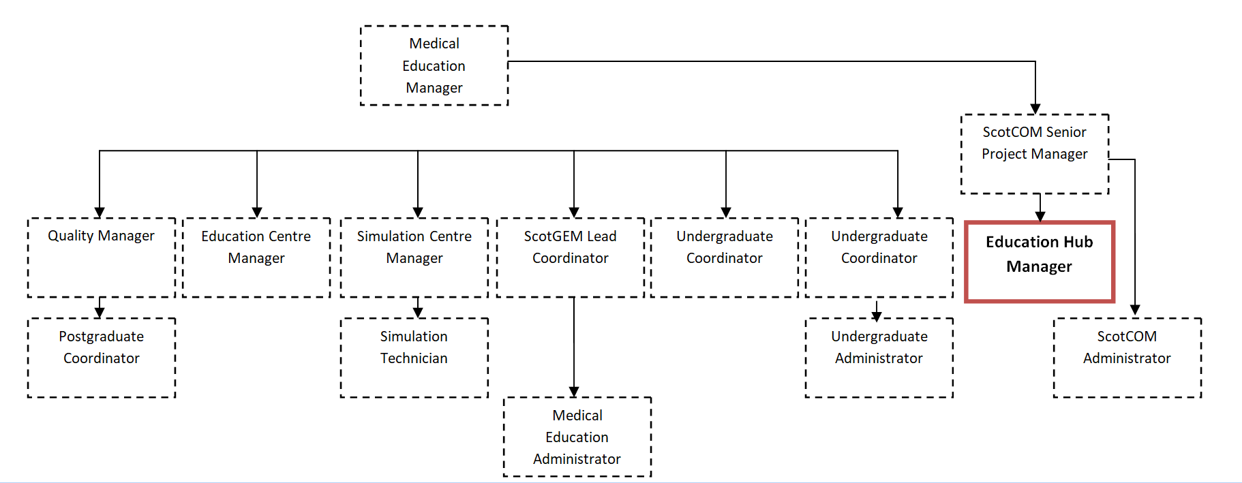

|  |
| --- |
| **5.   ROLE OF DEPARTMENT** |
| The team coordinates the delivery of medical education within NHS Fife for over 800 medical students and around 220 postgraduate doctors in training. Partnership working with the universities of Edinburgh, St Andrews, Dundee and Aberdeen is a key activity. The rotation of doctors in training is also a significant management exercise, undertaken in partnership with the local HR, and NHS Education Scotland.    Medical Education undertakes rota design and New Deal Contract monitoring. It also manages the delivery of the core teaching programmes of Foundation doctors and GP trainees.    Medical Education partners with SEFCE (the South East Scotland Faculty of Clinical Educators) so help NHS Fife Education Supervisors and Clinical Supervisors to gain GMC recognition and approval.    The post holder will be involved in the delivery of high fidelity medical simulation and human factors training for medical, nursing, and allied health professionals working throughout the NHS Fife organisation and wider healthcare organisations in Fife. |

|  |
| --- |
| **6.  KEY RESULT AREAS** |
| * Advertise and market education hub courses to staff of NHS fife and wider healthcare community. * Manage course bookings. * Manage running of courses including registration, catering, certification and collection and collation of instructor and participant feedback. * Analyse feedback on centre courses and initiate improvements as required. * Represent and report on the centre at medical education management meetings. * To work with ADME and other stakeholders to develop and run NHS Fife specific courses. * To develop and maintain a network of contacts with clinical staff/tutors. * To develop systems for and contribute to effective communication between the education hub, clinical settings and educational establishments on issues related to participant simulation experience. Thus ensuring that the participant experience is of the highest quality and enable the greatest benefit from the individual simulation experience. * To promote partnership working in relation to the provision of doctor, nurse and AHP education. Thus facilitating the integration of theory and practice in participants. * To ensure that identification of potential and existing learning opportunities for participants links to the learning needs of different participant groups. * To contribute to the development and evaluation of learning opportunities on an ongoing basis. * Manage day to day activity of the centre. * Demonstrate a high level of initiative, adaptability and effective leadership. * To be responsible for the organisation and prioritisation of own workload under the supervision of the Medical Education Services Manager. * To be able to work without direct supervision but to recognise the need for help/support/advice when necessary. * To recruit and manage the sim patient bank. |

|  |
| --- |
| **7a. EQUIPMENT AND MACHINERY** |
| The post holder will be familiar / trained in the use of the following equipment:  General   * Telephone, paging and e-mail systems * Computer / Laptop * Printer, laminator, scanner * Audio Visual Aids: overhead projector, laptop computer, portable projection screens, portable LCD TV screens, Smartboard, Electric Screen * Videoconferencing / Teleconferencing   Clinical   * Oxygen & suction devices * Intravenous equipment and fluids * Routine clinical monitoring equipment * Defibrillators * Specialist / Simulator * Simulator equipment (type and range TBC) |
| **7b.  SYSTEMS** |
| * Microsoft Office * Microsoft 365 * Blink * Integrated Booking System * TURAS * Doctors LearnPro |
| **8. ASSIGNMENT AND REVIEW OF WORK** |
| The post holder is expected to act with considerable autonomy and initiative, seeking guidance from the Medical Education Services Manager when required.  They will be responsible to the Medical Education Services Manager for professional management, work review and formal appraisal of performance.  Workload will be defined within the scope of the project and the post holder will have responsibility for managing this workload within professional guidelines and the discretion to deliver within set timescales. |

|  |
| --- |
| **9.  DECISIONS AND JUDGEMENTS** |
| * The post holder will be expected to manage their own workload to   ensure the smooth and efficient working of the education hub.   * Dealing with complex facts and unique situations, the post holder should have the ability to make autonomous decisions and be an expert in their field. * Problems should be anticipated (e.g. failure of equipment) and systems and processes should be identified and developed that significantly improve the departments effectiveness in medical education. * Provide specialist advice to the Medical Education Services Manager and Director(s) of Medical Education, on doctors in trainings, medical students, and others’ needs and expectations. * The post-holder will require the ability to exercise a significant degree of initiative to lead the scoping, development, management and delivery of the education hub * The post holder will exercise discretion, tact and judgement and display professional behaviour in all dealings with internal and external colleagues and other stakeholders. * The post-holder will take in to account and interpret national guidelines relating to the area of work. * The post holder will comply with and implement all NHS Fife Policies and Procedures. |

|  |
| --- |
| **10.  MOST CHALLENGING/DIFFICULT PARTS OF THE JOB** |
| * Driving forward the culture of learning and development of the medical education department in NHS Fife. * Dealing with conflicts that arise between a doctors training requirements and their requirements to provide clinical service and often a need to advocate from both sides to find a resolution. * Staying up to date and assimilating various reports and guidance resulting in the provision of comprehensive knowledge, skills and experience of medical education services, taking into account the guidance from NES, and other governing bodies. * Developing and maintaining collaborative relationships to effectively manage and deliver medical education requirements. * Balancing the provision of professional leadership, guidance and support to senior management against ensuring the working lifestyles of doctors in training are satisfactory. * Influencing internal staff and external stakeholders to drive change forward. * Co-ordinating and implementing teaching which involve a requirement for multi-disciplinary/department input. |

|  |
| --- |
| **11.  COMMUNICATIONS AND RELATIONSHIPS** |
| The post holder will be expected to:   * Communicate and liaise with clinical staff in terms of course requirements, participant needs, course feedback, etc * Maintain verbal and written communication systems within the department * Maintain a professional manner when dealing with course participants ensuring confidentiality |

|  |
| --- |
| **12. PHYSICAL, MENTAL, EMOTIONAL AND ENVIRONMENTAL DEMANDS** |
| Physical   * Moving equipment for in-situ simulation   Mental   * Retention and communication of knowledge and information * Concentration required in developing reports, presentations and resources for clinicians * Problem solving and innovative thinking in a developing role * Adaptability to changing needs on a daily basis – post holder is required to prioritise workload dependent on needs * Tailoring teaching to meet multi-professional needs   Emotional   * Ensuring conflict resolution is achieved whenever there it arises in the clinical training environment with participants or with colleagues in general * Acting as change agent where individuals/teams resistant * Provision of supportive contact to participants at time of personal or professional stress * Mediation and compromise skills where multiple stakeholders engage |

|  |
| --- |
| **13.  KNOWLEDGE, TRAINING AND EXPERIENCE REQUIRED** |
| Minimum required undertaking the role:   * Educated to degree level * Knowledge of technical and non technical skills * Knowledge of medical or nursing student training and role of ACT (Additional Cost of Teaching) funding * Display awareness of evidence based practice in the clinical environment * Ability to work autonomously * Exhibit a creative and innovative approach to education and designing teaching programme * Presentation skills * Degree of technical proficiency and computer literacy * Mandatory Induction Standards and Code of Conduct for Healthcare Support Workers – NHS Circular CEL(2010)23 * Your performance must comply with the “Mandatory Inductions Standards for Health Care Support Workers in Scotland” 2009; and with the Code of Conduct for Health Care Support Workers, both as amended from time to time, which will be issued with your contract (further copies can be obtained from Human Resources). Failure to adhere to the Standards or to comply with the code may result in poor performance measures or disciplinary action and could lead to dismissal; or if you are self-employed, such failure will be deemed to be a breach of an essential term of your contract, allowing us to terminate with or without notice |

|  |  |
| --- | --- |
| **14.  JOB DESCRIPTION AGREEMENT** | |
| **Post holder’s Signature:**      **Head of Department Signature:** | Date:      Date: |