JOB DESCRIPTION

JOB IDENTIFICATION
Job Title: Chief Biomedical Scientist, Immunology

Accountable to : Haematology and Blood Transfusion Services Manager

Department(s): Haematology and Blood Transfusion

Directorate: Women, Children and Diagnostic Services

Operating Division: General Hospitals

CAJE No: 800-3408

No of Job Holders: 1

Effective From: Nov 2024

2. JOB PURPOSE
To ensure the efficient management of the Immunology laboratory service in NHS Ayrshire and Arran on behalf of Departmental Haematology and Immunology Consultants and the Haematology Services Manager.
To liaise with the Lead Scientist in Haematology to ensure the provision of effective and optimal diagnostic services in this area.
To perform a complex range of tests on patient samples utilising dedicated equipment, reporting and authorising results according to agreed standards, and be involved in the setting of those standards.
To help in the training of unqualified staff and is expected to oversee Senior BMS, Specialist BMS, Trainee BMS and Medical Laboratory Assistant (MLA) staff.
To respond positively to the changing demands on the service, through innovation, communication, setting standards and achieving results.

3. DIMENSIONS
- Based at University Hospital Crosshouse
- First line manager for 1 x Senior BMS plus 1-2 x Specialist BMS and 1 x MLA
- Manage the staff rotating through Immunology on a daily basis.
- Have responsibility for organisation of the variety of sections within Immunology.
- Provide supervision and training to qualified and unqualified staff on a daily basis
- Oversee stock management within Immunology and order stock directly via the managed service provider, and will advise the Lead Scientist in Haematology when goods require to be ordered in Pecos.
- Liaise with other departments / laboratory disciplines / health boards
- Provide a highly specialised diagnostic service for clinicians throughout Ayrshire and Arran

4. ORGANISATIONAL POSITION

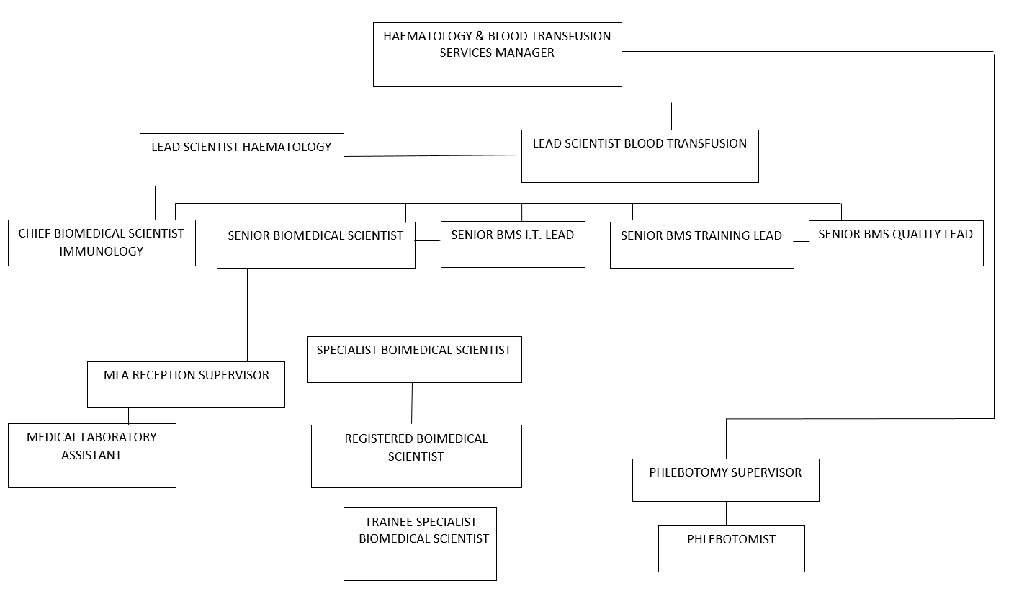

This post

5. ROLE OF DEPARTMENT
The Department of Immunology provides highly specialised Immunological and Haematological diagnostic services for all clinical disciplines within Ayrshire and Arran. This may be by on-site testing or via a referral lab.

Immunological clinical support is provided remotely whilst Haematological clinical support is provided on site for all reported results. Clinical support focuses on the diagnosis and treatment of immunological and haematological disorders at ward, outpatient clinic and laboratory level. The clinicians are complemented by an extensive analytical service provided by qualified scientific and support staff carrying out analysis in Immunology and Haematology. The diagnosis, treatment and management of patients in most clinical areas, both in primary and acute care in Ayrshire and Arran will utilise laboratory immunology and haematology findings as an essential part of their care package. Requests may also be received from private sources.

Requests from all hospital and GP sources within Ayrshire and Arran are submitted to the laboratory via comprehensive van and portering services.

The Immunology service is provided from University Hospital Crosshouse, Mon – Fri 9am – 5pm. Routine Haematology and Blood Transfusion services are provided 24/7 at Crosshouse, and at Ayr 0900-2300 Mon – Fri and 0900-1200 on a Sat.

Two separate Phlebotomy services are centred on University Hospital Crosshouse and University Hospital Ayr site. The main role for the Phlebotomy service is to perform venepuncture on patients in relation to clinicians’ requesting patterns.

6. KEY RESULT AREAS

Personal responsibility for compliance with NHS Ayrshire and Arran’s policies, procedures and instructions, departmental rules, standards, Standard Operating Procedures (SOPs) and abiding by any instruction given by accountable line management in this regard.

- Participate in departmental dissemination of information including staff meetings and contribute to effective communication within the department and with appropriate colleagues out with the department in a manner as outlined in NHS Ayrshire and Arran’s code of confidentiality.

Is responsible for the analytical procedures and staffing effectiveness within the Immunology area of the Department, in liaison with the Haematology Laboratory Manager and the Lead Scientist inHaematology.

- Manage the staff in the Immunology area of the laboratory. Senior BMS and Specialist BMS staff will rotate through these work areas on a rolling roster as published by the Lead Scientist in Haematology.

- Performs staff appraisals and performance review of designated staff.

- Lead in stock management of consumables including receipt from suppliers

Immunology – performs a range of specialist testing which involves a mixture of automated and manual processes including rheumatoid and glandular fever screening, auto-immune testing, allergy testing and haemoglobinopathy screening.

Analyse and report immunological tests used in the diagnosis, maintenance and support of NHS Ayrshire and Arran’s patients. Will have personal responsibility for completion and authorisation of such investigations, using appropriate support, and if necessary, subsequent validation by Consultant Haematology and Immunology staff.

- Deal with test or quality control failures, reporting to the appropriate Lead Scientist in Haematology if errant results issued. Is expected to fault find and troubleshoot problems relating to the equipment listed in Section 7a.

Use the Laboratory Information Management System to enter requests and record and report test results and issue blood and blood components as required.

- Perform control checks on reagents and systems for internal and external quality assurance in accordance with departmental SOPs

Supervise and control the work and training of Trainee BMS and MLA under the direction of the Laboratory Manager and in conjunction with the departmental Training Officer.

- Plan the introduction of new equipment, and assist in the subsequent validation and training of all staff grades

- Participate in quality management duties including development and review of standard operational procedures (SOPs), raising / resolving non-conformances whilst ensuring compliance with UKAS ISO15189 standards

Demonstrate both professional and personal development as required by HCPC.

Participate in the week-end and Bank-holiday rosters.

- As necessary, deputise for Lead Scientist in Haematology

Participate in Foetal Services & Neonatal Steering group meetings
- Participate in quarterly review meetings with managed service contract provider and individual suppliers
- Participate in laboratory executive group meetings for Haematology and Immunology
- Participate in and review NEQAS results, acting on results out of consensus
- Ensure quality controls are within agreed levels

7a. EQUIPMENT AND MACHINERY
The main equipment used within the Immunology department is as follows:
- Phadia 250 – is a fully automated platform which uses fluorescence enzyme immunoassay (FEIA) to test for specific IgE (allergy testing), Rheumatoid Arthritis (RA + anti-CCP) and dsDNA. There is one of these platforms in the department.
- Werfen Quantalyser 3000 – is a fully automated testing platform that uses indirect immunofluorescence technique (IIF) to test patient samples for autoimmune antibodies - anti-nuclear antibodies (ANA), anti-mitochondrial (AMA) and anti-smooth muscle (SMA) antibodies. There is one of these platforms in the department.
- Werfen Novaview / Quantalink – the Novaview is an electronic slide reader and camera that uses ultraviolet microscopy to read the fluorescent slides prepared by the Quantalyser 3000. The images are then transmitted to the Quantalink which allows the operator to view the captured images on a PC and interpret the results. There is one Novaview and Quantalink in the department.
- Becton Dickinson FACSPresto – is a table-top instrument which uses fluorescence photo microscopy and light absorbance to estimate the percentage of CD4 positive T-lymphocytes and the CD4 positive absolute count in patients with HIV. There is one of these in the department and no maintenance required on this piece of equipment.
- Tosoh G8 HPLC Analyser – this is a semi-automated, table-top High Pressure Liquid Chromatography (HPLC) instrument used for the investigation of haemoglobinopathies. This instrument uses the Piano application but is not interfaced with the laboratory computer system.
- Microscopes – Used for blood film assessment.
- Centrifuges extensively used for the separation of serum and plasma from whole blood. Requires the operator to understand the safe use and decontamination, as they can present a considerable mechanical and infection hazard if used carelessly. These undergo yearly calibration to UKAS standards.
- Other non-specialised equipment that the individual requires to be conversant with includes thermometers, pipettes and other general laboratory equipment.

Equipment used within other departments as required
- XN3100/9100 – Used for Full Blood Count analysis
- CS2500 – Used for Blood Coagulation analysis on both laboratory sites.
- KC4 – Semi-automated equipment used at anti-coagulant clinics throughout Ayrshire.
- Interliner FRL – Used for Erythrocyte Sedimentation Rate estimation.
- IH500 – Used to perform blood grouping, antibody screening and antibody identification protocols.
- Blood Fridges and Freezers – There are 14 blood fridges and 3 blood component freezers in various sites across Ayrshire and Arran.

7b. SYSTEMS
- Competent in the use of the computer systems including: Clinisys Systems - Winpath the Laboratory computer database for request entry, result reporting, outstanding work queries, request amendment, telephone enquiries, patient management and sample referral management. Instrument Manager is the application that provides connectivity between all analytical platforms within and out with the laboratory environment.
- Q-Pulse – is the software application used to achieve quality, compliance and improvement. There are many modules within the software including document control and review, audit schedules, internal incident logs and reports, supplier and customer information as well as a workload module for reviewing non-conformities and the status of reports etc.

- Standard software packages will be used in the collection of quality control data for comparison and evaluation.
- Werfen Quantalink – middleware connecting Werfen platforms to LIMS using bi-directional flow. It relies on a programme called Multionline to help transfer information. Quantalink sends the information about tests requested to the QL3000. It then analyses what has been requested. The QL3000 then sends this information to Quantalink which then passes it on to the Novaview.

- Piano – middleware connecting the G8 to Winpath
- Use will be made of NHS Ayrshire and Arran’s intranet package, particularly for perusal of laboratory result reporting system.
- DATIX incident reporting software package. It allows the reporting and investigation of adverse events across the health board and is governed by the Risk Management team.

- TrakCare – patient management system used to review specific electronic test requests
- Clinical Portal – to check for outstanding referral tests
- Folding Space – software package which allows request forms etc to be scanned for storage and look-up.
- MySirius temperature monitoring system for fridges and freezers in the department.

8. ASSIGNMENT AND REVIEW OF WORK
The work performed in the Immunology department is largely demand led. This means it is subject to the fluctuations in hospital bed occupancy, out-patients clinics attendance, waiting list initiatives and GP requesting patterns. Additional work may be generated by the post holder based on the clinical details being presented with each request and the baseline results obtained.

The post holder will have regular contact with the remote consultant Immunologist via a schedule of planned meetings both face to face and by Teams. Set agenda topics include equipment, staffing, training, I.T., IQC /EQA, Service strategy, KPI and objectives and managed service contracts.

Staffing levels within the department may fluctuate dramatically with little or no notice due to holidays, illness etc and the relative needs of the Haematology and Blood Transfusion Departments. The post holder will work in conjunction with the Lead Scientists in Haematology and Blood Transfusion to ensure a co-ordinated approach to overall staffing issues. The post holder is expected to manage the Immunology team overseeing the variety of sections as outlined in section 6.

The post holder will manage and participate as a leader in the performance of analytical procedures within Immunology. In times of staff shortages, annual leave, etc, the individual is expected to perform bench work as part of a team or alone as circumstances dictate.

Requests for leukaemia typing are made personally to the jobholder by the Consultant Haematologist staff. Ensuing discussions will determine the appropriate testing regime required for each individual patient, prior to sending to external laboratory for analysis.

Undergoes regular staff appraisal by the Haematology Laboratory Manager, where the work performed is reviewed. New objectives and subsequent training, if necessary, are scheduled.

9. DECISIONS AND JUDGEMENTS
- Provide expert advice on analyser performance and result significance to all grades of BMS and MLA staff as appropriate.

- Manage the Special Haematology/Immunology laboratory co-ordinating staff and consumable resources to achieve optimum quality and efficiency.

- Advise all BMS and MLA Grades where unusual or difficult requests are received.

- Work in lone working scenarios in various laboratory sections where all quality assurance and testing is under personal monitoring and control.

- Use judgement and skills daily to ensure valid performance of equipment and test protocols in use and to interpret the validity of the results obtained.

- Decide on the appropriateness of addition of further tests.

- Decide significance of findings and informs Medical and Lead Scientist staff of findings where urgent intervention may be required.

- Check accuracy of data on request forms and seeks clarification from sender.

- Ensure appropriateness of current diagnostic equipment and replacements via managed service contracts

- Review appropriateness of scope of testing

10. MOST CHALLENGING/DIFFICULT PARTS OF THE JOB
Regular complex unsupervised decision making required when interpreting results.

Staffing levels within the Department may fluctuate dramatically with little or no notice due to holidays, illness etc and the relative needs of the Haematology, Special Haematology/Immunology and Blood Transfusion sub-departments.

High level of concentration and accuracy required whilst processing and interpreting results from samples. Microscopy demands particular concentration and attention.

Being responsive to the fluctuations on incoming workload and resultant tasks involved.

Coping with frequent interruptions, particularly from the telephone, during all working scenarios.

11. COMMUNICATIONS AND RELATIONSHIPS
Will:

- Work in conjunction with appropriate departmental Lead Scientists to ensure smooth running of section.

- Communicate with senior clinical staff to agree optimal test pathways for patients.

- Communicate with users of the service to give results, answer enquiries or seek clarification of data on request forms and samples whilst maintaining patient confidentiality.

- Engage in open communication and two-way dialogue amongst peers and hierarchical groups within the Area Laboratory complex.

- Communicate with staff out with the laboratory including medical staff, nursing and midwifery staff, theatre staff, portering and laboratory van staff, service engineers and commercial representatives.

- Liaise with colleagues from other laboratory departments to ensure shared samples are dealt with appropriately.

- Involved in providing training of all BMS and MLA grades.

- Conduct laboratory tours to visiting professionals/students.

12. PHYSICAL, MENTAL, EMOTIONAL AND ENVIRONMENTAL DEMANDS OF THE JOB
Daily periods of prolonged concentration when dealing with highly specialised test procedures and equipment.

Due to the amount of equipment within laboratory settings the environment often becomes very warm and stuffy.

Required to safely use many varied chemical reagents, some of which may be toxic, flammable, hazardous or corrosive. Attention to appropriate regulations, safety measures and exposure limitations is essential.

Frequent light physical effort for several short periods per shift. Bends and lifts boxes of consumables/reagents//waste daily.

Daily exposure to samples which may contain unpleasant and/or infectious material.

Managing expectations of staff can be challenging.

13. KNOWLEDGE, TRAINING AND EXPERIENCE REQUIRED TO DO THE JOB
The post holder will be an existing Health and Care Professions Council (HCPC) Biomedical Science registrant.

Must have attained MSc status or equivalent educational level.

Maintaining Registration requirements of the HCPC is mandatory. Participation in Continuing Professional Development (CPD) as required by HCPC.

Detailed knowledge of Haematology and Immunology are essential,
High standard of health & safety awareness and training required to process samples according to the laboratory safety protocols.

Ongoing training including mandatory updates and refresher courses.

Numeracy and keyboard skills required.

May be involved in the delivery of Departmental and/or laboratory wide CPD activities.

Will have displayed proven effective managerial skills at supervisory level.

14. JOB DESCRIPTION AGREEMENT
Job Holder Signature:  Head of Department Signature: | Date:  Date:

