Form JE 2
NHS Scotland National Template



JOB DESCRIPTION

Job Title: Clinical Educator (Simulation)

Responsible to (insert job title): Associate Director of Medical Education (Simulation)

Department(s): Medical Education Directorate

Directorate:

Operating Division: Corporate Services

Job Reference: L-CORP-MED-CES

No of Job Holders: One

1. JOB IDENTIFICATION

2. JOB PURPOSE
To plan, deliver, facilitate and evaluate clinical simulation education and training throughout Lothian. The focus of the role is to facilitate procedural clinical skills that are acquired, rehearsed and maintained through simulation alongside educational input and support for broader clinical education programmes and initiatives. This will entail the delivery of a variety of simulation education solutions to meet the Lothian Simulation Service strategic agenda.

3. DIMENSIONS
Staffing Responsibilities:
Direct line management of a team of Simulation Technical Assistants (4 x FTE).
Financial Responsibilities:
The post holder will have budgetary responsibility for simulation supplies to a value of £25000 as required for consumables and maintenance of specialist equipment to ensure established and approved programmes can meet and deliver training needs throughout the year.

Educational Responsibilities:
To assist in the design, development and implementation of simulation-based education to internal staff and departments as well for external clients across NHS Scotland.

4. ORGANISATIONAL POSITION
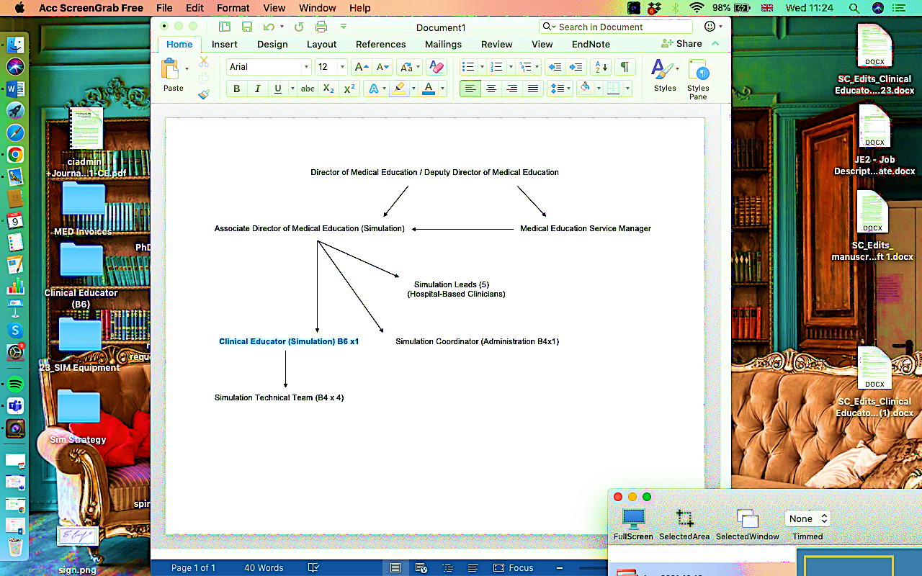

5. ROLE OF DEPARTMENT
The Medical Education Directorate [MED] is led by the Director of Medical Education and is managed by the Medical Education Services Manager and a team of administrative staff (see organisational chart attached). The site based strategic direction of medical education is led by the Associate Directors on each of our acute adult, paediatric and mental health sites in Lothian. The Directorate’s main focus is to ensure delivery of high- quality medical education and training from undergraduate through to postgraduate and on-going mandatory CPD for career grade staff.

Undergraduate
The Undergraduate curriculum is the first stage of medical education, providing a foundation for future learning and practice. The MED focuses on enhancing the UG experience in Lothian through the use of innovative teaching and learning strategies in collaboration with the University of Edinburgh as an educational partner.

Postgraduate
Postgraduate training is delivered within managed competency assessed training programmes based on clear curricula. Two-year foundation programmes lead doctors through a programme of training and education dealing with areas as diverse as team working and patient safety. Foundation Programmes are followed by Speciality and General Practice Training Programmes leading to a Certificate of Completion of Training (CCT) and entry to the Specialist or GP Register of the GMC.

All medical practitioners are required to evidence aspects of continuing medical education.

The MED also coordinates closely with the wider healthcare education infrastructure in Lothian promoting a team based approach to healthcare training and delivery. The focus of the simulation strategy in Lothian is on enhancement of individual skills but also developing and enhancing the team based performance and testing of systems.

Overall, MED ensures that medical practitioners can meet and evidence that they are operating within their professional standards and competencies through continued medical education.

Professional Support Services

The MED supports health professions beyond medicine at NHS Lothian with faculty development for clinical skills assessment and simulation to enhance team performance through shared purpose and interprofessional education.
6. KEY RESULT AREAS

Education and Training

- Responsible for overseeing and delivering clinical skills and simulation training to support the development of undergraduate and post graduate skills & expertise. The post holder will be expected to achieve this by collaborating with the ADME (Simulation), the wider MED team and local stakeholders to assist with designing, developing and delivering simulation-based education programmes that are run and supported by the Medical Education Directorate.

- To be a simulation educator and facilitator pre-briefing, debriefing and meta-debriefing as and when required to ensure that core programmes are delivered. To educate on, and facilitate a variety of technical and non-technical clinical skills.

- Responsible for the day-to-day delivery of allocated training programmes and supporting the implementation of programmes that have been identified by the ADME (Simulation) as necessary to meet and fulfil service requirements.

- Contributing to the development of simulated learning environments across NHS Lothian by assisting in the development and implementation of specialist simulation programmes and clinical skills to maintain essential competencies identified by regulators, service providers and practitioners.

- Assist in maintaining the efficacy of simulation learning environments and provide teaching and learning for clinical staff by utilising a wide range of pedagogical methods that are related to simulation to facilitate lifelong learning linked to KSF dimensions and in accordance with PDPs.

- Supporting scholarship and working alongside the ADME (Simulation) to assist in gathering data to shape educational interventions that align with clinical standards, quality assurance, governance agendas and simulation-based education within service areas.

- Assist with devising standard operational procedures for implementing educational programme pathways and regularly reviewing and updating them as and when required.

- Ensuring the provision of comprehensive technical support for all simulation-based activities and provide advice, troubleshoot, maintain and provide basic repairs to the fleet of patient simulators and provide maintenance of clinical, audio-visual, information systems equipment and software as necessary.

- Assist with the maintenance of quality assurance databases that underpin learning governance of all training and education by ensuring that it is up to date and GDPR compliant.

- Seek collaborative inter-professional opportunities to meet the needs of multiple staff groups who avail of our services to enhance clinical team-performance, safety and service deliver across the health board. This will be KPI in the next iteration of the simulation strategy that will come into effect in 2024.

- Complete three-monthly reports to ADME (Simulation) that summarises quarterly activity and appraises implementation processes for education and training within allocated work-streams.

- To deputise for the ADME (Simulation) in the Medical Education Directorate as required.

Managerial and Financial
- Responsible for the day to day management of the simulation technician including recruitment, promoting attendance, performance management, PDPR, first line discipline and grievance and participating in setting priorities for the simulation technician team, including work stream planning, personal and professional development and outreach activities that align with four benchmarks of the technician commitment framework.

- Responsible for ensuring that all NHS Lothian employment policies and procedures are adhered to.

- Keep accurate employment records on the relevant NHS Lothian systems.

- To maintain a simulation inventory and monitor levels and purchases of supplies within the parameters of post-holders’ fiscal responsibilities across all Lothian sites.

- To develop and sustain links with relevant industry partners and negotiate maintenance contracts and system upgrades for equipment as necessary to a value of £12000. If deputising for the Associate Medical Director (ADME) for Simulation this amount may be in excess of £12,000 with approval but not exceeding £25,000.

7a. EQUIPMENT AND MACHINERY
The following are examples of equipment which will be used when undertaking the role:

General

Personal computer for correspondence and recording relevant information.

Microsoft office software for producing reports, audits, inventory and simulated scenarios.

Smart printer and photocopier for duplicating and sharing educational and service-related materials.

Fax, phone, e-mail, inter/intranet to send and receive documents and communicate internally and externally.

Manual Handling Equipment such as Trolley’s and Transport Bags to transfer teaching materials in and across sites.

Policies and procedures manual.

Specialised

CD writer

Digital projector.

Video-conferencing equipment.

A Variety of clinical education and skills equipment.

Such as part-task trainers,

Educational resources and digital platforms.

NHS Lothian IT systems.

Very Specialised

Laerdal Simulation Manikins.

Scotia: SMOTS Systems and software.

Immersive simulation and class-room technology.

3D printed materials.

Defibrillator.

Airway Equipment.

7b. SYSTEMS
The following are examples of systems which will be used when undertaking the role:

Human Resource Administrative System – PWA - documenting training records.
DATIX Intranet – Entering Incidents /educating and training staff in using web browser incident.
Reporting documents.
Internet and Intranet – Professional Development and Business.
Databases for attendance and records of education, including financial data.

Note: New systems may be introduced as the organisation and technology develops, however training will be provided.

8. ASSIGNMENT AND REVIEW OF WORK
The post holder will be responsible to the Associate Medical Director of Education (Simulation) who will provide guidance and professional management, work review and formal appraisal of performance.

The portfolio of work is carried out in collaboration with the team lead ensuring work is clinically focused and quality assured.

9. DECISIONS AND JUDGEMENTS
The post-holder is expected to work independently on a daily basis with numerous stakeholders internally and when required, externally to design, develop and deliver clinical and simulated education based on learner and partner needs. The job will involve appraising the use of educational materials and technology; identifying essential and unnecessary resources;
assisting on a variety of educational projects related to clinical skills and simulation; overseeing, supporting and developing the simulation technical team to ensure optimal performance as
well as assisting the wider MED team meet their strategic goals. The Clinical Educator is expected to be a key driver in implementing the next iteration of the NHS Lothian Simulation Strategy that will be a phased project based with short, medium and long-term objectives.

10. MOST CHALLENGING/DIFFICULT PARTS OF THE JOB
Having to work across boundaries and teams when necessary to deliver clinical and simulation-based education as service requires. Ensuring the delivery and quality of education, training, and development activities which balance the learning needs of students with the demands of (clinical) service, often within limited resources, in time pressured environments. As such, the post-holder will need to be organised, prioritise, work to deadlines, be a team-player, balance and respond to competing demands, provide constructive feedback and challenge, seek solutions and remain flexible.

11. COMMUNICATIONS AND RELATIONSHIPS
The post holder will communicate with multiple stakeholders internally and externally.

Internal communication
ADME (Simulation) as programme lead for strategic advice, professional guidance, and support and to fulfil PDP’s.
Simulation Technicians whom they directly line manage to coordinate resources and activities across sites to deliver simulation programmes throughout Lothian.
Simulation Coordinator for administrative support, stationery supplies, distributing communications, managing attendance, bookings and coordinating timetables.
Clinical educator is to assist with developing, facilitating and delivering clinical skills and simulation programmes where specific and local needs have been identified by the simulation leads and ADME (simulation).
All members of the Medical Education Directorate to foster collegiate links and work constructively with broader team to deliver on wider MED objectives.
Clinical Directors to support service needs as and when required.
Educational Supervisors to assist with creating bespoke courses to address trainee needs and aid progression throughout various levels of training as and when required.
Trainee Doctors to assist in supporting their learning and development throughout all stages of training.
NMAHP to foster interprofessional education and collaboration.
HR to ensure all policies and procedures are being adhered to in order to enhance positive employment relations.
Procurement services for purchasing and finance.

External communication

Answering queries that the General Medical Council may have when they visit to review all programmes to ensure that standards are being met.
Answering queries that NHS Education for Scotland may have when they visit to oversee foundation and middle-grade trainee experience and programmes to ensure their needs are being met.
Liaising with Further and Higher Education Institutes partners in implementing educational initiatives for undergraduate learners and supporting faculty development.

Liaising with NHS approved suppliers and representatives for procuring cost-effective equipment.
Union Representatives to ensure transparency, honesty, and fairness in employment relations.

12. PHYSICAL, MENTAL, EMOTIONAL AND ENVIRONMENTAL DEMANDS OF THE JOB
Physical:
Standard keyboard skills.
Overseeing and the providing comprehensive technical support for all simulation-based activities and advising on a fleet of simulation equipment in relation to the maintenance of clinical, audio-visual, information systems equipment and software as necessary.
To assist with the set-up, delivery, and pack down simulation programmes in Lothian as and when required. This includes the requirement to regularly act within scenarios as patients, family members or staff members, donning moulage (make up), clothing, or clinical props and prosthetics as required.
To be a simulation educator and facilitator debriefing on potentially distressing situations

Mental:
Delivering education to meet the demands of a dynamic, diverse and complex organisation undergoing major service change during a period of economic challenge.
Assisting in the maintenance of impact evaluation and audit databases to assess and provide where clinical education solutions can be utilised.
As the simulation team is spread over multiple sites it is imperative to ensure effective communication with colleagues.

Periods of prolonged concentration to:
Prepare and deliver clinical facilitation/education by reflecting, reviewing, revising and planning education sessions and lesson plans that are evidence based.

To actively participate in educational design meetings with stakeholders from various sites and departments to offer advice and troubleshooting around how best to operationalise new and enhanced simulation programmes.

To set realistic expectations, counsel and communicate clearly with existing and prospective simulation on what is and is not feasible in terms of programme ambition; accessing space; using technical equipment or simulation technician support time.

Act as a role model and coach to learners and the team.

Being flexible to best manage and prioritise own workload.

Emotional:
Communicating potentially stressful issues with various individuals and groups. For instance, there is a need to explore real-world considerations and consequences alongside simulated scenarios. While this is done in partnership with learners in a safe and supported space, these situations can be highly emotive and complex; requiring the ability to actively listen and genuinely empathise in an emotional situation.
Liaising between groups of colleagues in different areas who may have conflicting agendas, and ways of working. For example, several specialists in one discipline can have differing ideas and approaches toward education and training that may or may not, be evidence-based.
Working with colleagues at different levels of experience and motivating and facilitating personal development with them.
Dealing with individuals who demonstrate poor performance in clinical practice by managing poor performance, raising concerns or actively overseeing disciplinary issues.

Environmental:
Travelling to venues spread across NHS sites, necessitating the transporting of manageable teaching materials and/or equipment between sites regularly. While the frequency of travel is based on service need and timetabled sessions, it is expected that the post-holder will travel across centres on a weekly basis.

13. KNOWLEDGE, TRAINING AND EXPERIENCE REQUIRED TO DO THE JOB
Degree in a clinical area e.g. AHP, nursing
Specialist knowledge in clinical education obtained through e.g. PgCert/Diploma in Clinical Education or equivalent knowledge and experience in delivery of clinical education.
Previous experience of delivering simulated-based education.
Evidence of collaboration and partnership working.
Evidence of Continuous Professional Development.
Staff management experience
Well-developed organisational and time management skills.
PC skills and computer literate.

14. JOB DESCRIPTION AGREEMENT
A separate job description will need to be signed off by each job holder to whom the job description applies.  Job Holder’s Signature:  Head of Department Signature:  (I confirm that the Job Description accurately reflects the duties and responsibilities of the postholder and does not impact upon any other postholders role) | Date:  Date:

