Job Description
1. | Job Identification
 | Job Title:  Responsible to:  Department:  Directorate:  Operating Division:  Number of Job Holders: | Appointments Coordinator – Health Records  Supervisor  Health Records  Digital and Information  Corporate Services  18
2. | Job Purpose
 | Responsible for the day-to-day support relating to all areas of Health Records within the centralised appointment booking office including the management of both New and review Waiting list and all associated tasks.
3. | Dimensions
The Outpatient services section provides administrative support to ensure the accurate processing of referrals from SCI Gateway and Consultant to Consultant referrals.
Each year in Fife more than 210,000 New referrals are received in addition to 470,000 return appointments
Take responsibility for a specialty or group of specialties and liaise directly with service managers to ensure capacity maximisation.

Duties are undertaken with the support of the Health Records Supervisors and may involve the supervision of Band 2 staff in relation to co-ordination of appointments.
4. | Organisational Position
 | 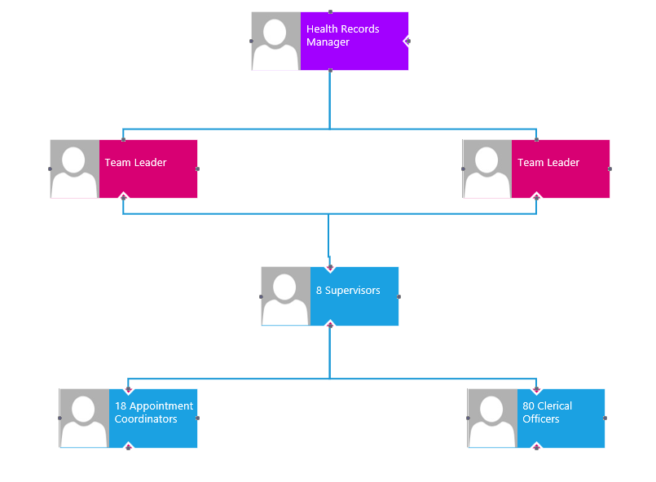
5. | Role of Department
The overall aim of Digital & Information is to deliver and maintain a comprehensive integrated digital information technology and health information strategy in order to ensure that the right information is provided in the right place at the right time, to support highest possible levels of diagnosis, treatment and care of patients and clients, to support continuous improvement of the health of the populations we serve and to achieve more effective integration between Health and the care services of our Local Authority partners.

This includes patients’ case notes and other information for clinicians working in the community and primary care, in outpatient clinics, on the point of admission for inpatients/day cases and for review after discharge: it includes developing and supporting electronic information systems for clinical and management use: and it includes collection and analysis of data required by the Scottish Executive Health & Social Care Department, for local monitoring of activity or performance, and for surveillance and protection of the health of our populations

The Digital & Information has approximately 300 staff, a revenue budget of approximately £11m, annual capital budget of approximately £1m. The eHealth Directorate comprises the following departments:

- Operations – responsible for the overall IT service delivery to NHS Fife, H&SCP, Contractor Services, and partner organisations including the delivery of the underpinning technical infrastructure and applications to support the health and corporate directorates across NHS Fife and partner organisations to agreed KPI’s and SLA’s.
- Strategy and Programmes - responsible for the development of the medium to long term eHealth/IM&T Strategy and the delivery of a large number of highly complex programmes and projects including significant service reconfiguration
- Information Management – responsible for the collection and analysis of information, information governance and delivery of knowledge management services. This service comprises Knowledge Services, Information Governance and Business Intelligence Acute, Partnerships and Public Health Scotland (previously ISD).
- Health Records – 24 hr delivery of a comprehensive Health Records Service across NHS Fife incorporating Clinical Coding, Information Management, Inpatient Services, Emergency Department, Minor Injuries Unit, Records Libraries, Scanning, Subject Access Requests, Outpatients, Waiting Times, Overseas Visitor Status and NHS Fife Switchboard.
- Business and Resource Management – responsible for financial management, procurement & contract management, audit & FOI co-ordination and aspects of HR, health & safety, General Governance, and facilities management activities.
6. | Key Result Areas
- Responsible for the management and coordinating of all New and Review Outpatient Waiting lists ensuring all available capacity is utilised in accordance with the Waiting Times guarantee, 18 week RTT, New Ways, Patient Focused Booking and Patient Access Policy
- Adding unavailability, removing and reinstating waiting list entries, booking, cancelling and rescheduling of appointments.
- Assisting with weekly validation queries in respect of the Waiting List
- Booking of Interpreters where required, generation of patient appointment letters and addition of appropriate leaflets
- Notifying service managers/clinical services coordinators of reasonable offers declined, any capacity issues and advise of any template/clinic issues.
- Dealing with generic appointment requests via email
- Plan and organise daily workload ensuring it is completed to a high standard and to meet deadlines.
- Assist with the training of new staff in all procedures including general induction and new systems of work within the section, ensuring that understanding and standards are met.
- Deal with telephone enquiries in respect of appointments and waiting list enquiries, promptly and efficiently.
- Call answering within the booking team from patients calling to query, cancel and reschedule appointments ensuring they adhere to the reasonable offers guidelines.
- Endeavour to address any local patient dissatisfaction where possible.
- Compliance with all aspects of GDPR and Patient confidentiality
- The post holder, with appropriate training given, will be expected to cover other same grade Health Records posts across all sites to support the overall service in times of staff shortage, annual leave or workload pressure.
- Process letters for Long Waiting patients
- Process patients added to ACRT Opt in, ACRT Asynchronous and PIR pathways
- Ad hoc duties as assigned
7. | Equipment and Machinery
- Personal Computer
- Follow you printer/Copier
- Barcode label printer
- Desk phones and handheld Dect phones

8. | Systems
- Trakcare
- Queuebuster Call handling System
- Netcall Patient Hub
- Datix
- Turas
- iMatter
- Intranet/Internet
- Microtech
- Microsoft 365
- SCI Store
- MICAD
- Stafflink by Blink
- Terminal Digit Filing System
9. | Assignment and Review of Work
Workload is generated by the needs of the service and on instruction from the supervisors, team leader and manager.

Postholder is expected to work on own initiative and be innovative and proactive in organising all tasks assigned to them

Ad hoc workload will be allocated by the Supervisors/Team Leaders/Manager

Line management support is provided by regular staff meetings and annual Turas and iMatter meetings.

10. | Decisions and Judgements
The post holder will work to clearly defined timescales for routine duties and will be directed by the Supervisor, Team Leader, or Health Records Manager in non-routine tasks.

Post holder will be expected to use initiative to make decision regarding workload priorities.
11. | Most Challenging/Difficult Parts of the Job
By its nature, the Health Records service interacts with a wide range of services and specialties within the NHS. The resulting dependencies placed upon the service are numerous, varied, and complex and require the post-holder to continually review their workload and skill set and priories as appropriate.

Managing an outpatient waiting list when there are capacity issues.

Managing time effectively, prioritising work to meet competing demands.

Maintaining service provision during periods of staff absence.

Fitting in appointments when clinics are overbooked/cancelled/reduced, etc – the post holder may require to contact Supervisor/Health Records Manager/clinical staff to discuss and agree how to resolve.
Dealing with anxious or upset patients/relatives by telephone when there are delays in out-patient clinics or when there are errors re appointment dates/times/cancellations (either patient’s or hospital’s mistake) and trying to resolve to patient’s satisfaction.

Highly developed concentration and accuracy required to ensure patient documentation is filed in accordance with local procedures.

12. | Communication and Relationships
The postholder will be expected to demonstrate sensitively an awareness of “politically” sensitive issues and recognise the need to adjust style and behaviours to accommodate different situations and cultures

The postholder needs to be competent in a wide range of communication skills i.e., negotiations, active listening, difficult behaviours, reassurance, and persuasion

Internal
Medical/Nursing/Allied Health Professionals/GPs

Colleagues in the Digital Directorate associated with managing the patient administration/information systems utilised by all staff.

Verbal, written and e-mail communication with a wide range of staff including attendance at many meetings in person or via Teams

External
Patients and their relatives when enquiring about appointments, directions, and advice.
Ambulance staff
Volunteers
13. | Physical, Mental, Emotional and Environmental Demands of the Job
The geographical spread of Health Records services locations across Fife may result in the post-holder travelling across sites.

The wide-ranging aspects of the post-holder’s role require that responses are given to enquiries for advice or information from patients and external agencies within very short timescales. Switching tasks frequently is an inevitable consequence of this type of interaction.

Physical skills:
Keyboard skills requiring a high degree of speed and accuracy.

Physical demands:
Long periods sitting at PC

Mental demands:
Concentration required when entering and retrieving data from patient administration system to ensure accuracy of work. Coping with frequent interruptions and competing demands from clinical staff and work-related queries.

Emotional demands:
Exposure to clinical information. Interface with distressed patients and relatives. Dealing with personal problems of own staff which may have an impact on the day to day running of department.
Potential exposure to clinically unwell patients which may cause distress.

Working conditions:
Use of computer for extended periods
Frequent exposure to dusty conditions in archive storage area.
Occasional exposure to increased noise levels when working in a shared office
Occasional exposure to verbal aggression (patients and/or staff)

Mandatory Induction Standards and Code of Conduct for Healthcare Support Workers – NHS Circular CEL(2010)23
Your performance must comply with the “Mandatory Inductions Standards for Health Care Support Workers in Scotland” 2009; and with the Code of Conduct for Health Care Support Workers, both as amended from time to time, which will be issued with your contract (further copies can be obtained from Human Resources). Failure to adhere to the Standards or to comply with the code may result in poor performance measures or disciplinary action and could lead to dismissal; or if you are self-employed, such failure will be deemed to be a breach of an essential term of your contract, allowing us to terminate with or without notice.
14. | Knowledge, Training and Experience required to do the Job
Good standard of education including English is essential
Previous Health Records/Clerical/Admin experience is desirable
Knowledge and experience of patient administration system, outpatient clinic systems
Good understanding of Waiting times including 18 week RTT,
15. | Job Description Agreement
 | A separate job description will need to be signed off by each job holder to whom the job description applies:
 | Job Holders Signature: | Date:
 | Head of Department Signature: | Date:

Version | Date | Comment
V1.0 | 01/12/2004 | Implementation of Agenda for Change
V1.1 | Feb 2019 | Updated to reflect current Health Records status/scope.
V1.2 | Aug 2023 | Updated to reflect current Health Records status/scope.

