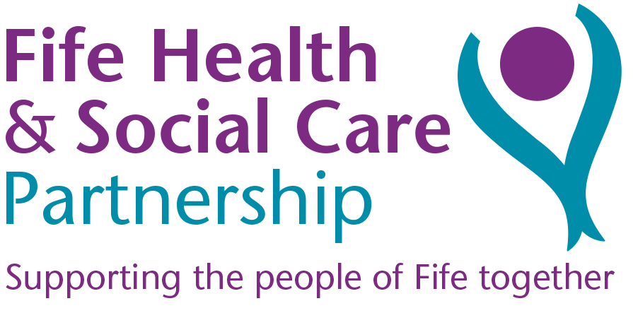
JOB DESCRIPTION

JOB IDENTIFICATION
Job Title: Community Children’s Nurse

Responsible to: Nurse Manager

Department(s): Children and Young Peoples Community Nursing Service

Operating Division: Children’s Services, Fife Wide Health & Social Care Partnership

No of Job Holders: 3

Last Update (insert date): April 2023

2. JOB PURPOSE
- Responsible for the delivery of high quality nursing care to children and young people with acute / chronic / complex health care needs in the community.

- To manage and organise a defined caseload, carrying clinical responsibility for a group of children / young people and their families. Acting as a liaison and resource within the multi-disciplinary and multi-agency team.

- The post holder will be responsible for implementing specialist nursing skills, knowledge and expertise in the care and management of children and young people on their caseload.

3. DIMENSIONS
- Client group is children and young people with a variety of health care needs, ranging from 0 – 16 years of age. This age can increase to 18 /19 if the young person has complex additional health needs and still attends full time education.

- The post holder will visit children, young people and their families not only in their own home environment, but in a variety of community settings including schools, nurseries and the children’s ward within the boundaries of Fife.

4. ORGANISATIONAL POSITION
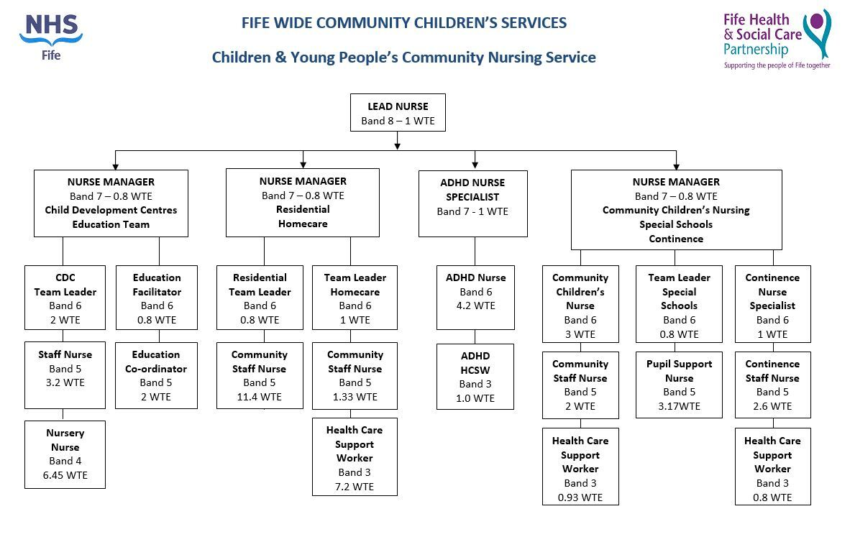

5. ROLE OF DEPARTMENT
- The Community Children’s Nursing (CCN) Team is a division within the Children and Young People’s Community Nursing Service.

- The Community Children’s Nurses support children / young people, families and carers at home and in the community, to prevent unnecessary hospital admission.

- Community Children’s Nurses promote effective discharge planning to avoid prolonged hospital admission and encourage safe discharge.

- Referrals are mainly from primary, secondary or tertiary centres, but also from any health professional / parents and other agencies such as social work or education.

- The CCN team provide a Monday to Friday service.

6. KEY RESULT AREAS
- Be responsible for the ongoing assessment, development, implementation and monitoring of health care for children and young people in the community with additional healthcare needs.

- The post holder works autonomously planning own day to day workload, being able to prioritise and schedule caseload accordingly.

- Provide clinical expertise and knowledge to families and other professionals.

- To co-ordinate discharge planning from hospital to home for children, young people and neonates with nursing needs in the community e.g. tracheostomy / enteral feeding.

- To communicate effectively with children / young people / parents / carers / multi-agency and multi-professional teams within and outside of Fife.

- To coordinate and monitor medical supplies and equipment for children / young people in the community.

- Maintain accurate up to date clinical records in accordance with divisional / national policies, good practice and patient confidentiality.

- Have an awareness of the professional work of staff within the team in accordance with:
- NMC The Code
- Division Policies
- National guidance documents
- Evidence based practice
- Child Protection Processes

- To be responsible for and ensure own practice and professional development is in line
with the above documents.

- Contribute to the development and implementation of policies / guidelines / training programmes with a particular focus on improving the quality of practice in the community setting for children and young people and their families.

- Teach children / young people and their families and carers to competently carry out specific nursing care and procedures at home. In accordance with approved teaching guidelines.

- Teach within associated health, education and third sector agencies ensuring that specific aspects of nursing care and procedures are delivered in accordance with approved teaching guidelines.

- To act as a mentor and assessor to students undertaking pre and post registration courses and to orientate new members of staff to the wider team.

- To participate in research and clinical audit as directed by the Nurse Manager.

- Work within all Health and Safety policies and guidelines.

- Ensure Equality and Human Rights policies are followed and respected.

7a. EQUIPMENT AND MACHINERY
- To have a working knowledge of all the equipment being used within children and young people’s community nursing.

- To be responsible for the safe use of client related equipment.

- To teach parents and families in the use of specific pieces of equipment in the home in accordance with approved guidelines and manufacturing instructions.

7b. SYSTEMS
- To maintain accurate patient records in written format and on database.

- To have IT knowledge and skills, in order to accept laboratory results, access patient information, send emails and order supplies.

- To contribute timely and accurate data to assist in the monitoring and evaluation of the Community Children’s Nurse Team.

- Contribute to CCN / specialist nursing workforce planning tool.

8. ASSIGNMENT AND REVIEW OF WORK
- Work is generated by Primary, Secondary and Tertiary healthcare establishments / Education and 3rd Sector agencies.

- The jobholder works autonomously within the generic community children’s nursing team and is accountable for their own professional actions.

- The standard and quality of work is reviewed through own professional codes of conduct and Division Policies.

- Personal and professional development is undertaken annually through objective setting and PDP process.

9. DECISIONS AND JUDGEMENTS
- The post holder will make clinical and professional decisions on a daily basis.

- The jobholder will assess and interpret acute changes in the child / young person’s condition and take appropriate action.

- The jobholder determines when to refer to other health care professionals and statutory and voluntary services and other agencies.

- Organising and planning own workload and that of new staff to the team when required.

- Clinical judgement regarding the child’s safety at home, e.g. Child protection.

10. MOST CHALLENGING/DIFFICULT PARTS OF THE JOB
- Supporting children / young people and their families with life limiting conditions, terminal illness or multiple complex health and social care needs.

- Working with children and families who have complex medical needs in the community without direct medical support.

- Maintaining the quality of service within the existing resources.

- Flexible approach required when going into a family’s home environment. Working with these families at the same time as ensuring the child is safe and happy can be challenging.

- Acting as an advocate for the child when they cannot communicate their needs to you.

- High level of child protection, child well being issues.

- Lone working / working autonomously in the community.

11. COMMUNICATIONS AND RELATIONSHIPS
- To establish good relationships with children, young people, parents and professionals. Communication will take place through face to face, on the telephone, electronically or written correspondence.

Internal Contacts
- Line Manager and working colleagues – attendance and contribution at team meetings re clinical, service and policy issues
- Administrative staff
- GP’s / Hospital Consultants / Community Paediatricians/ Nurse Practitioners
- Health Visitors / Head Teachers – discussions could be around concerns of a child protection nature
- Hospitals – Specialist Nurses regarding individual patients / ward Staff and discharge planning department

External
- Statutory agencies such as social work, education – attendance and contribution at multi agency meetings about a child / young person’s care needs
- Voluntary agencies
- Networking with other community children’s nurse teams and Nurse Specialists locally and nationally

12. PHYSICAL, MENTAL, EMOTIONAL AND ENVIRONMENTAL DEMANDS OF THE JOB
Physical
- A combination of standing, walking and kneeling for several short periods per shift. Examples being wound dressings, changing medical devices, the transferring of supplies to a community building / setting.

Mental
- Concentration on child / young person and family assessments.
- Planning workload within geographical area.
- Concentration on clinical procedures
- Updating nursing documentation.

Emotional
- Communicating with and supporting children / young people and their families who are distressed / anxious / worried
- Dealing with difficult family situations, such as their coping abilities.
- Exposure to verbal and physical aggression due to client group.
- Dealing with the death of a child / young person and supporting family.

Environmental
- Exposure to body fluids, faeces.
- Working in isolation.

13. KNOWLEDGE, TRAINING AND EXPERIENCE REQUIRED TO DO THE JOB
- Registered Nurse (RN) Child Branch or Registered Sick Children’s Nurse (RSCN)
- Evidence of substantial acute and community post registration experience.
- Excellent communication and interpersonal skills.
- Ability to work on own initiative and prioritise own workload.
- Ability to work under pressure, lone working and ability to travel throughout Fife.
- Time management skills.
- IT skills

14. JOB DESCRIPTION AGREEMENT
A separate job description will need to be signed off by each jobholder to whom the job description applies.  Job Holder’s Signature:  Head of Department Signature: | Date:  Date:

