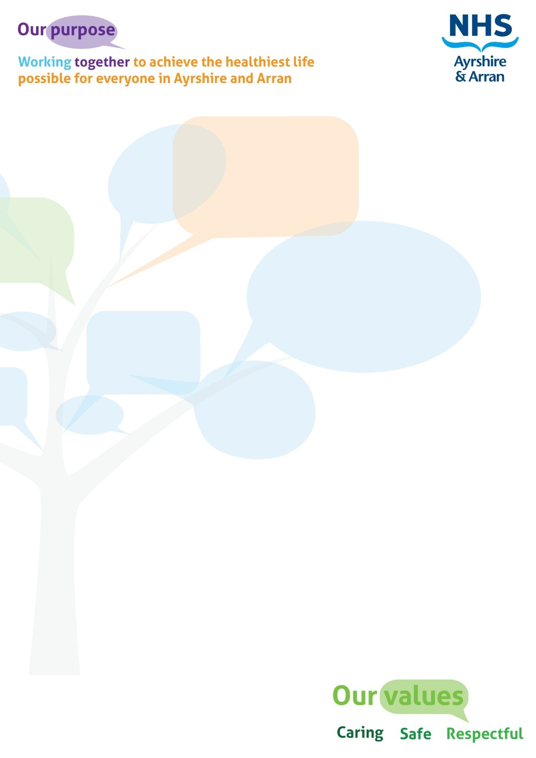

**JOB DESCRIPTION**

|  |
| --- |
| JOB IDENTIFICATION |
| Job Title: Macmillan Improving the Cancer Journey- Project Support Facilitator  Responsible to (Job title): North Ayrshire Primary Care Development Manager(s)  Department(s): Health and Community Care  Directorate: North Ayrshire Health & Social Care  Partnership  Job Reference: 800-3119  No of Job Holders: 1.3 WTE  Last Update (insert date): December 2023 |
|  |
| 2. JOB PURPOSE |
| |  |  |  | | --- | --- | --- | | |  |  | | --- | --- | | |  | | --- | | In partnership with Macmillan Cancer Support, the purpose of this post is to provide a person-centred service that enables people affected by cancer to navigate the health, social care and wider systems to access practical, emotional and social support and promote  self-management for people to live well, addressing their holistic needs during and after cancer treatment. There will be a requirement to work across organisational boundaries with partners to ensure the best possible outcomes for people affected by cancer.  The post-holder will be responsible for proactively identifying the needs of people affected by cancer using Macmillan’s Holistic Needs Assessment (HNA) tool to ensure individuals get the right support to meet their needs, offering the time to find out what matters to the individual and their family, and for providing appropriate information and signposting to local services.    The post holder will also be responsible for providing health, wellbeing and social care expertise and advice to develop capacity to positive disease specific (cancer) outcomes and reduce health inequalities and access to support services and organisations.  The post holder will identify community resources and facilitate relationships between these resources and the service for the benefit of people affected by cancer. They will also build relationships and processes with statutory organisations, health services and voluntary organisations, NHS services and third sector organisations. | | | |
| **3. DIMENSIONS** |
| The post will be based within North Ayrshire HSCP at Cunninghame House, Irvine and will be employed by NHS Ayrshire & Arran. There is a requirement to work flexibly to meet the service demands.  Ayrshire has 53 GP Practices and covers socially and economically deprived areas.  Operationally, this post will report to the Primary Care Development Manager(s) within North Ayrshire but will also work closely with the Macmillan Programme Lead – Improving the Cancer Journey (ICJ). The North Ayrshire Primary Care Development Manager(s) will be responsible for performance management issues and appraisals  The Macmillan Programme Lead is responsible for the delivery of an ICJ across Ayrshire & Arran, including within North Ayrshire. As such, a collaborative approach will be taken to ensure Support Facilitators are supported and joint training and opportunities to skill-share are in place. |
| 4. ORGANISATIONAL POSITION |
| Director of North Ayrshire Health & Social Care Partnership  Head of Health & Community Care  Project Co-ordinator  Programme Lead – Improving the Cancer Journey  **Project Support Facilitators (this post)**  Primary Care Development Manager(s)  Senior Manager |

|  |
| --- |
| 5. ROLE OF DEPARTMENT |
| A key priority area is to ensure that individuals receive support in relation to non-clinical needs to address difficulties faced due to health inequalities, social isolation, and the challenges of managing long-term conditions. This Macmillan-funded post will have a particular focus on supporting people affected by cancer and will join the team of Community Links Workers who provide support for people with multi-morbidities mainly referred from GP and the wider Practice Team and offer support to individuals on a wide range of social, emotional and practical issues that are impacting on health and wellbeing, including intensive 1:1 support and linkage to a range of community based supports in North Ayrshire.    The main functions and objectives of the ICJ service are:   * To provide a person-centred service to people affected by cancer (patients, carers, wider family) and link with community-based health, social and third sector services in Ayrshire. * To identify the non-clinical needs of the person using Macmillan’s Holistic Needs Assessment (HNA), a validated assessment tool, to co-produce a care plan with the person and use a variety of sources to meet the person’s needs. This will be within a robust Clinical Governance framework as well as in line with local and national strategies and priorities. * To support individuals to link into local services that meet non-clinical needs, e.g., managing symptoms, psychosocial support, benefits advice, and spiritual care. * Provide evidence-based advice and information to people after a cancer diagnosis and act as a resource and support to health and social care professionals. * To support the Public Health Agenda by identifying and promoting the non-clinical needs of people affected by cancer in partnership with colleagues, service users and the local community. |
| 6. KEY RESULT AREAS |
| * To support NHS Ayrshire & Arran’s values of quality, teamwork, care and compassion, dignity and respect, and openness, honesty and responsibility through the application of appropriate behaviours and attitudes. * To provide a specialist service to people affected by cancer who are often experiencing complex circumstances using agreed, person-centred principles for monitoring, auditing and evaluating programme delivery. * To identify the non-clinical needs of individuals using Macmillan’s Holistic Needs Assessment (HNA) with people affected by cancer and co-produce a care plan. The Care Plan sets out the agreed actions that come from the assessment and belongs to the service user. The Care Plan can be shared electronically across the health & social care system, with permission. Examples of actions include giving direct information and advice to support self-management, e.g., managing fatigue; as well as signposting onto services such as Welfare Benefits, physical activity programmes. Review and follow-up as appropriate, depending on individual’s needs. * To support individuals in the coordination and navigation of the complex health, social care and wider systems (e.g., benefits, housing) – so that the person affected by cancer can access the right help at the right time, both during and following completion of treatment, so experiencing seamless care. * Provide practical and emotional support to the person affected by cancer. The assessment process is person-centred and offers protected time to be actively listened to. In addition, direct practical support is offered, e.g., advice on managing fatigue such as pacing, keeping a diary on sleep or eating, as well as understanding what local services are available to help, e.g., shopping, transport, housing, money. Act as a central point of access to help navigate the system. * To act as an advocate and facilitator to resolve issues for patients that may be perceived as barriers to care or support. * Build extensive knowledge of local community based supports. * Build strong partnership working with linked services and wider teams as well as associated health and social care professionals. * Work autonomously to manage workload, appointments etc. * To document and monitor all aspects of service delivery, supporting data collection for evaluation and audit. * Provide written and verbal reports on the programme to line manager. * Enable and support the team to build and maintain a comprehensive knowledge of services and activities across Ayrshire & Arran and local community areas which can be utilised to the best interest of the person affected by cancer. * Liaise with primary and secondary care teams, service providers and management teams as required. |
| 7a. EQUIPMENT AND MACHINERY |
| The post-holder is expected to use the full range of IT Systems and Equipment for long periods of time including:   * Microsoft Word, Excel and PowerPoint * eHNA * CRM for client management * Near Me * Internet and Intranet including developing and maintaining web pages; and * Standard range of Office Equipment is used including Video Conferencing, Projection Equipment |
| **7b. SYSTEMS** |
| * Standard Microsoft Office packages e.g., Word, Excel, and PowerPoint to manipulate information and produce reports to aid decision making and insight into operational/strategic matters as well as to external parties. * Intranet/internet for sourcing information to support development and delivery of services. * Understand and apply the concepts of performance management systems, quality assurance systems, benchmarking and best practice. |
| 8. ASSIGNMENT AND REVIEW OF WORK |
| The caseload is generated by the specific service needs of the people opting into the service, i.e., some will be supported over an approximate 12-week period, while others may need support for longer.  The workload will be delegated by the Primary Care Development Manager(s) and/or the ICJ Programme Lead and the post holder will work independently on a day-to-day basis being responsible for managing their own workload within broad guidelines, being accountable for own actions, with input/supervision as required. The post holder will be required to re-prioritise workload frequently as ad-hoc requests arise.  Formal and/or informal meetings/support with senior staff for purposes of discussion will be regularly available and form part of routine practice.  Participation in the appraisal process through Personal Development Planning and review in line with the TURAS and continuing professional development will be facilitated via the ICJ Programme Lead.  Participation in Macmillan induction and cancer specific training programme. |
| **9. DECISIONS AND JUDGEMENTS** |
| Assess the holistic needs of people affected by cancer and provide relevant information, advice and signpost to other services as required. For example, Macmillan Welfare Benefits service to access Macmillan Grants, PIP and DS1500 payments; engaging in groups and activities to address social isolation and loneliness; ‘Move More’ to keep active and manage symptoms like fatigue.  Prioritise own delegated caseload.  Through analysis of information presented, determine when to refer to other professionals and statutory and voluntary services e.g., smoking cessation, housing, Welfare Benefits, mental health services. |
| 10. MOST CHALLENGING/DIFFICULT PARTS OF THE JOB |
| Utilisation of time management skills to provide a service incorporating management of personal caseload, support to other staff, administrative tasks including producing service reports.  Ongoing monitoring and evaluation of outcomes to ensure appropriate caseload management, maintain safety and working within scope of skill set.  Dealing with emotional and/or distressing situations including patients with co-morbidities that require the utilisation of motivational, negotiating and persuasion skills to support behaviour and lifestyle change.  Supporting patients on self-management strategies to embed and sustain behaviour change and effectively manage their condition. |
| **11. COMMUNICATIONS AND RELATIONSHIPS** |
| * NHS colleagues - The Care Plan produced following the assessment is shared electronically via Clinical Portal to support effective working relationships with primary and secondary care. * Macmillan Cancer Support colleagues - in addition to working with and making referrals to other local Macmillan funded services such as Welfare Benefits, Move More, to be part of Macmillan’s Link Worker ‘Community of Practice’, to keep abreast of good practice and developments in fellow ICJ services, peer support and opportunities for reflective practice, identify training needs. * Health and Social Care Partnership staff – referrals and signposting into appropriate teams to meet identified needs e.g., Allied Health Professionals, social care for home adaptations; as well as promoting the service to colleagues. * People affected by cancer, including family members and carers - to support planning and ongoing service developments as well as regular feedback as part of monitoring and evaluation. * Third sector organisations and community groups throughout Ayrshire - referrals and signposting into appropriate services to meet identified needs, e.g., VOCAL, as well as promoting the service to colleagues. * Clinical teams across primary and secondary care to get any medical information for patients etc - The Care Plan produced following the assessment is shared electronically to support effective working relationships with primary care and secondary care colleagues. Also, to advocate/support and help resolve issues for patients that may be perceived as barriers to care or support. * The information shared may be of a sensitive nature - excellent communication skills are required to help manage this, to build rapport quickly and work in an empathic and person-centred way. * Communicating with service users who have language barriers e.g., where English is not their first language. * Participate in meetings, email and telephone conversations ensuring a two-way flow of information. * Disseminate service information as appropriate. * Promote and share ideas. * Utilise team support for emotional and challenging situations. * Liaise with third party agencies for example Macmillan for ongoing support and advice. * Engage with the general public and service users in consultation as required. |
| **12. PHYSICAL, MENTAL, EMOTIONAL AND ENVIRONMENTAL DEMANDS OF THE JOB** |
| **Physical skills**  Accurate IT skills – daily use of computer e.g., communicate with other colleagues, complete data input.  **Mental:**   * Concentration required when manipulating and inputting data and dealing with enquiries; workload unpredictable due to changing priorities. * Reacting flexibly to constantly changing situations and prioritising the workload as necessary within existing resources. * Concentration required when undertaking assessments, assessing queries and signposting to appropriate resources. * Concentration required when dealing with individuals who may be emotional or anxious.   **Emotional:**   * Communicating frequently with distressed/anxious/worried and emotionally demanding service users. * Potential exposure to emotional situations from service users during a potentially stressful and emotive time. * Providing emotional support to peers.   **Environmental:**  Regular use of a VDU, especially when conducting virtual assessments and utilising NHS Near Me. Face-to-face assessments can now be conducted and so a choice can be given that suits the patient ie telephone, NHS Near Me or face-to-face at an agreed venue.  Attending meetings/working across multiple sites.  Requirement to travel between locations to meet colleagues and patients. |
| 13. KNOWLEDGE, TRAINING AND EXPERIENCE REQUIRED TO DO THE JOB |
| * Educated to HND/SVQ (Scottish Vocational Qualifications) level 4 in health and social care, community development and/or equivalent relevant health and social care experience * Completion of training in nationally accredited Holistic Needs Assessment Tool * Experience of working with and understanding the concerns of people affected by cancer * Knowledge and experience of working with people who are experiencing complex social and emotional circumstances, for example people who have social, emotional and mental health issues, live in complex life circumstances, experience chronic pain, drug and alcohol misuse or homelessness * Strong understanding of the challenges faced by people living in areas of deprivation in relation to living well * Experience of delivering a person-centred service, in a support/advice giving role * Experience in the use of data management * Evidence of good communications skills both written and verbal * Understanding of the health and social care environment with experience of working across organisational boundaries * Experience managing own daily workload with an ability and willingness to travel extensively within locality and wider area * Experience of retrieving information from a wide range of sources and in different formats * Good IT skills * Excellent interpersonal skills with the ability to listen actively, motivate, support, advocate, influence and counsel individuals in order to engage people affected by cancer and to enable them to take up a wide range of community services and activities * Knowledge of facilitating service improvement and appreciation of different organisational cultures and workforce development * Ability to work effectively as part of a team and on own initiative * Skills to deal with complex and emotional situations * Flexible approach to carrying out duties and responding to the needs of service users * Skill to empathise with individual and family psychosocial circumstances |