

**NHS GREATER GLASGOW & CLYDE JOB DESCRIPTION 04/21**

|  |  |  |
| --- | --- | --- |
| **1.** | **JOB IDENTIFICATION** |  |
| **Job Title:** | | Childhood Immunisation  Team Lead |
|
| **Responsible to:** | | Service Manager, Children & Families |
| **Department(s):** | | Children’s Services |
| **Directorate:** | | Partnerships |
| **2. JOB PURPOSE**  The post holder will be responsible for operational management and professional leadership of childhood immunisation staff in NHS Greater Glasgow and Clyde (NHSGGC). The post holder will effectively manage the deployment of team resources within the area to provide an efficient service which complements the overall Children and Families service within the area.  The post holder will work with key stakeholders to coordinate all programme elements involved in the operational delivery, ie pharmacy, transport, screening, Children’s Services, the nurse bank, Public Health and Primary Care.  To assist in the identification and delivery of all planning tasks, engagement with all key stakeholders and coordination of multi-disciplinary planning groups.  The post holder has change management, staff development (via PDPs), local health and safety and clinical risk management responsibilities. The post holder may also undertake clinical work when required to support the effective functioning of the team.  The post holder will actively contribute to clinical/care governance activity in collaboration with other members of the multi-agency, multi-disciplinary teams within Children and Family Services and at national level where appropriate.  **3. ROLE OF DEPARTMENT**  Children and Family teams include a range of nursing and related support staff in the provision of universal and multi professional health services to children and families across Health and | | |
|
|
|
|
|
|
|

Social Care Partnerships (HSCPs). These services include assessment and support of children, families and young people up to age 19 years, promoting mental, physical and emotional wellbeing. They may be delivered across a range of settings, eg in community clinics or GP practices. Following assessment, allocation of case work to Core, Additional or Intensive Health Plan Indicator will be carried out in order that services can be targeted to the most vulnerable babies, children and families. There will be provision of support/referral in relation to child protection, domestic abuse and substance misuse and also to health promotion in relation to eg.smoking cessation, infant feeding (working closely with Community Midwifery) and support for childhood immunisation. Children and Families Health teams will work in collaboration with Health Improvement colleagues and other agencies to address Health Inequalities.

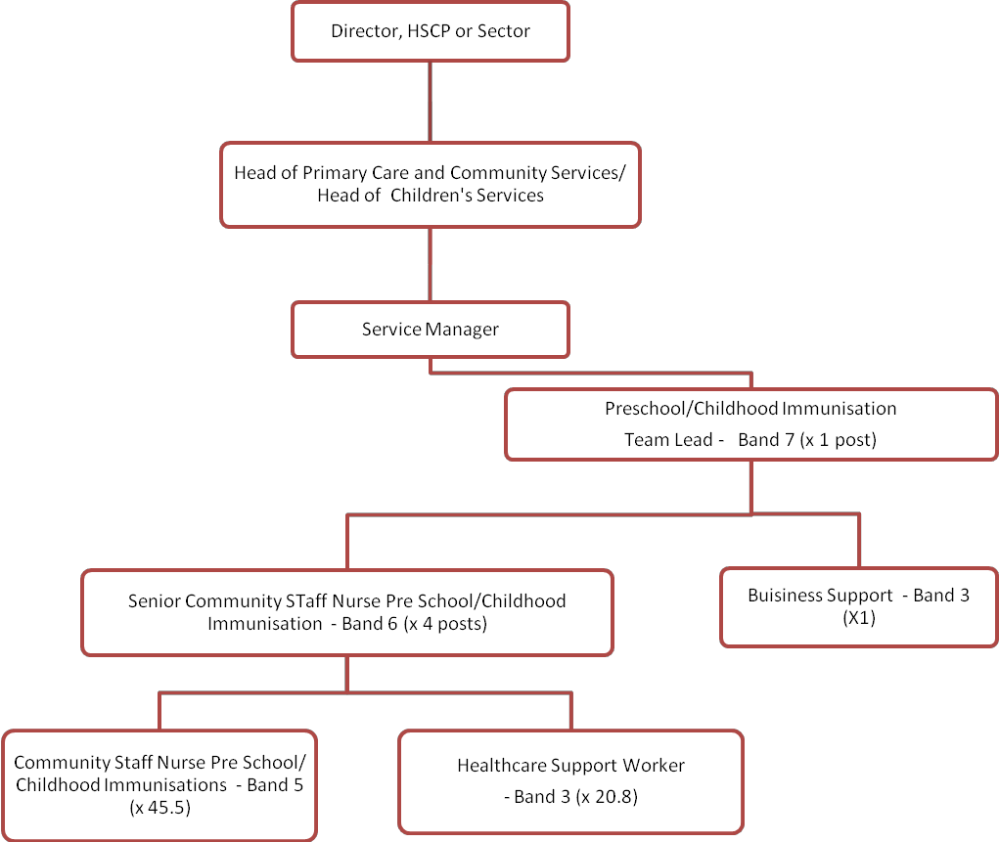

**4. ORGANISATIONAL POSITION**

Assistant

Chief Nurse

**5. SCOPE AND RANGE**

The role of the childhood immunisation teams is to promote the health of the local

community through the immunisation of the local 0-19 childhood population.

The immunisation team lead will have direct responsibility for the line management, professional leadership and supervision of immunisation nurse coordinators across NHSGGC.

The immunisation team lead will be an authorised signatory for a range of processes including invoices up to locally agreed limits.

The post holder will lead on recruitment for childhood immunisation teams to

Band 6 and below.

The post holder may have budget authority delegated via local schemes of delegation and will work closely with the service manager to ensure effective utilisation of resources within the area of service. They will be managerially responsible to the service manager and professionally responsible to professional nurse advisor. They will work independently and autonomously and receive supervision from and meet with the service manager/professional nurse advisor on a regular basis.

The post holder will work with the Immunisation Programme Manager on all aspects of the strategic and operational planning, management, coordination and delivery of government-directed, national, pre-school/childhood immunisation programmes across NHSGGC within the stipulated constraints of time, budget, resource and quality.

The post holder will work with the Immunisation Programme Manager to ensure the Board’s achievement of government-set immunisation uptake targets, where established or at least aligning Board performance with national average achievement.

The post holder will work with the Immunisation Programme Manager in the coordination of multi-disciplinary programme planning groups, engaging with key stakeholders from all 8 NHSGGC HSCPs sectors Children’s and Families Services, Public Health, pharmacy, transport, facilities, IT, screening services, and the nurse bank.

With the Immunisation Programme Manager, the post holder will develop and share successful approaches with the Scottish Government, Health Protection Scotland and other NHS Boards to contribute to national programme success across Scotland.

**6 . MAIN DUTIES/RESPONSIBILITIES**

To work collaboratively with the service manager and Practice Development staff to facilitate, lead, support and co-ordinate the development of staff within their team ensuring that an ethos of shared responsibility and joint working is embedded in practice.

Undertake the leadership and management of the childhood immunisation staff and develop an effective and positive team environment.

Ensure communication systems verbal and electronic are clear and effective at all levels.

Through supervision and collection of statistical information, monitor and review resources and activity with colleagues across the HSCP and system as required.

Directly supervise Immunisation Nurse Co-ordinators and use this supervision to identify areas of good practice or concern. This includes clinical supervision where professionally appropriate.

Ensure that staff within the service are clinically skilled and appropriately supported to manage safe guarding issues.

Ensure (along with the colleagues) that effective arrangements are in place for student and qualified nurse sessions for pre and post registration students.

Promote and work effectively in partnership across Children and Families Services and other agencies to tackle health inequalities and public health issues.

Identify and manage all staff capability and performance issues including attendance management.

Ensure that the team maintain up to date and accurate records that comply with current data collection requirements and meet legal and professional standards (NMC). Provide written reports as requested and complete statistical returns in accordance with policy requirement.

Ensure system in place for undertaking KSF PDPs with the staff in the team including annual PDP reviews and monitor this to ensure that KSF, PDP and eKSF targets are delivered.

Ensure corporate and profession specific induction of new staff within their team.

Work within legal and professional guidelines (NMC), policies and procedures of NHSGGC and ensure that these are implemented by the team this includes for instance implementation of Getting it Right for Every Child National Practice Model and compliance with child protection procedures.

Identify key risk areas and ensure action is taken to minimise risk wherever possible.

Together with the service manager and practice development staff lead on reviews of

clinical effectiveness and development, implementation of best practice guidelines, clinical care pathways and clinical audit and evaluation of services within immunisation teams.

Contribute to patient and public involvement activities, including developing service information for children and families, user satisfaction surveys and focus groups, etc.

Support the service manager in dealing with complaints and incidents within childhood immunisations, undertaking investigations and preparing responses for the Service Manager, in line with the NHSGGC complaints policy.

Work with public health to interpret and implement national and local immunisation policies relevant to the clinical area identifying implications for the immunisation teams.

Lead on the planning and delivery of childhood immunisation campaigns across NHSGGC, working with key stakeholders including immunisation nurse co-ordinators, pharmacy, primary care, screening, education, nurse bank, and public health.

**7a. EQUIPMENT AND MACHINERY**

The post holder will be required to use and be competent in the use of the following:

Mobile phones

Personal computers and associated software

Cars

**7b. SYSTEMS**

The post holder will require to use and operate within:

NHSGGC Policies

Health and Safety Guidelines, Risk Assessment and Incident Reporting mechanisms

IT Systems (ie Intranet, Internet, email, GGILES, SAA, IAF & Share Point)

Microsoft packages including Excel - development & management of spreadsheets for project/programme planning, scheduling, capacity planning & resource management.

Personal Development Planning

Child Protection Guidelines

Standing Financial Instructions

**8. DECISIONS AND JUDGEMENTS**

The post holder will be directly managed by the service manager.

The post holder will be accountable for their own managerial and professional decisions and

actions and must be able to justify these based on the assessment of needs and adherence to local and national policy.

The post holder will be required to consider complex facts or situations requiring analysis, interpretation and comparison of a range of options. They will be required to assess and interpret client conditions and decide appropriate action including child protection issues and to make decisions on complex staff issues.

The post requires day-to-day autonomous working and horizon scanning on complex strategic, planning, theoretical and conceptual issues.

Required to use own discretion and initiative when planning and organising a broad range of complex activities to tight deadlines.

Analyse and interpret national guidance and research findings to inform programme/service developments.

**9. COMMUNICATIONS AND RELATIONSHIPS**

The post holder will regularly be involved in communicating internally and externally with health, education and social care professionals. They may be frequently required to receive and communicate complex and sensitive information. The post holder will identify potential interpersonal conflict and manage these using motivational, persuasive and negotiating skills. This is a feature of the managerial/leadership dimension of the role. The post holder will actively participate in a range of meetings that support effective communication.

Internal

Head of Service Service Manager Professional Nurse Advisors

Immunisation Programme Manager

Public Health colleagues

Team Leader colleagues

Child Protection Adviser/Child Protection Unit

Practice Development Nurse

Education staff

Specialist Children’s services

Social Workers Clinical Director General Practice

Acute Division colleagues e.g. Community Midwives and A&E staff. Addictions/Mental Health, Learning Disability, Social Work staff Learning & Education/Organisational Development Advisors

Human Resources Recruitment Department Administration Manager/staff

External

Other NHS Health Boards

NHS Health Protection Scotland

NHS Health Scotland

NHS Education for Scotland

Information Services Division, NHS National Services Scotland

Scottish Government

Local Authority Education services

**10. PHYSICAL, MENTAL AND EMOTIONAL DEMANDS AND WORKING CONDITIONS OF THE JOB**

PHYSICAL DEMANDS

Working between various areas, driving is an essential requirement for the job.

Often need to climb stairs within community venues

Dexterity and accuracy required for injections

Continuous use of computer, VDU and keyboard.

WORKING CONDITIONS OF THE JOB

Contact with body fluids through immunisations

Working between various areas, driving is an essential requirement for the job, within city/countryside environments

EMOTIONAL AND MENTAL DEMANDS OF THE JOB

Working with children, young people and families who have mental health, domestic abuse of substance misuse problems.

Working with children with serious illnesses, disabilities/challenging behaviour.

Long periods of concentration required, unpredictable workload pattern, in order to meet strict immunisation programme launch dates.

Communicate complex information to families, staff, and partners re communicable diseases.

Speed and accuracy required during immunisation campaigns.

**11. MOST CHALLENGING / DIFFICULT PARTS OF THE JOB**

The most challenging parts of the job are in relation to the following:

Managing the planning and delivery of large scale childhood immunisation programmes,

Childhood immunisation programmes may be launched in response to an emerging outbreak eg pandemic. The nature of this rapid turnaround will be mentally and

physically demanding with intense and complex working days being required to establish the new services.

Effectively supporting and monitoring the practice of experienced nurses who manage their own caseloads.

Ensuring clinical and case load supervision is embedded in practice.

Meeting the needs of families in crisis within the local and national frameworks on child protection

Dealing with both internal and external/service user complaints.

Managing interpersonal, interdisciplinary and interagency tensions when differences arise.

**12. KNOWLEDGE, TRAINING AND EXPERIENCE REQUIRED TO DO THE JOB**

**Essential**

First level registered nurse with a current valid registration with the Nursing and Midwifery

Council

Educated to degree level or equivalent level of experience

Post-registration qualification or significant equivalent experience within immunisation

programmes including experience in an immunisation coordination role

Working knowledge of relevant legislation in relation to Child Protection, Children’s Act, Police Act and Vulnerable adults

Experience of working at a national strategic level

Evidence of continuing professional development, including immunisation, line management, reflective practice

Excellent communication skills – oral, written, visual and presentation

Leadership and management qualifications and experience

Significant experience of planning and organising complex activities, programmes, projects and implementation of change

Demonstrable experience of leading and supporting staff through change

Problem solving skills

Ability to work on own initiative and as part of a team

Ability to work to challenging deadlines

IT Skills – word processing/ PowerPoint /email/internet/intranet

Competent in the use of software packages commensurate with the requirements of the post, especially Microsoft Excel for implementation modeling and planning.

Travel required to meet the demands of the service

**Desirable**

Experience of service redesign

**13. JOB DESCRIPTION AGREEMENT**

A separate job description will need to be signed off by each jobholder to whom the job description applies.

**Job Holder’s Signature:**

**Head of Department Signature:**

**Date: Date:**

**PERSON SPECIFICATION FORM Job Title: School Immunisation Team Lead Department: Children’s Services**

|  |  |  |
| --- | --- | --- |
| **Qualifications** | **Essential**  **(√)** | **Desirable**  **(√)** |
| First level registered nurse with a current valid registration with  the Nursing and Midwifery Council | **√** |  |
| Educated to degree level or equivalent level of experience | **√** |  |
| Post-registration qualification suitable for registration on Part 3  of the NMC Register |  | **√** |
| Evidence of continuing professional development, including  immunisation, line management, reflective practice | **√** |  |

|  |  |  |
| --- | --- | --- |
| **Skills** | **Essential**  **(√)** | **Desirable**  **(√)** |
| Excellent communication skills – oral, written, visual and  presentation | **√** |  |
| Problem solving skills | **√** |  |
| Ability to work on own initiative and as part of a team | **√** |  |
| Ability to work to challenging deadlines | **√** |  |
| IT Skills – word processing/ PowerPoint /email/internet/intranet | **√** |  |
| Competent in the use of software packages commensurate with  the requirements of the post, especially Microsoft Excel for implementation modelling and planning | **√** |  |
| Car driver, driving within city/countryside environments | **√** |  |

|  |  |  |
| --- | --- | --- |
| **Experience** | **Essential**  **(√)** | **Desirable**  **(√)** |
| Experience in an immunisation coordination role | **√** |  |
| Leadership & management qualifications and experience | **√** |  |
| Significant experience of planning and organising complex  activities, programmes, projects and implementation of change | **√** |  |
| Experience of working at a national strategic level | **√** |  |
| Demonstrable experience of leading and supporting staff  through change | **√** |  |
| Experience of service redesign |  | **√** |

|  |  |  |
| --- | --- | --- |
| **Knowledge** | **Essential**  **(√)** | **Desirable**  **(√)** |
| Working knowledge of relevant legislation in relation to Child  Protection, Children’s Act, Police Act and Vulnerable adults | **√** |  |