1. JOB IDENTIFICATION
Job Title: Lead Pharmacist (Non-Medical Prescribing)

Responsible to: Lead Pharmacist Medicines Governance and Guidance
Department(s): Pharmacy Services
Directorate: Corporate
Operating Division: NHS LOTHIAN
Job Reference: 165633
No of Job Holders: 1
Last Update: [November 2022]

2. JOB PURPOSE
The Lead Pharmacist for Non-Medical Prescribing (this post) has responsibility for enacting the strategic vision for Non-Medical Prescribing (NMP) across all hospital, primary care, and community pharmacy services of NHS Lothian in line with local and national policies. Providing expert advice on the safe, clinical, and cost-effective use of non-medical prescribing to ensure optimal care of patients and ensure compliance with all relevant medicine legislation.
Working with Lead Pharmacists across Lothian, the post holder will ensure that appropriate governance systems and processes are in place to support NMP for mentoring, supervision and line management.
The post holder has a key role to play in the governance of Non-Medical Prescribing, not only within Pharmacy Services but across the NHS Lothian NMP professions, including supporting the development and publication of an up to date NMP Framework for NHS Lothian. Also, responsibility, as Chair of the NHS Lothian PGD Committee, for ensuring that all Patient Group Directions (PGDs) in use across NHS Lothian, are appropriately reviewed, authorised, and published, with appropriate training and competency assessments in place to support their safe and effective use.
The post holder will split their time approximately 50% (governance), 50% (clinical), providing an advanced clinical pharmacy service to a defined patient group.
3. DIMENSIONS
The Department of Pharmacy provides services to primary and secondary centres throughout Lothian. Services include dispensing, aseptic, clinical, radio pharmacy, procurement and distribution, medicines information, medicines management and quality assurance. These services are currently delivered across 4 Health and Social Care Partnerships and 7 hospital sites: the Western General Hospital (WGH), the Royal Infirmary of Edinburgh (RIE), the Royal Hospital for Children and Young People (RHCYP), St John’s Hospital (SJH), Royal Edinburgh Hospital (REH), East Lothian Community Hospital (ELCH) and Liberton Hospital (LIB).

The Department of Pharmacy dispenses over 543,000 prescription items. The combined drug budget for NHS Lothian hospital services is £96.6m per annum and c.£160m per annum across the 4x HSCP prescribing budgets. The budget is not held by the pharmacy service but expenditure against this is monitored and reported on to senior management.

The average monthly stockholding across the pharmacy services is £11 million with monthly stock value issues of £8 million.

The Pharmacy and Medicines Service employs 526WTE staff including Pharmacists, Pharmacy Technicians, Pharmacy Support Workers, Business Managers and Administrative staff, including 177 WTE Clinical Pharmacists and Pharmacy Technicians working in GP practices supporting delivery of the General Medical Services Pharmacotherapy Services.

Last year, across the network of 182 Community Pharmacies in Lothian, 9.5 million prescription items were dispensed, 280k Pharmacy First consultations took place and over 20k flu vaccinations administered.

Financial Responsibility:
The post holder will not have any direct budget management but will be expected to contribute to the delivery of prescribing action plans to deliver safe, clinical and cost-effective use of medicines.

Staffing Responsibility:
The post holder does not have line management responsibility but will have responsibility for delivery of training to professional staff and supporting managers to manage performance and capability.

4. ORGANISATIONAL POSITION
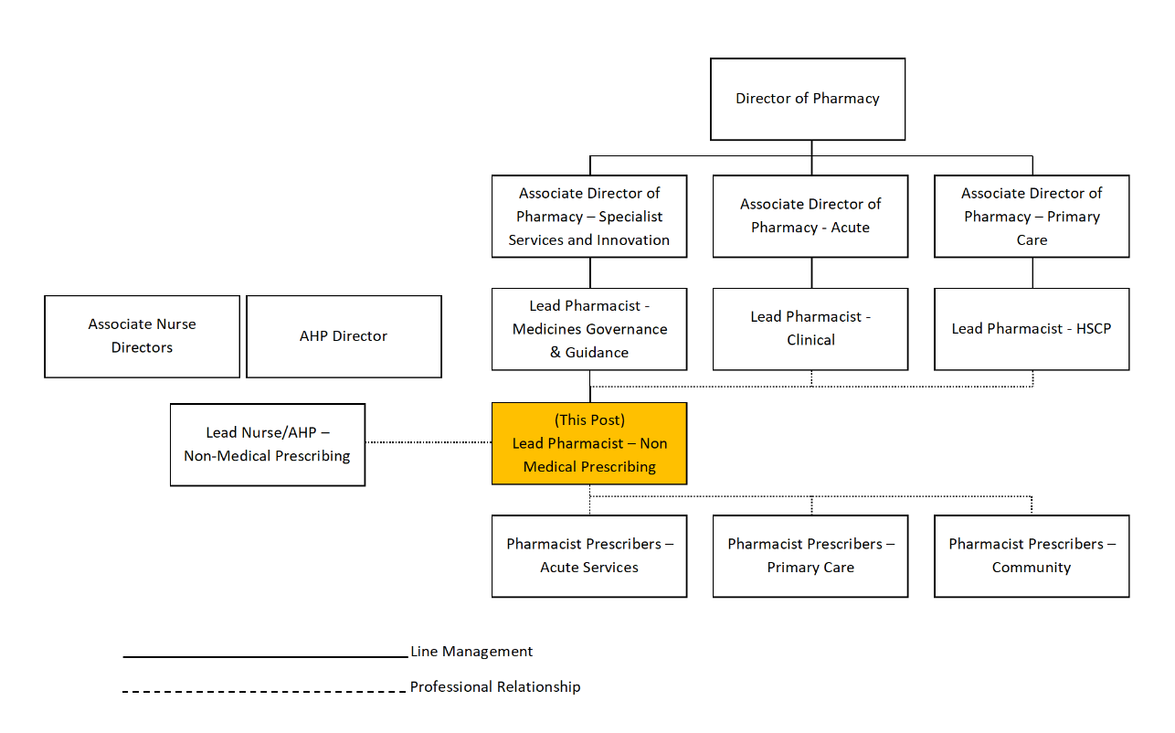

5. ROLE OF DEPARTMENT
The aim of the Pharmacy Service is to assure quality of patient care in the provision of treatment with medicines. To this end the objectives are:

- To provide pharmaceutical care to individual patients by meeting their particular needs while maximising efficiency in the use of resources.

- To provide medicines through systems of quality control which ensure safe, effective and economic use.

Clinical Pharmacy Services supports the achievement of the above objectives.

The mission statement of the NHS Lothian Pharmacy Service Strategic Plan 2021-2026 is to ensure that the medicines we supply are high quality, that the evidence to drive practice is robust and that we take care of our patients, our staff, and our colleagues. Our Pharmacy Leadership Team (PLT) have collectively agreed a programme approach to deliver our strategy across the single system pharmacy service. Our priority workstreams include: the remobilisation, recovery, and renewal of our services as we come out of the pandemic; the integration of our clinical pharmacy services; aseptic service transformation and ensuring our skill mix and recruitment of team members is optimised.
Common to all these workstreams are our intentions to ensure Pharmacists and Pharmacy Technicians, who work in a wide range of settings, are working at the very top of their skill level, delivering advanced clinical practice including independent prescribing.

The Pharmacy Department has a major role in the teaching and professional development of pharmacists and pharmacy technicians and other healthcare staff.

6. KEY RESULT AREAS
- To support NHS Lothian’s values of quality, teamwork, care and compassion, dignity and respect, openness, honesty, and responsibility through the application of appropriate behaviours and attitudes.

Non-Medical Prescribing
- Lead and influence the development, implementation, and evaluation of pharmacist non-medical prescribing by working with Site Lead and Lead Clinical Pharmacists across Primary, Community and Secondary Care to progress the delivery of clinical services within NHS Lothian in line with local and national strategies and delivery plans.

- Providing expert pharmaceutical advice and leadership to healthcare practitioners, managers, GPs and clinical leads relating to the supply and administration of medicines under the directions of a Patient Group Direction (PGD). For example, ensuring appropriate policies and procedures for non-medical prescribing and Patient Group Directions are developed and reviewed by multi professional groups and appropriate existing committees. Specifically, to chair the PGD Sub-Group of the Lothian Area Drugs and Therapeutics Committee (ADTC). Ensure provision of specialist professional input to appropriate sub-committees of the ADTC.

- To maintain up to date knowledge and skills regarding professional codes of practice for all professionals qualified to supply, administer and prescribe, use expert professional knowledge to advise professional leaders, senior management, and prescribers, developing and implementing policies and guidelines to ensure the safe, clinical, and cost-effective use of medicines ensuring compliance with all relevant UK Medicines legislation.

- Provide professional support and resources that enable Site Lead Pharmacists and Lead Clinical Pharmacists in primary care and acute directorates to support the non-medical prescribers within their service areas. For example, provide strategic professional and prescribing expertise and advice to multi-professional meetings. Meetings may be at board level reporting on non-medical prescribing implementation, governance, and service improvements or at local level to ensure partnership and inclusion for service improvements or change.

- Represent NHS Lothian on appropriate national and regional level professional groups, contributing to the development of national and local guidelines, frameworks, and policies. For example, co-lead with the NMP Lead Nurse/AHP, the review and publication of the NHS Lothian Non- Medical Prescribing Framework through engagement with all key stakeholders.

- In conjunction with the Lead Nurse/AHP Non-Medical Prescribing, plan, develop, implement and evaluate education and training for the multi-disciplinary team, including pharmacy and nursing staff, in relation to safe, clinical and cost-effective prescribing and application of medicines legislation. Ensuring a range of appropriate sources of support are in place for nonmedical prescribers to enable them to identify and meet ongoing development needs.

Advanced Clinical Practice (50%)

- Works autonomously as an Advanced Pharmacist Practitioner undertaking assessment, history taking, examination, treatment, request/interpret/undertake tests, full comprehensive documentation, prescribe medication within the role of an independent non-medical prescriber.

- Responsible and accountable for the assessment of patients with acute and/or long-term conditions and for decisions about the clinical management, including prescribing. Post holder will employ advanced clinical skills to support their prescribing decision and ongoing monitoring for example: physical examination with competence or requesting / monitoring blood results, phlebotomy as required, and ongoing relevant monitoring to be followed up as part of the medication review process e.g. spirometry, PEFR, BP urinalysis.

- To lead and direct the clinical pharmacy activities when delivering a specialist pharmacy service in own area of practice, including, establishing and resolving individual patient pharmaceutical care issues and providing expert pharmacy advice with the aim of ensuring safe and effective use of medicines e.g.

Systematic approach to individual patient care: - Take account of patient and medication risk factors when assessing the patient to confirm pharmaceutical needs, and to identify, assess and prioritise pharmaceutical care issues. Medication history taking, medicines reconciliation, prescription monitoring, consulting case notes and liaising with patients, carers and other healthcare professionals will all contribute to the process of assessment.
- Therapeutic drug monitoring (TDM): - For patients prescribed medicines with a narrow therapeutic index assess their individual dosage needs and monitor treatment. Advise on dosage adjustment when required.
- Adverse drug reactions (ADR): -Monitor patients for adverse reactions or unexpected events related to their medication. Investigate and report suspected adverse effects to the MHRA. Ensure that details of any ADR and hypersensitivity reactions are documented under the hypersensitivity section of the case notes, the prescription and administration record and immediate discharge letter. Discuss the findings of the investigation and any necessary future avoidance with the patient.

- Responsible for individual actions within a clinical pharmacy team. Providing an advanced clinical pharmacy service in the delivery of quality pharmaceutical care and efficient patient flow within the specialist area. Factors to be considered (dependent on area of practice) include; medicines reconciliation; patient education, adherence to medication regimen; seamless care; clinically checking prescriptions; review of patients own medicines for return to patient or destruction; named patient medication.

- To lead in multidisciplinary working groups to develop and implement protocols, guidelines, patient group directions and to train relevant staff in their use. Also participate in guideline development at a national level when required.

7a. EQUIPMENT AND MACHINERY
The following are examples of equipment which will be used when undertaking the role.
IT keyboard
Presentation equipment
Office equipment, telephone, scanner, photocopier, printer etc

Equipment to support the delivery of clinical skills (incl. stethoscope, sphygmomanometer, blood glucose testing meter, finger pricker).

Demonstration of medical devices e.g. inhalers, spacers, injection devices.

Note: New equipment may be introduced as the organisation and technology develops, however training will be provided.
7b. SYSTEMS
The following are examples of systems which will be used when undertaking the role:
The post-holder will utilise the following resources on a regular basis:
PRISMS /PIS / HEPMA will be used to generate prescribing reports.
Microsoft Office, i.e., Word, Excel, Access and Powerpoint will be used regularly, e.g., to analyse data from PRISMS / PIS / HEPMA, maintain register and database of NMPs, create reports for a wider audience, present to a wide range of audiences.
The internet, e-library and medicines information databases will be used to effectively source specialised medicines related information e.g., Medline
Professional registration databases and websites for standards codes of practice and ethics to ensure professionals have correct registration and meet standards.
E-mail will be used to communicate quickly and effectively daily.
Have a working knowledge of clinical equipment used by staff, e.g., AED equipment, syringe drivers, glucose meters, peak flow meters, sphygmomanometers etc
Note: New systems may be introduced as the organisation and technology develops, however training will be provided.

8. ASSIGNMENT AND REVIEW OF WORK
The post holder will be subject to formal annual review by the Lead Pharmacist – Medicines Governance and Guidance.

The post-holder is an advanced, autonomous, independent practitioner who is responsible for managing their workload guided by local and national policies and principles.

9. DECISIONS AND JUDGEMENTS
To act as a role model and provide expert professional advice on the safe and effective use of medicines. This will often involve analysis of highly complex clinical situations, including evaluation of management options before decisions are made. For example, the decision to prescribe medicines otherwise than in accordance with their product license, where licensed alternatives are not available and a risk assessment has been undertaken to determine the risks versus benefits of using an unlicensed formulation.
To interpret clinical evidence and individual patient information and then prescribe medicines as an independent prescriber for identified patients.
To critically appraise, communicate, negotiate and influence to promote the safe, appropriate, cost effective and evidence-based use of medicines in clinical practice.
Use expert knowledge, skills and judgement to manage conflicting opinions and evidence, and advise on solutions when there is a lack of information or insufficient evidence. For example, taking the decision to de-prescribe medication for a patient with multi-morbidity and polypharmacy, when the risks of continuing therapy outweigh the benefits the patient may derive from it.
To interpret service strategies, policies, professional standards and legislation that determine the delivery of non-medical prescribing care to patients and the safe and effective use of medicines. These strategies, policies, standards and legislation will have an impact across multiple hospital sites and care settings. The post-holder has significant discretion to modify these policies and principles as required according to need. For example, the post holder will be expected to regularly update the Non-Medical Prescribing framework in line with national developments, and to present this to the relevant medicines governance committee (ADTC) for approval.
Judgements must be made on a regular basis involving overall NMP and medication supply and administration issues including priorities for clinical governance.
To advise managers on NMP service levels and priorities using professional judgement and negotiation with senior managers. For example, to advocate for and negotiate the application of policy within a care setting not currently utilising the skills of the Non-Medical Prescriber i.e. community pharmacies.

10. MOST CHALLENGING/DIFFICULT PARTS OF THE JOB
Ensuring effective communication regarding complex legislation and systems for administration and supply with the pharmacy leadership team and the medicines governance committees of NHS Lothian.

Communicating information which the recipient may not agree with. Opinions may be divided any information may be sparse. Negotiate consensus view. For example, staff caring for patients in a care home may not agree with the decision not to treat a patients infection. Evidence will inform the joint decision making.
Difficulties in communicating across boundaries to many different groups of people where communication channels have not been established.
Team members working across acute and primary care may have other responsibilities.
Conflicting priorities of differing staff groups. Negotiation skills may be necessary.
Based on communications across community and acute various opinion will emerge.
The post-holder will be required to manage, analyse and act professionally when faced with difficult and ambiguous problems.

11. COMMUNICATIONS AND RELATIONSHIPS
The post holder will build strong, collaborative relationships across the health and social care system. The post holder will regularly produce written work and present this to local, regional and national meetings and have to defend recommendations when constructively challenged. The post holder will be empathetic in their communication style, particularly when communicating and imparting information to patients.
Key relationships to be formed are with;
Consultants, GP’s and other grades of doctors, and nursing staff i.e., reviewing, approving and publishing PGD, PSDs and NMP ensuring safe and effective administration of medicines
Patients and their carers i.e., Pharmaceutical Care activities including face to face and telephone assessment of pharmaceutical needs, counselling, facilitating joint decision-making based on prescribing decisions and advising ongoing care and monitoring including side effects and interactions.
Senior clinical management team (incl. General Manager, Clinical Director, Clinical Services Manager, Directors of Nursing, heads and leads of NMAHPs, clinical pharmacy directorate / HSCP leads) i.e., report writing, presenting papers orally and submission for meetings. Creating SBAR, risk assessments and escalating issues appropriately.
Audit Scotland, QIS, Scottish Government and Professional registering organisations (incl. NMC, GPhC, HPC) i.e., Influencing policy direction by active participation in stakeholder events and submitting feedback on national consultations on behalf of Lothian.
Other Health Service managers, Higher Educational Institutes (HEI), Regional and National Bodies (incl. Managed Clinical networks, Expert panels), i.e., to negotiate and advocate for the advancement of Pharmacist NMP and bid for funding and resources to support this work.
Multi-disciplinary health and social care team (incl. GP’s, community pharmacists, district nurses) i.e., to effectively communicate verbally and in writing to support good clinical decision making and for the provision of pharmaceutical care. This may include discharge planning and negotiating a package of care for a patient.
Pharmacy and other NMP peers locally and nationally i.e., to build coalitions and actively contribute to national professional groups by meeting and collaborating for the advancement of pharmacy NMP.
12. PHYSICAL, MENTAL, EMOTIONAL AND ENVIRONMENTAL DEMANDS OF THE JOB
Physical:
Computer skills and database work on a daily basis.
Mental:
Concentration on specific tasks ensuring accuracy with numbers. Working to timelines for strategic papers and action.
Unpredictable workload, frequent interruptions and reprioritisation required e.g., responding to urgent requests for advice.
Clinical work requires a high level of concentration, characterised by assessment of information, sometimes conflicting, from a variety of sources and forming a clinical opinion. Such work is often conducted under time pressure and subject to frequent interruptions from members of the wider healthcare team, for example you may be working on a busy ward area, pharmacy dispensary or within a GP practice, where others will seek your opinion or assistance urgently.
Emotional:
Manage and reconcile conflicting opinions in situations that are complex, sensitive or contentious e.g. decisions to prescribe treatment or to withdraw treatments in palliative care situations.
Frequent contact with patients and relative / carers which can be emotionally demanding i.e., provides advice and guidance to patients on medication regimens that require explanation and reassurance.
Environmental:
Whilst having a base, expectation would be to work in various settings within NHS Lothian, all of these will vary in size and equipment.
Travelling to various stakeholders across Lothian

13. KNOWLEDGE, TRAINING AND EXPERIENCE REQUIRED TO DO THE JOB
Qualifications and Knowledge
Masters degree in pharmacy or equivalent.
Registration with the General Pharmaceutical Council.
Postgraduate qualification in clinical pharmacy or equivalent.
Post-registration clinical pharmacy practice experience.
Annotated as an independent prescriber on the General Pharmaceutical Council register.

Skills and Experience
Good interpersonal skills
Good communication skills including verbal, written and formal presentations.
Good numeracy skills.
Standard keyboard skills and knowledge of Microsoft office packages.
Experience of planning, delivering and reporting audit and research projects.
Experience of planning, delivering and assessing teaching.
Experience of service development and staff management.

14. JOB DESCRIPTION AGREEMENT
A separate job description will need to be signed off by each job holder to whom the job description applies.  Job Holder’s Signature:  Head. of Department Signature: | Date:  Date:

