NHS Ayrshire & Arran JOB DESCRIPTION



|  |  |
| --- | --- |
| 1. JOB IDENTIFICATION | |
| Job Title: | Senior Pharmacist - Electronic Prescribing and Clinical Assessment Unit (CAU) |
| Department(s): | Pharmacy Department, Crosshouse Hospital |
| Job Reference Number (coded): |  |
| 2. JOB PURPOSE   * To apply expert pharmaceutical knowledge to ensure the clinical safety of the Hospital Electronic Prescribing and Medicines Administration system (HEPMA) in association with the HEPMA team and   contribute to future implementations of the system within NHS Ayrshire & Arran   * To participate in the development and implementation of higher level HEPMA clinical functionality * To contribute to the wider development and improvement of pharmaceutical services to inpatients and out patients * To be accountable for the safe and cost effective use of medicines within areas of practice | |
| 3. DIMENSIONS     * Based within University Hospital Crosshouse the post holder has an area wide responsibility for the clinical risk and safety aspects of the Hospital Electronic Prescribing and Medicines Administration system at all NHS Ayrshire & Arran hospital sites, working as part of the HEPMA team. * Undertakes extended prescribing in accordance with legislation * Supervises and trains pharmacists, pre-registration pharmacists or undergraduates rotating through relevant clinical areas * Provides clinical pharmacy cover for other patient groups or clinical specialties when required. This may include provision of a clinical pharmacy service to outpatient clinics e.g. anticoagulation * In addition to the specific responsibilities outlined in this job description, the post holder will be expected to fulfil each of the basic pharmacist competencies required as part of registration with the General Pharmaceutical Council. The post holder will be required to act at all times in accordance with medicines and Health & Safety legislation (e.g. Medicines Act 1968, Misuse of Drugs Act 1971, Poisons Act 1972, and Control of Substances Hazardous to Health Regulations 2002) and professional standards as outlined by the General Pharmaceutical Council. | |

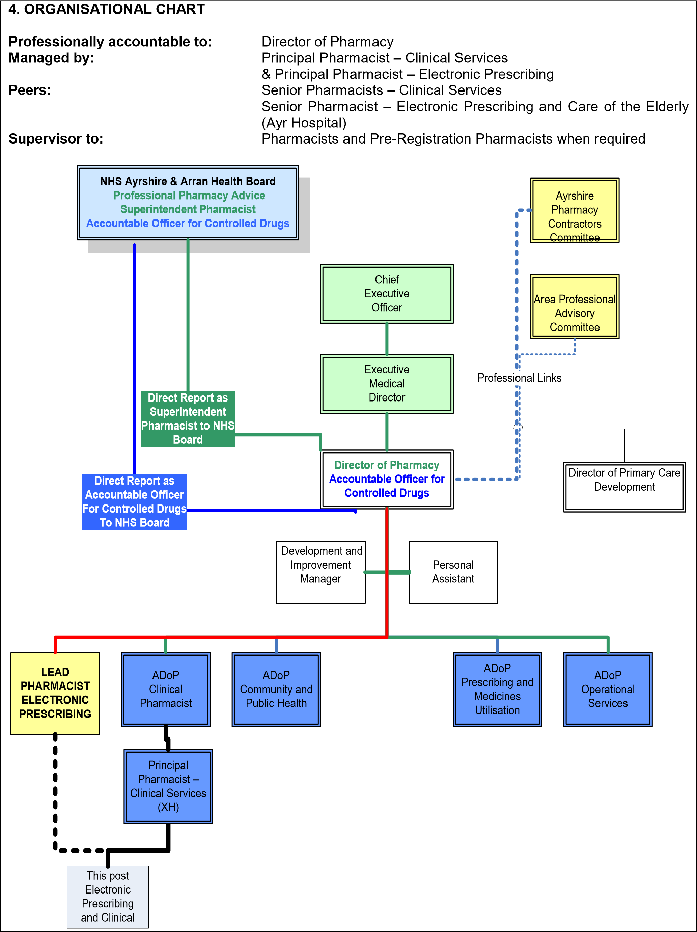

|  |
| --- |
| 5. ROLE OF THE DEPARTMENT    The function of the pharmacy service is to develop and deliver integrated patient focused pharmaceutical care, which meets the present and anticipated needs of the population of NHS Ayrshire & Arran in accordance with the Local Health Plan and national strategies. The intention of the service is to link all branches of the profession in order to better co-ordinate pharmaceutical care for patients and members of the public. The focus is on active participation in and contribution to multi disciplinary, multi professional and multi agency teams in a fully integrated manner. The main responsibilities are :     * The development and operational delivery (managed services) of pharmaceutical care across NHS Ayrshire & Arran * The provision of expert advice on pharmaceutical matters to the NHS Board, Healthcare Directorates, senior managers and prescribers * The provision of support regarding the development of Community Pharmacy * The implementation of robust clinical, corporate and staff governance systems to minimise risk and assure patient and staff safety and well being * The promotion of safe and cost effective prescribing taking into account the clinical needs of individual patients * The integration of services based on patients and integrated care pathways not boundaries * The provision of support for the work of the Drug & Therapeutics Committees including the provision of educational support to a wide audience * Ensuring that all aspects of the managed service comply with all statutory and quality standards |
| 6. MAIN DUTIES & RESPONSIBILITIES    Planning and Organisation   * To participate in the implementation and roll out of the Hospital Electronic Prescribing and Medicines Administration system to all hospital sites within NHS Ayrshire & Arran. * To participate in the development and implementation of higher level HEPMA clinical functionality. * To deliver, develop and evaluate a clinical pharmacy service to relevant areas in line with local strategies, policies and procedures to ensure optimum patient care. * To provide highly specialised advice regarding the clinical use of medicines within the CAU. * To implement and monitor policies and procedures within the clinical pharmacy service to ensure service quality and safe working practice, complying with all relevant standards and legislation included in the General Pharmaceutical Council Code of Ethics and Practice. * To participate in the development and maintenance of policies and procedures within the clinical pharmacy service. * To participate in the wider development of the hospital pharmacy service by identifying areas for improvement and developing suggestions for change * To implement and monitor relevant policies and procedures in conjunction with the consultants, senior nursing staff and other allied health professionals to ensure evidence based and safe working practice, complying with all relevant standards and legislation and in accordance with agreed objectives. * To assist the Principal Pharmacist – Clinical Services in service planning for the pharmacy service taking into account national and local strategies and guidelines. * To participate in local and where required national and regional groups involved in the pharmaceutical care of patients. * To work collaboratively with senior pharmacy and medical staff, the multidisciplinary team ensuring that issues related to the pharmaceutical care of patients attending the CAU are appropriately represented. Resource Management * To supervise junior clinical pharmacists and technical staff rotating through relevant clinical areas as allocated by the Principal Pharmacist - Clinical Services. This includes prioritising and allocating work and tasks based on patient need, on a day-to-day basis to ensure the continuity of the clinical pharmacy service. |

|  |
| --- |
| * To monitor expenditure and drug utilisation trends within the clinical area, highlighting areas of concern to the Principal Pharmacist, Clinical Services * To implement policies and procedures for monitoring the use of medicines, identifying areas for cost improvement, promoting formulary management and good prescribing practice * To implement the managed entry of new medicines according to the agreed policy thus contributing to the overall management of the drug budget * To ensure the security of medicinal products in all settings including wards, clinics and the main pharmacy department     Clinical Practice     * To undertake a daily clinical commitment by providing highly specialised clinical pharmacy input to patients attending the CAU, participating in consultant-led ward rounds and multidisciplinary team meetings as appropriate. To ensure that the medicines prescribed are clinically appropriate, cost effective and safe for individual patients, i.e. reviewing prescriptions, identifying, resolving and preventing medicine related problems, devising, recording and maintaining pharmaceutical care plans, interpreting blood serum results where appropriate and advising patients and other healthcare staff on all aspects of medicines * To identify opportunities for extended prescribing by pharmacists and develop independent prescribing within the team linking with other healthcare practitioners as required * To act as an independent pharmacist prescriber in areas identified. To be responsible and accountable for the assessment of patients with undiagnosed and diagnosed conditions and for decisions about the clinical management, including prescribing * To report medication errors and participate in investigations as appropriate, to ensure that the risks associated with medicines are minimised * To improve pharmaceutical public health by identifying and preventing adverse drug reactions, reporting suspected adverse reactions on medicines to the Medicines and Healthcare Devices Regulatory Authority * To authorise the pharmaceutical aspects of unlicensed medicines as required having evaluated the evidence for the use of the medicine     Education and Training   * To participate in training of all professions (including medical, nursing and pharmacy staff) in the safe use of the HEPMA system * To participate in the development and implementation of training programmes for clinical pharmacy, to all grades of pharmacists e.g. undergraduates, pre-registration pharmacists and qualified pharmacists * To act as a tutor to those undertaking nationally recognised qualifications giving formal assessment where required * To identify and address any training needs to improve medicines management within the clinical area to support the wider education of healthcare staff e.g. medical and nursing staff * To counsel individual patients, groups of patients or carers regarding their medicines to improve understanding and optimise concordance     General   * To initiate, undertake, or guide others, in audit and research within their specified clinical speciality in line with the national standards and frameworks in order to maintain standards and develop the service e.g. pre-registration pharmacist projects, pharmacy technician projects, national and local audits * The post holder will be required to maintain a relevant pharmacy practice commitment, including dispensing and clinical pharmacy, depending on their own experience and service needs * To participate in departmental rotas and / or emergency duty according to service need, as outlined in the contract associated with this post * To implement all local policies and procedures in accordance with corporate, clinical and staff governance |

|  |
| --- |
| Information Systems     * To ensure that any risks associated with the Hospital Electronic Prescribing and Medicines Administration system are identified and managed to minimise risks to patients * To ensure the correct links are implemented within the HEPMA system to ensure the system alerts are accurate. * To work with clinicians to develop treatment protocols and input and test them prior to implementation, linking with Medicines Information and the Area Drug & Therapeutics Committee as required * To contribute to the development of clinical procedures with respect to HEPMA, working with the Lead Pharmacist – Clinical Services. * To assist in creating and carrying out a clinical test plan for new HEPMA system software releases and ensure adequate testing of new releases prior to general implementation. * To assist in dealing with all clinical and technical queries regarding the HEPMA system. * To act as the first point of contact for any clinical incidents within the system and to take the appropriate action to safeguard patient care. * To advise the Principal Pharmacist Electronic Prescribing immediately, or in their absence, the Lead Pharmacist – Ayr Hospital and Clinical Services, of all system non conformances, where patients could be put at any risk, and if required the HEPMA team members and Senior Clinical Pharmacists at the relevant site. * To assist in ensuring that a database of system non conformances is maintained, any non conformances being addressed with the supplier to satisfactory conclusion. * To work with HEPMA users to identify areas for system improvement and develop specifications for technological development * To assist in the roll out of the HEPMA system in association with the Principal Pharmacist – Electronic Prescribing linking with lead clinicians as required * To participate in the retrieval of information from the HEPMA system and writing reports when required. * To participate in a wider research agenda to identify the benefits of HEPMA in the clinical setting. |
| 7. SYSTEMS AND EQUIPMENT     * Regular use of JAC pharmacy stock control and dispensary computer system and hospital electronic prescribing and medicines administration systems to input and retrieve information in connection with clinical and dispensing practice and to produce management reports. * Regular use of the NHS Ayrshire and Arran Intranet to access laboratory reports for individual patients. * Regular use of Business Objects. * Regular use of Microsoft Office computer software for email and internet enquiries, word processing of reports and policies, producing spreadsheets of management information and statistics and PowerPoint for presentations to staff. * Acts as key holder, performs security checks, sets and deactivates department intruder alarm when required. |
| 8. ASSIGNMENT AND REVIEW OF WORK    The post-holder is managed by the Principal Pharmacist – Clinical Services with respect to Clinical Pharmacy and Principal Pharmacist – Electronic Prescribing with respect to HEPMA.   * Works autonomously against objectives agreed with the Principal Pharmacist – Electronic Prescribing (HEPMA) and the Principal Pharmacist – Clinical Services (Clinical Pharmacy) * Workload will be largely self-generated, influenced by HEPMA objectives, patient needs, service needs and the local clinical pharmacy strategy. * Accountable for own professional actions and outcomes - guided by legislation, local protocols, procedures and the local formulary. * Accountable for personal decisions taken regarding individual patients in the course of managing their care and for decisions regarding the safety of the HEPMA system * To plan and prioritise own workload and that of junior pharmacists rotating through the speciality to meet patient needs. * The Principal Pharmacist – Clinical Services / Principal Pharmacist – Electronic Prescribing carries out formal performance review meetings for this post. * The job description is subject to review by mutual agreement between management and the post holder. |
| 9. DECISIONS AND JUDGEMENTS     * The post holder will be expected to assure the safe operation of the HEPMA system by analysing a complex range of information including software specifications and programmed logic ensuring that the technical aspects of the system recognise human behaviour and implied human logic. * The post holder will be expected to exercise their own discretion on how to provide and develop the clinical pharmacy service to their specified clinical area taking account of local and national policies. * The post holder is expected to anticipate problems/needs and resolve these in a proactive independent manner * Decisions made may be complex, e.g. the calculation of doses based on surface area, the use of unlicensed medicines for individual patients, where there may be limited or only anecdotal information on which to base a decision to treat. * The post holder is professionally accountable for his/her own actions in advising and influencing nurses, medical staff and other healthcare professionals regarding the treatment of individual patients on a daily basis e.g. monitoring and adjusting doses for drugs with a narrow therapeutic index or in patients with renal impairment. |

|  |
| --- |
| 10. COMMUNICATIONS AND RELATIONSHIPS     * The post holder will be expected to communicate with, and influence a range of healthcare staff regarding the implementation of new technology, where there may be barriers to acceptance of the required change processes. * The post holder will be required to communicate directly with the software supplier regarding test plans and clinical system errors / incidents. Such exchanges may involve providing and receiving highly complex information to enable the linkage of clinical practice to computer logic. * The post holder is expected to communicate on a daily basis with medical staff, nursing staff and other healthcare staff using evaluated information to enable informed decisions about patient’s therapies * Negotiating and influencing skills are required when dealing with multi-professional teams where agreement and co-operation are required in order to achieve a satisfactory outcome * Presentation and mentoring skills at local level are necessary to fulfil the role of developing and supporting staff in an often stressful and changing environment. * Information received and communicated will often be complex, including the need to interpret and analyse drugs charts, patient information and clinical trial data in a rapidly changing research environment. * Regular contact with General Practitioners, community pharmacists, practice nurses and other healthcare workers in the community for the seamless pharmaceutical care of patients. * There will be daily contact with patients as individuals or in groups, regarding information about their medication, to be delivered in a manner that is easily comprehensible to those who may have a limited knowledge of the subject matter |
| Internal Communications External Communications   * Consultant Physicians General Practitioners * Consultant Anaesthetists Community Pharmacists * Senior Medical staff Healthcare workers in primary care * Consultant Surgeons Pharmacists in other Health Boards * Junior Doctors External IT Companies • Medical Students Other HEPMA users • Nursing Staff * Allied Health Professionals * Patients and their carers * Other Pharmacists and Technicians * eHealth staff |
| 11. MOST CHALLENGING / DIFFICULT PART OF THE JOB     * Balancing the two components of this job, clinical support for the Hospital Electronic Prescribing and Medicines Administration system and the clinical care of individual patients * Dealing with unpredictable patterns of work, often working to tight timescales, with frequent interruptions to ensure that each patient’s medication regimen is safe and appropriate for its intended purpose and is supplied on time, where there is sometimes limited information to guide decisions. * Challenging the decisions of consultant, other medical staff and practitioners from other professions to ensure that each patient’s medication regimen is evidence-based. * Balancing the demands of the specified clinical speciality and the HEPMA system implemented across multiple hospital sites to ensure continuity of service and the maintenance of patient safety. * Developing partnerships working between primary and secondary care * Keeping up to date with a rapidly changing knowledge base. |

|  |  |  |  |  |
| --- | --- | --- | --- | --- |
| 12. QUALIFICATIONS, KNOWLEDGE, SKILLS AND / OR EXPERIENCE      Qualifications | | Essential |  | Desirable |
| Masters of Pharmacy Degree or equivalent | |  |  |  |
| Scottish Hospital Pharmacy Vocational Training Scheme  (or demonstrable evidence of clinical knowledge equivalent to that level) | |  |  |  |
| Practice Certificate in Pharmacist Independent Prescribing | |  |  |  |
| Postgraduate Diploma in Clinical Pharmacy (for the HEPMA aspect see knowledge)  (or demonstrable evidence of clinical knowledge equivalent to that level) | |  |  |  |
| Member of the General Pharmaceutical Council (including evidence of CPD) | |  |  |  |
| Member of the Royal Pharmaceutical Society of Great Britain | |  |  |  |
| Experience  Relevant pharmacy experience with considerable experience in clinical pharmacy | |  |  |  |
| Full Driving Licence | |  |  |  |
| Approved tutor for pre-registration pharmacists or pharmacists /technicians undertaking further qualifications. | |  |  |  |
| Ability to work autonomously | |  |  |  |
| Ability to work effectively as part of a team, in a pharmacy and multi-disciplinary environment | |  |  |  |
| Knowledge  Required to demonstrate a highly specialised level of clinical pharmacy knowledge skills, clinical reasoning and judgement | |  |  |  |
| Good knowledge and understanding of relevant standards and guidelines | |  |  |  |
| Required to demonstrate an expert level of pharmacy information systems and their application to clinical practice equivalent to post graduate diploma level | | √ |  |  |
| Requires advanced arithmetic skills | | √ |  |  |
| Required to demonstrate a good understanding of Business Objects to develop information and reports | | √ |  |  |
| Critical Leadership behaviours   * Working in partnership * Learning and developing * Caring for staff * Improving performance through team working * Communication effectively * Improving quality * Achieving results | | √ |  |  |
| 13. WORKING ENVIRONMENT    PHYSICAL EFFORT / SKILLS:   * Computer keyboard skills used daily. * Driving required * Lifting and handling skills used occasionally to lift and move boxes and containers. * Standing for periods of time to perform checks on dispensed prescriptions. * Standing for periods of time on a daily basis while participating in the multidisciplinary ward rounds. * Standing or sitting in awkward positions on a daily basis for periods of time in the wards to input and retrieve clinical data at a patient’s bedside, notes trolley and computer terminals or mobile laptops.     MENTAL EFFORT / SKILLS:   * Understanding computer logic as it applies to human behaviour * Frequent periods of prolonged concentration required every day when reviewing prescribed medicines, counselling patients or performing checks on dispensed items where an undetected error could result in serious patient harm. * Required to concentrate continuously and apply mental attention at all times. * A high degree of speed, accuracy and attention to detail is expected in all duties. * Tasks are frequently interrupted to deal with queries or requests for advice that have to be dealt with immediately. * Requires confidence to contribute and lead in clinical settings. * High level of concentration required when carrying out complex calculations, analysing/interpreting complex data and interpreting or appraising reports or documents.     EMOTIONAL EFFORT / SKILLS:   * Frequent direct contact with patients, some of whom may be physically or emotionally distressed, aggressive or suffering from serious or terminal disease. * Conflicting demands and pressures from individuals.     WORKING CONDITIONS:   * Potential exposure to toxic pharmaceutical materials. * Occasional risk of verbal or physical abuse from patients or their relatives. * Frequent use of visual display units. * Frequent direct patient contact involving occasional exposure to environmental risk/ communicable diseases at ward level. | | | | |
| 14. JOB DESCRIPTION AGREEMENT      Job Holder’s Signature:      …………………………………..      Head of Department Signature:      …………………………………. | Date:      ………………………………….      Date:      ………………………………….. | | | |