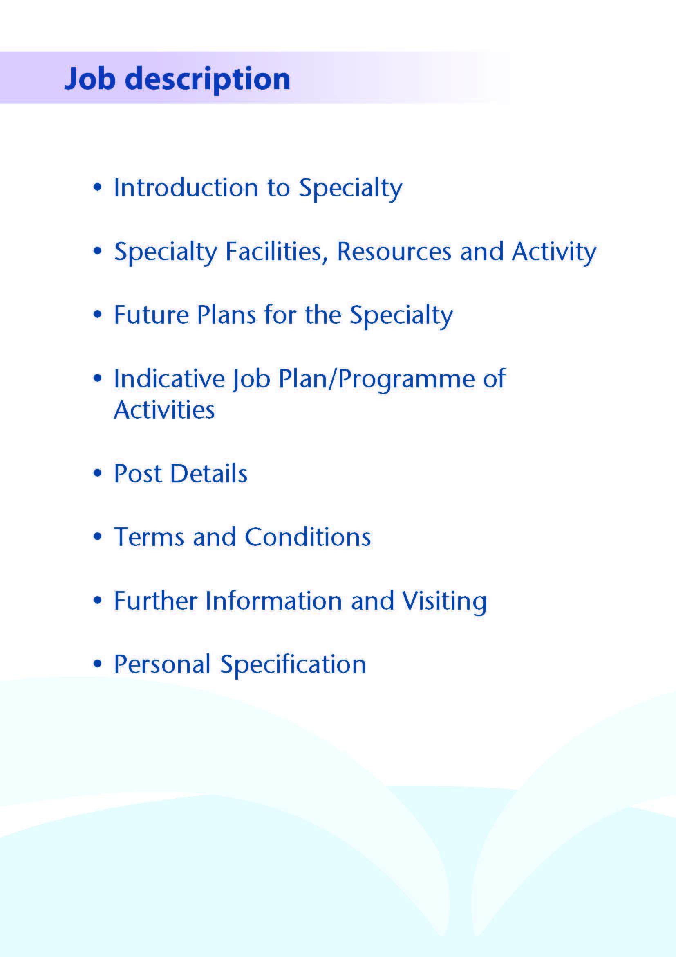



This post will be part of a team of 20 consultants within the Ayrshire and Arran Trauma and Orthopaedic Service which is delivered over two sites, University Hospital Crosshouse (UHC) and University Hospital Ayr (UHA). The trauma service is delivered from the UHC site with the inpatient elective service based at UHA. Outpatient clinics and day case/23 hour surgery procedures are delivered on both sites. All paediatric orthopaedic inpatient and day case surgery is delivered from the UHC site. NHS Ayrshire and Arran is also in the process of full business case development in relation to a National Treatment Centre focussing on Orthopaedics. Additional consultant posts will be recruited to support this Centre in due course.

The successful candidate will contribute to the on call on a 1:6 basis.

The successful candidate should have wide surgical experience and be on the Specialist Register in Trauma & Orthopaedic surgery. Candidates should offer a specialist interest that complements the current skillset of the Department.

University Hospital Ayr is a 250-bedded general hospital located to the south east of Ayr town in South Ayrshire. University Hospital Crosshouse is a 478 bedded general hospital located just outside Kilmarnock in East Ayrshire.

The post holder will work between hospitals, delivering all trauma from UHC. The elective component of the job will be provided on the UHA site for any inpatients. All other elements of the post can be delivered from either site to fit with the overall job plan.

Both Hospitals are easily accessed by road, with the M77 providing rapid access to Glasgow (30 minutes from Crosshouse Hospital, 45 minutes from the Ayr Hospital). Rail services also link both Kilmarnock and Ayr to Glasgow and other surrounding towns, and Prestwick Airport lies midway between both hospitals, approximately a 15 minute drive to each. Both Crosshouse Hospital and the Ayr Hospital provide free car parking facilities.

Ayrshire is able to provide excellent local education, competitively priced real estate and excellent leisure opportunities such as water sports, cycling and world class golf courses.



The Trauma & Orthopaedic Unit forms part of the Surgical Directorate. The Directorate is headed up by the Director of Acute Hospitals who is supported by Assistant Directors for each of the acute hospitals. There is also Associate Medical Director support for the surgical services. The management team also consists of general managers, clinical nurse managers and theatre management support. There is also excellent support from our Advanced Nurse Practitioners and Advanced Physiotherapy Practitioners.

The Trauma & Orthopaedic Directorate provides a comprehensive elective and emergency service to patients within a catchment population of 375,000. Within the current Consultant complement there are a range of subspecialty interests as noted below. Both hospitals provide personal office space with excellent Information Technology support and comprehensive secretarial support.

The Orthopaedic Services includes:

* Emergency and Elective inpatient care.
* Day Surgery treatment utilising day surgery theatres supported by a comprehensive nurse- led pre-operative assessment service currently being further expanded.
* Range of out-patient clinics.
* Advanced Physiotherapist Practitioner service, provided by experienced physiotherapy staff, Arthroplasty Specialist Nurse Service and Surgical First Assistants.
* Advanced Nurse Practitioner support for in-patient care on both sites.
* Trauma Co-ordinators
* Paediatric in-patient and day-case services.
* Management support for monthly audit meetings on a rolling half day basis as well as support for Continuing Professional Development.
* Rotational trainees from the West of Scotland Trauma & Orthopaedic Training Programme. Trainee feedback is very positive.
* eTrauma electronic trauma management software
* Orthopaedic Assessment Unit (OAU)
* At UHC there is a dedicated OAU co-located in the orthopaedic outpatient clinic. The unit is open on week days 09:00 – 20:00 and staffed by the on-call Orthopaedic team (Attending Consultant & Attending Registrar), an Advanced Physiotherapy Practitioner (APP) and an orthopaedic clinic nurse. It supports the delivery of unscheduled patient care with the ultimate goal of reducing avoidable admissions and unnecessary flow through the Emergency Department (ED).

|  |  |  |
| --- | --- | --- |
| No. of Facilities | UHC | UHA |
| Main Theatres (5 with laminar flow) | 8 | 6 plus an interventional theatre |
| Day Surgery Theatres | 3 | 3 |
| DSU Treatment Room | 1 | - |
| Endoscopy Procedure Rooms | 4 | 3 |

**Activity**

###### Annual Workload:

|  |  |  |  |  |  |
| --- | --- | --- | --- | --- | --- |
|  | Elective Inpatient Admission | Emergency Inpatient Admissions | Day case Admissions | New Outpatient Appointments | Return Outpatient Appointments |
| Based on 2022/23 | 920 | 2600 | 1630 | 13000 | 20250 |

The Department is well supported by the Physiotherapy and Occupational Therapy services.

# Imaging

An extensive range of imaging facilities are available including spiral CT with 3D reconstruction, MRI, MRA, radio-isotope facilities and digital subtraction angiography.

**Out-patient Services**

A good sized outpatients department is provided at both UHC and UHA where a range of general and specialist out-patient clinics are held.

**Outreach Services**

Outreach services are provided at Ayrshire Central Hospital, Irvine, East Ayrshire Hospital in Cumnock and Girvan Community Hospital. In addition a service is provided to the Arran War Memorial Hospital on the Isle of Arran.

**Emergency Department**

Currently both hospitals offer full Accident Emergency facilities through the two departments. Both are currently staffed by teams of Consultants in Emergency Medicine and Emergency Nurse Practitioners.

**Laboratory Services**

The Area Laboratory Service for the whole of Ayrshire is based at University Hospital Crosshouse and offers a comprehensive diagnostic biochemistry, haematology, microbiology and histopathology service.

# Medical Photography

The Medical Illustration Department can provide a full service at both hospitals for clinical photography, preparation of slides, PowerPoint etc, for lecture purposes.

# Education Centres

Excellent post-graduate facilities are provided at both hospitals, with the Alexander Fleming Education Centre based at UHC and the MacDonald Education Centre at UHA. Both centres include a full size lecture theatre, classrooms and a number of tutorial rooms. The facilities are supported with modern audio visual and information technology, including teleconferencing facilities, and both centres incorporate an excellent up-to-date library with a proactive resident librarian. More recently, the knowledge network resource has transformed access to medical publications. The patient management system, Trakcare, further enhances audit opportunity.

**3. Medical Staff Resources**

The medical staffing within the Unit is as follows:

|  |  |  |  |
| --- | --- | --- | --- |
| **Consultant Staff** | | **Specialist Interest** | |
| Mr B Syme, Joint Clinical Director | | Knee surgery | |
| Mr A Tanagho, Joint Clinical Director | | Shoulder surgery | |
| Mr K Young | | Lower limb arthroplasty | |
| Mr L Al-Mouazzen | | Knee surgery | |
| Mr K Cheng | | Shoulder surgery | |
| Mr M Foxworthy | | Lower limb arthroplasty | |
| Miss S Gibson | | Hand surgery | |
| Mr A Gilmour | | Knee surgery | |
| Mr G Holt | | Lower limb arthroplasty | |
| Mr K Kailash | | Hip surgery | |
| Miss J McMillan | | Knee surgery | |
| Mr E O’Flaherty | | Shoulder surgery | |
| Mr N Obi | | Foot and ankle surgery | |
| Mr J Press | | Lower limb arthroplasty | |
| Mr A Ross | | Hip surgery | |
| Mr D Russell | | Lower limb arthroplasty | |
| Miss R Short | | Paediatric orthopaedic surgery | |
| Mr B Thomas | | Elbow and hand surgery | |
| Mr K Young | | Lower limb arthroplasty | |
| Mr P Young | | Lower limb arthroplasty/MSK oncology | |
|  |  | |
| **Associate Specialist** | | **Specialist Interest** | |
| Mr K David-West | | Foot & ankle surgery | |
| Mr B Shrestha | | Lower limb arthroplasty | |
|  | |  | |
| **Specialty Doctor** | | **Specialist Interest** | |
| Mr T Weerasuriya | |  | |
| Mr S Sett | |  | |
| Mr Z Alhag | |  | |
| Mr V Jayasankar | |  | |

**Junior Medical Staff (current)**

6 x ST3 – ST8

2 x ST1 – ST2

1 x Core Trainee

5 x FY2

6 x CDF

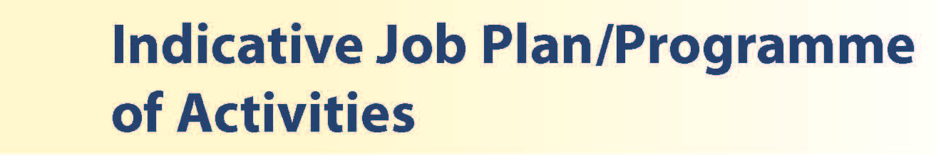

A representative weekly programme is shown below. Activities with current fixed time commitments will be carried out as detailed in the work programme. Other DCC and SPA activities are shown with indicative timings within the weekly programme and will be discussed with the appointee. This timetable will be reviewed three months following appointment and should therefore be regarded as an interim programme. Opportunities exist for Extra Programmed Activities to be undertaken subject to service requirements and in accordance with national terms and conditions of service.

The job plan is offered on the basis of 8 direct clinical care sessions (DCC) and 2 supporting professional activity (SPA) sessions. On appointment the Clinical Director will review the job plan with the post holder and will discuss any additional delegated duties in respect of SPA, and allocated SPA sessions may be reviewed accordingly.

**Indicative Job Plan – Core 10 PA Programme**

|  |  |
| --- | --- |
|  | Number of Professional Activities per week |
| SPA | 2 |
| Admin | 1 |
| Elective Clinic | 0.8 |
| Fracture Clinic | 0.8 |
| Operating Theatre including post op ward review | 1.8 |
| Trauma Attending | 1.2 |
| Trauma Theatre | 2.2 |
| Unpredictable emergency Work | 0.2 |
| Total | 10 PAs |

Additional programme activity may be available if desired.

The elective duties would typically be scheduled on non-trauma related weeks. All elective work is cancelled during attending and trauma theatre weeks. Provision of elective theatre and clinic sessions will be based in UHC or UHA depending on subspecialty.

**Notes on the Programme**

**Patient Administration**

This activity covers the management of individual patients including Out Patient administration, results reporting, letters/phone calls to patients, carers, GP’S and members of the wider multidisciplinary team involved in the patients care.

**Ward Rounds**

The time allocated is indicative and will be discussed with the appointee. Ward work will include teaching ward rounds as required.

**Travel**

Any travel allocation will be included within the Total Programmed Activities and will be determined by location at which Direct Clinical Care and Supporting Professional activities are carried out.

**On call arrangements**

1:6 on call basis.

**Supporting Professional Activities**

NHS Ayrshire and Arran recognise the important role Job Planning has in ensuring consultants are supported in delivering high quality, safe, sustainable clinical care to patients. It is therefore important to ensure there is an adequate balance between direct clinical care activities and activities which support both the personal and professional development of the consultant workforce and facilitates agreed contribution to activities including:

* Under and post graduate teaching/training
* Clinical Governance
* Quality and Patient Safety
* Research and Innovation
* Service management and planning
* Work with professional bodies

All consultants will have 2 SPA sessions to support job planning, appraisal and revalidation with the final balance of SPA to be agreed between the appointee and clinical manager prior to contracts being agreed.

There may be a requirement to vary the DCC outlined in the indicative timetable below when the final balance of DCC and SPA is subsequently agreed. There may also be opportunities to contract for Extra Programmed activities Opportunities subject to service requirements and in accordance with national terms and conditions of service.

If the post-holder will be responsible for the formal training and supervision of post-graduates and under-graduates, a suitable additional allocation of SPA time will be made in accordance with national guidance.

**Job Plan Review**

New appointees will discuss the indicative job plan with the Clinical Director, prior to commencement and will at that time review the balance of activities. Where it is possible to agree a revisions to the indicative plan in advance of commencement this will be acted upon. In any event however, there must be an interim Job Plan review conducted at 3 months post commencement to agree and finalise the Job Plan. The consultant at time of induction should ask for an interim review date to be scheduled. The agreed job plan will include all the consultant’s professional duties and commitments, including agreed Supporting Professional Activities.    Thereafter Job Planning will be carried out annually as part of the Boards Job Planning process.

**Private Practice**

If the post-holder wishes to undertake any private practice, they are obliged to inform their employer at the time of appointment of their intentions to do so. This should be submitted in writing to the Clinical Director. The conduct of private practice will be in accordance with the Consultant Contract (Scotland) Terms and Conditions.

The post-holder shall be free to undertake private practice without approval provided such work is undertaken outside the time agreed in the job plan for programmed activities. (Refer Section 6 of the New Consultant Contract).



The post holder will be accountable to the Clinical Directors who will agree the Job Plan.

He/she will be expected to work with local managers and professional colleagues in the efficient running of services and will share with Consultant colleagues in the medical contribution to management. Subject to the provisions of the Terms and Conditions of Service, he/she is expected to observe the Organisation’s agreed policies and procedures, drawn up in consultation with the profession on clinical matters, and to follow the standing orders and financial instructions of NHS Ayrshire & Arran.

In particular, where he/she formally manages employees of NHS Ayrshire and Arran, the post-holder will be expected to follow the Local and National Employment and Personnel Policies and Procedures.

He/she will be expected to make sure that there are adequate arrangements for hospital staff involved in the care of patients to be able to make contact with the post-holder when necessary.

The post-holder is required to comply with the Organisational Health and Safety Policies.

He/she will be responsible for the training and supervision of Junior Medical Staff who work with the post-holder and will be expected to devote time to this activity on a regular basis. In addition, he/she will be expected to ensure that Junior Staff have access to advice and counselling. If appropriate, the post-holder will be named in the Contracts of Doctors in training grades as the person responsible for overseeing their training, and as the initial source of advice to such Doctors on their career.

**Resources**

The staff resources of the Directorate are listed elsewhere. The post-holder will have access to such general administrative support as is required for the discharge of his/her duties and responsibilities.

This will include the provision of adequate secretarial and clerical support and the availability of accommodation, equipment etc.

The post-holder will receive support from such other professional staff as are employed within the Organisation and are deployed to his/her area of patient care.

**Duties and Responsibilities**

The main duties and responsibilities of the post include:

* Responsibilities for carrying out teaching, accreditation and examination duties as required, and for contributing to undergraduate andpostgraduate medical education. The post-holder will be expected to comply with College recommendations on Continuing Medical Education.
* The post-holder will be required to comply with Organisational Policies on Clinical Governance.
* The successful applicant will be encouraged to participate in research and to develop a relevant subspecialty interest, subject to resources and local priorities.
* Requirements to participate in medical audit and in continuing medical education.
* Managerial, including budgetary, responsibilities (where appropriate).

**Annual Appraisal & Job Planning**

You shall also be required to participate in annual appraisal. Job planning is linked closely with, but is separate to, the agreed appraisal scheme for consultants. The job plan review will take into account the outcome of the appraisal discussion and reflect the agreed personal development plan.



The Terms and Conditions of Service are those determined by the Terms and Conditions of the New Consultant Grade (Scotland) as amended from time to time. The distance that a consultant can reside from the principal base hospital, where travel time is seen as more important than mileage, is subject to the agreement of the Executive Medical Director, but it is usually anticipated that a journey that takes no more than 30 minutes for any emergency situation would be acceptable.



Applicants wishing further information about the post are invited to contact:

Mr B Syme, Clinical Director on Tel: 01563 825183 or Mr A Tanagho, Clinical Director on Tel: 01563 827333



**Post of**: Consultant Trauma & Orthopaedic Surgeon

**Location**: University Hospital, Ayr

## Qualifications:

|  |  |
| --- | --- |
| Essential | Desirable |
| Full GMC Registration with a current Licence to Practice  Royal College Membership/Fellowship (FRCS Tr &Orth.) |  |
| **Existing Consultants**: Inclusion on the GMC Specialist Register    **New Consultants**: Award of CCT / CESR, or be within 6 months of the anticipated award of CCT. | Evidence of Higher Specialty Training covering the breadth of Trauma & Orthopaedic Surgery |

**Skills/Knowledge/Competence**

|  |  |  |
| --- | --- | --- |
| **Requirements** | **Essential** | **Desirable** |
| General Experience: | -Specialist training in the diagnosis and management of patients presenting to the Department of Trauma & Orthopaedics.  -Knowledge of and skills relevant to the management of patients.  -Ability to communicate effectively with all levels of staff and patients  -Ability to work efficiently and timeously.  -IT literacy  -Specialist interest that complements the current skillset of the department | Specialist experience from an appropriate fellowship or equivalent |
| Teaching & Training | -Proven ability to deliver high quality teaching  - Interest in and knowledge of advances in medical education and training. |  |
| Team Working | -Effective team player |  |
| Development | -Evidence of sustained involvement in improvement activity |  |
| Research & Publications | -Evidence of commitment to audit & research throughout surgical career | -Evidence of peer reviewed publications of a high standard relating to Trauma & Orthopaedic surgery. |
| Clinical Audit | -Evidence of audit relating to surgical services, including a clear standard and loop closure. | -Peer reviewed publications and presentations relating to audit. |
| Management and Administration | -Commitment to effective departmental management and management of multi-disciplinary group  -Proven organisational skills | -Proven ability to lead a clinical team  -Proven management experience  -Understanding of resource management and quality assurance |
| Personal and Interpersonal  Skills | -Effective communicator and negotiator  -Demonstrate effective leadership  -A willingness to develop special interest which conforms to the needs of NHS Ayrshire & Arran  -Ability to operate on a variety of levels  -Knowledge of recent changes in the NHS in Scotland  -A willingness to accept flexibility to meet the changing needs of the NHS in Scotland. |  |