# recruitcover final2.jpg

**Job Title: Specialty Doctor**

**Location: Breast / General Radiology Department, Aberdeen Royal Infirmary**

**Ref No: PM162022**

**Closing Date: Sunday, 10 September 2023**

Aberdeen is a lively, cosmopolitan city located in the North East of Scotland. In the city, there are beautiful parks and gardens and superb beaches. Aberdeen city and surrounding towns across Aberdeenshire boast fantastic museums, theatres, galleries, bars and restaurants, and a variety of shopping, including unique family-run businesses.

*North East of Scotland – a great place to work and live*

There is a wide range of annual festivals across Grampian, from food and drink, music and arts and festivals celebrating local culture and traditions. There are excellent and varied schools within the city, Aberdeenshire and Moray, with a great range of housing to suit all tastes. There are strong public transport links and a modern comprehensive road network.

Aberdeen is a gateway to explore natural landscapes from the northeast coastline to beautiful Royal Deeside and the stunning Cairngorms National Park, with many Munros and Corbetts. The castle and whisky trails across the region make the northeast famous, and there is a wide range of outdoor leisure activities, such as hill walking, water sports and skiing. There are over 50 golf courses and excellent salmon and trout rivers.

Moray has many pleasant and unique characteristics, including a varied landscape ranging from the Moray Firth's shores to the Cairngorms' foothills. As well as breath-taking scenery Elgin has a strong cultural scene with wide and varied leisure options. Elgin is family orientated and offers a peaceful and calm quality of life.

Aberdeen's international airport is served by several major carriers providing an extensive network of routes throughout the UK, direct to Europe and worldwide through major hubs. There are good road and rail connections to the major Scottish cities of Edinburgh, Glasgow and Inverness.

***Patient care***

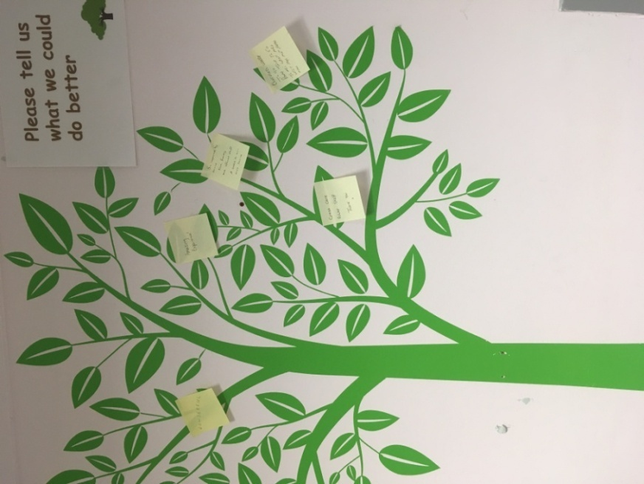The multi-disciplinary teams in NHS Grampian Radiology Breast Department and North East of Scotland Breast Screening service are very patient-centric. Our teams make all efforts to ensure that patients feel comfortable and confident, ensuring their care and dignity. We undertake patient satisfaction audits, which help with any service redesign and respect our patients' rights and responsibilities, underpinned by person-centred values.

We take all patient feedback seriously and consistently act on complaints and compliments, both within our department and through our Divisional Clinical Governance Group. This enables a drive towards service quality and improvement. This approach to our service provision is attractive to people who also carry these values and we are keen to appoint such individuals into our team.

*Future plans for NHS Grampian Radiology*

The Executive Team in Radiology are very ambitious. There is a common understanding that Radiology is at the heart of the hospital, and as such, we have a constant drive for further investment across all our staffing disciplines and capital. The major capital investment for a new Baird Family Hospital and ANCHOR Centre for Oncology and Haematology will improve patient care and augment patient imaging service. NHS Grampian is also pursuing major capital investment through the National Treatment Centre Programme, which will increase the imaging footprint with additional MRI, CT and improved x-ray facilities in Aberdeen, with plans underway for an MRI in Dr Gray's Hospital, Elgin. In addition, the Interventional Radiology suite has recently been updated with state-of-the-art equipment with further significant investment to enable departmental redesign. Replacement plans to follow for all modalities.

Value-based care for our patients and staff requires collaboration across all modalities and work streams. We work closely with our eHealth and Health Intelligence colleagues to interrogate our data and activity, producing evidence for increased funding applications and future projections, working on the capacity gap and workflow efficiencies. We also value the contributions from our collective workforce and encourage participation in our strategic planning via the modality groups and participatory events.

A workforce plan is in development to enhance our retention and recruitment plans. Staff development is a key driver for improving services, and all staff are encouraged to engage with the weekly CPD lecture programme and given time and space to pursue their professional interests.

A consortium between NHS Grampian, Aberdeen University, Scottish Government and industry partners was successful in the funding competition – *Creating a network of digital pathology, imaging and AI centres.* The iCAIRD (Industrial Centre for Artificial Intelligence Research in Digital Diagnostics) project was initiated in the autumn of 2018 to develop infrastructure to apply AI in digital diagnostics, pathology and radiology built upon existing national initiatives. iCAIRD is a significant platform for research and service development to which NHS Grampian is committed, and Radiology is playing a leading role. The breast service has worked with the NHS Grampian Innovation team in establishing a leading role for Aberdeen in breast artificial intelligence research with the large scale retrospective and prospective studies.

Potential candidates will be encouraged to identify areas within the Breast department where they can lead and develop, acting as a conduit between contemporary thinking and local good practice/

The Radiology Department has representation around national and regional strategic programmes and ensures that NHS Grampian are part of the decision-making processes.



The plans for the radiology department are developed in conjunction with staff and underpinned by service needs and evidence to provide the best imaging service for our patients.

.

# Picture

NHS Grampian is one of 10 principal Health Boards in Scotland. It provides healthcare services to approximately 600,000 people living in Grampian and additional provision to 50,000 people living in Orkney and Shetland. The organisation employs around 17,000 staff.

NHS Grampian has a status as the Major Trauma Centre for the North East of Scotland, and we expect significant investment to improve elective care within the National Treatment Centre programme with a new building and increased workforce. These are exciting times for Radiology as all these strategic local and national drivers will bring investment to the Radiology Department, improving services for our patients. In particular, we are keen to develop the Breast service in line with contemporary strategic drivers to provide the best service we can for our patients.

***NHS Grampian Radiology Department***

Radiology services are structured on a modality basis with Service Clinical Directors and Clinical leads reporting to the Unit Clinical Director, Dr Senthil Ragupathy (senthilkumar.arcotragupathy@nhs.scot) and Radiography manager and superintendent radiographers reporting to the Unit Operational Manager, Mrs Grace Ball (grace.ball2@nhs.scot). The main department is based in Aberdeen Royal Infirmary, with imaging sites across Grampian.

The **Grampian Breast service** hosts two high quality Hologic mammography units within the Radiology department with digital tomosynthesis, vacuum biopsy and excision services with MRI-guided biopsy and family history screening. The service is soon to offer contrast enhanced mammography and biopsy. MRI is performed on a Siemens 1.5T and Philips 3T scanner (mainly research). The service also has ultrasound scanners with elastography available from Canon, GE and Philips. The service is soon to start using artificial intelligence in ultrasound.

The post-holder will work in a team as a Specialty Doctor in Breast Radiology in both the symptomatic breast imaging service, which takes place in Aberdeen Royal Infirmary, and the Scottish Breast Screening Service subject to QA approval. The post holder will work within an established cohesive and supportive Breast multidisciplinary team and take part in Screening and Symptomatic MDT meetings. Subsequent to our planned move to Baird Family Hospital, NHS Grampian will embrace co-location of screening and symptomatic services. There are two mobile mammography and two further static units for the Screening Programme. The Breast team enjoy very good relationships with their referrers and wider medical speciality teams.

Breast Screening: The Breast Screening is commissioned by National Services Division for the North East of Scotland, Orkney and Shetland. Approximately 25,000 women are invited annually to attend for a mammogram either in Aberdeen Royal Infirmary or at a mobile unit.

Symptomatic Service: The Breast Service is a multidisciplinary service. Mammography is carried out by a Radiographer and reported by a Consultant Radiologist or Consultant Mammographer. Ultrasound and biopsies are carried out by either a Radiologist, Consultant Mammographer or advanced practitioners. Further support is provided by breast care nurses and Health Care Assistants.

**Aberdeen Royal Infirmary** is a teaching hospital affiliated with the University of Aberdeen, the oldest medical faculty in the English-speaking world and home to one of the top Undergraduate teaching programmes in the UK. NHSG Radiology has a well-established and successful teaching programme for UG trainees. NHS Grampian is also the base for the North of Scotland training scheme, and currently, it supports radiology Specialist Training for 27 trainees across Grampian and the Highlands. The post-holder will participate in teaching trainee radiologists and wider clinical teams and will be encouraged and supported to take on recognised trainer roles.

There are strong links to Aberdeen University via the imaging research wing (www.abdn.ac.uk/abic) and Robert Gordons University, encouraging links to the UK and European academic settings for collaborative research. There is a robust audit and research component to the department for all staff members, both independently and as part of the RADIANT group at the Royal College of Radiologists. The post-holder will be encouraged to be part of the research and audit activities associated to Breast and will benefit from considerable research infrastructure and research management expertise.

The service is active in multiple research projects in breast surgery, oncology and imaging including advanced research in new MRI technologies such as fast field cycling. Further imaging research activities including the practical application of artificial intelligence in ultrasound, contrast mammography and MRI.

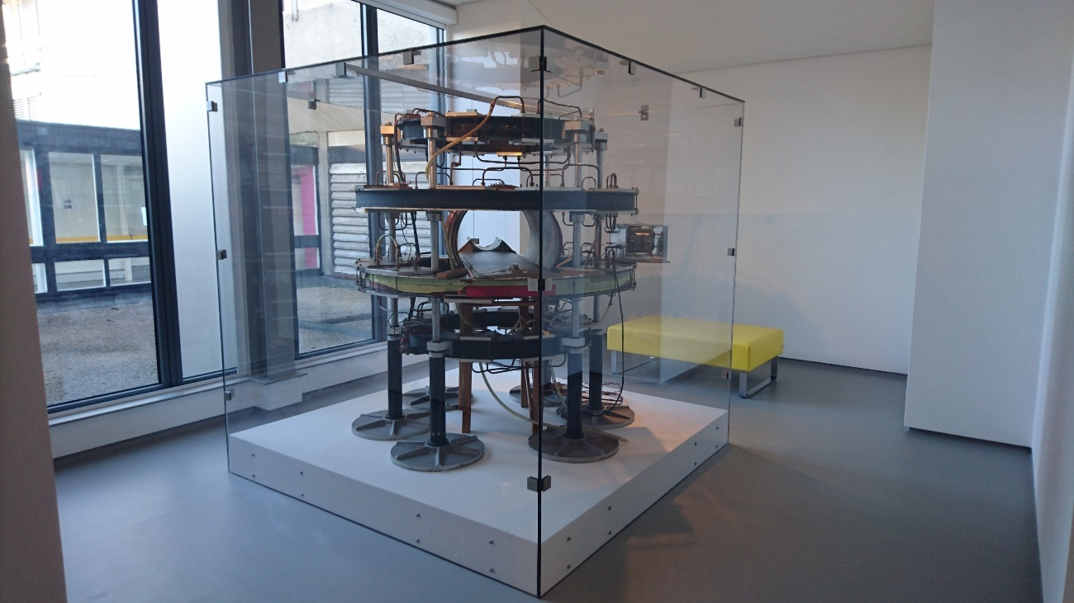

*Mark-1 is the world’s first clinically-used whole-body MRI Scanner, designed and built in the late 1970s by physicists and technical staff in the Medical Physics Department of the University of Aberdeen.*

**Dr Gray’s Hospital, Elgin** is a 180-bed acute hospital which provides a full range of consultant-led specialities. Registrars. The fully digital radiology department provides comprehensive plain film imaging, Ultrasound, Fluoroscopy and a newly installed 160-slice Canon Aquilion Prime SP CT (with full subtraction suite, cardiac and colon packages, and dedicated multi-user thin client post-processing Vitrea workstation). A new MRI service will be in place for 2023 through the National Treatment Centre programme. Dr Gray's provides an Ultrasound service using 2 x Logic e10 with advanced software, including Elastography, MI Doppler and Contrast package (CHI). A fully integrated Fuji AcSelerate digital system (x2) has Tomosynthesis capability. Moray also provides plain imaging services in community settings across Moray.

* The department is fully integrated with Carestream RIS/PACS/electronic requesting and uses a Soliton Voice Recognition System across all sites.
* We also have a well-established clinical governance structure as described below.

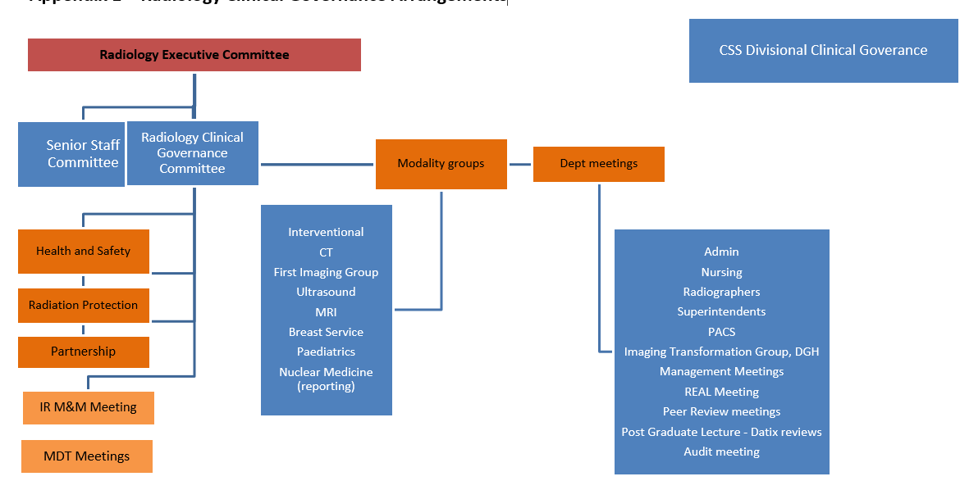

**Consultant Radiologists, NHS Grampian**

Dr S Arcot Ragupathy Unit Clinical Director,

Breast and Uroradiology

senthilkumar.arcotragupathy@nhs.scot

Dr D McAteer Chair - Radiology Senior Staff Committee

dympna.mcateer@nhs.scot Gastrointestinal and Head and Neck Radiology

Prof A Denison Dean of Postgraduate Medicine, NHS Education for Scotland

alan.denison2@nhs.scot PET, Chest Radiology

Dr S Walker Associate Medical Director for Professional Performance and Deputy

shonagh.walker@nhs.scot Responsible Officer

Paediatric Radiology

Dr S Olson Nuclear Medicine Service Clinical Director

shona.olson@nhs.scot Neuroradiology, Nuclear Medicine & PET

Dr L Saraswat CT Service Clinical Director

lokesh.saraswat@nhs.scot RCR Regional specialty advisor

Gastrointestinal & Hepatobiliary Radiology

Dr N Rose MRI Service Clinical Director

natasha.rose@nhs.scot IRMER - Lead

Musculoskeletal Radiology

Dr G Lip Service Clinical Director, North of Scotland Breast Screening Programme

gerald.lip@nhs.scot Breast radiology

Dr E Ramage Member - Radiology Executive Committee

emma.ramage@nhs.scot Gastrointestinal and Gynaecology Radiology

Dr L Narayanan Ass. Postgraduate Dean for Medicine & Diagnostics, North of Scotland

leela.narayanan@nhs.scot Neuroradiology and Gastrointestinal radiology

Dr R Mitchell-Hay Training Programme Director

Gastrointestinal and Hepatobiliary Radiology

rosalind.mitchell-hay@nhs.scot

Dr S Wilkie NHS Grampian Clinical Lead for Radiology IT

struan.wilkie@nhs.scot Unit Clinical Director DGH Medicine and Unscheduled Care

Training Programme Director

Musculoskeletal Radiology, Chest & Cardiac Radiology

Dr A Nandakumar Audits and Quality Improvement - Lead

anjali.nandakumar@nhs.scot Breast and Uroradiology

Dr D Reynolds Lead Clinician for First Imaging

daniel.reynolds@nhs.scot Musculoskeletal Radiology

Dr R Hamdy Clinical Lead – Dr Grays Radiology department

rafik.hamdy@nhs.scot Musculoskeletal Radiology, Paediatric

Dr A Thompson Area Medical Committee

Musculoskeletal Radiology

angus.thompson@nhs.scot

Dr V Akondi Joint Lead Clinician – Interventional Radiology

raghavendra.akondi@nhs.scot

Dr A Sethi Joint Lead Clinician - Interventional Radiology

akshay.sethi@nhs.scot

Dr D Basko Breast Radiology

Dr A Beaumont Nuclear Medicine & Chest (appointed and commencing in Aug 2023)

Dr J Brodie Head and Neck, Chest and Cardiac Radiology, Dr Gray's.

Dr F Caswell Chest and Oncoradiology

Dr S Dubios-Marshall Chest and Cardiac Radiology

Dr M Gandhi Uroradiology, Gastrointestinal and Haematology Radiology

Dr D Morgan Paediatric Radiology

Dr B Morrisey Chest and Cardiac radiology

Dr N Muhammad Gowdh Breast and Gynaecological Radiology (chair of the REALM)

Dr A Rana Neuroradiology

Dr B Sethi Paediatric Radiology

Dr S Somasundaram Neuro Radiology

Dr B Winter Musculoskeletal Radiology

Mrs Alice Dewar Consultant Mammographer

5 **Description of Post**

Specialty Doctor for Breast Radiology

This permanent post is designed for a motivated individual to complement and enhance existing services who wishes to pursue a career in breast radiology. As such, we are open to hearing from anyone who can bring their talent to the department. This post is advertised as 10 PA job in Breast Radiology, although we would welcome applicants wishing to work part-time. The post-holder will be supported in their individual speciality doctor’s training needs as they progress towards Certificate of Eligibility for Specialist Registration (CESR). Duties will be tailored to qualifications, knowledge and experience. Stereotactic procedures including large volume biopsies are undertaken in the unit and we also undertake large volume excisions for benign and malignant lesions. Successful candidates, if interested will be supported to develop competencies in these procedures.

The basic contract is negotiable. An indicative job plan will be agreed with the Clinical Director against 8 DCC and 2 SPA sessions if full-time with job planning reviews being carried out annually. Additonal extra programmed activities (EPAs) can only be awarded above contracted 10 PAs and would be the subject of detailed job planning discussions. This additional activity is separate from the main contract and variable at a three month notice period from either employee or employer.

There is the opportunity for home reporting workstations if additional reporting capacity is provided and depending upon availability of work stations and meeting requirements. It can also be negotiated that home workstations can be used for reporting sessions and some SPA. The workstations have full RIS and PACS and access to the NHS Board systems. Office space is largely shared, with shared secretarial support.

The post-holder as a Specialty Doctor will have a named mentor to help with career guidance and the appraisal process. Applicants will have their training needs assessed in terms of knowledge, clinical skills, training, performance and education. This will be in support to Breast Radiology, responding to increasing demand for Breast Radiology services. The department would be flexible in accommodating any secondary areas of interest.

Study leave and funding for approved courses and specialty study days is available.

**Clinical Commitments**

Job plans will be discussed individually but an indication on the bases of a 10 PA contract will usually be based around:

4 Radiology Sessions in Breast Specialist Area

2.5 Flexible session/prospective cover

0.5 MDT session

1 Reporting sessions

2 SPA sessions

This contract would be negotiable for candidates who wish to work part time. Candidates for this post will be expected to have proficiency in aspects of mammogram reporting, ultrasound examination and procedures including biopsies. It would be preferable if candidates have experience in diagnostic imaging including general radiology, CT and MR and also US and CT guided procedures.

**Emergency Duties**

As with all other trainee members of the department, the Specialty Doctor will also be required to perform duties in occasional emergencies and unforeseen circumstances at the request of the appropriate Consultant, in consultation where practicable, with colleagues both senior and junior.

It has been agreed between the professions and the Department that while Specialty Doctors accept that they will perform such duties, it is stressed that additional commitments arising under this sub-section are exceptional, and, in particular that Specialty Doctors should not be required to undertake work of this kind for prolonged periods or on a regular basis.

**MODEL JOB PLAN FORMAT**

**a) Specialty Doctor Contract Details**

|  |  |  |  |  |  |  |
| --- | --- | --- | --- | --- | --- | --- |
| **Name:** | | | | **Specialty:** Breast Radiology | | |
| **Principal Place of Work:** ARI | | | |  | | |
| **Contract :** | Full Time | |  | Honorary | **PAs** __10_____ | **EPA** _2 ______ |
| **Availability Supplement**: | | |  |  |  | **(Delete as appt )** |
| **OOH at Premium Rate worked :** | | | |  | | |
| **Managerially Accountable to:** Unit Clinical Director | | | | | | |
| **Responsible for :** | | Breast Radiology | | | | |

**b) Timetable of activities which have a specific location and time**

**NB: *A detailed Job Plan will be agreed with the successful candidate at the time of the appointment, taking account of the experience, skills and interests of the candidate and how they can best be used within the Consultant team.***

|  |  |  |
| --- | --- | --- |
| **DAY** | **HOSPITAL/ LOCATION** | **TYPE OF WORK** |
| **Monday**  **From / To** | Aberdeen Royal Infirmary | 0900 – 1300 Specialist session (4 hours DCC)  1300 – 1700 SPA (4 hours SPA) |
| **Tuesday**  **From / To** | 0900 – 1300 Specialist session (4 hours DCC)  1300 - 1700 Reporting session (4 hours DCC) |
| **Wednesday**  **From / To** | 0900 -1400 Breast MDT preparation and meeting (annualised 2 hours), flexible reporting (annualised 3 DCC hours)  1400 - 1700 Specialist session (3 DCC hours)  1700 - 1900 Flexible session & Contrast cover (2 hours DCC) |
| **Thursday**  **From / To** | 0900 – 1300 Specialist session (4 hours DCC)  1300 - 1700 SPA (4 hours SPA) |
| **Friday**  **From / To** | 0900 - 1300 – Flexible reporting/prospective cover (4 Hours DCC)  1300 – 1700 – Flexible reporting (2 hours DCC annualised) |
| **Saturday**  **From / To** |  |
| **Sunday**  **From / To** |  |

|  |  |
| --- | --- |
| **NHS GRAMPIAN**  **PERSON SPECIFICATION** | |
| The Person Specification should meet the demands of the job and comply with current legislation. Setting unnecessary standards may, for example, unfairly discriminate against one sex, the disabled or minority racial groups. Applicants should be assessed in relation to their ability to meet the real requirements of the job as laid down in the job description. Shortlisted candidates **MUST** possess all the essential components as detailed below. |

# POST/GRADE: Specialty Doctor (Permanent full time post)

**LOCATION/HOSPITALS: Aberdeen Royal Infirmary**

**WARD/DEPARTMENT: Breast Radiology**

|  |  |  |  |
| --- | --- | --- | --- |
| **Requirements** |  | **Essential** | **Desirable** |
| **Qualifications/Training** | Basic medical degree recognised by the General Medical Council*.  4 year minimum taught postgraduate qualification in Radiology.  Full registration with the GMC (with License to Practise) | Yes | FRCR or equivalent  Further relevant degree/diploma/fellowship  Distinctions, prizes |
| **Ability/Knowledge** | Ability to perform as an independent Specialty Doctor with sub-speciality interest in Breast. | Yes |  |
| **Experience** | Sub-speciality training and experience in the following: | Yes |  |
|  | * Breast Radiology –symptomatic | Yes | One-stop-clinic experience  Breast Screening experience |
|  | * Body CT |  | Yes |
|  | * Body MRI |  | Yes (including Breast MRI) |
|  | * CT & USG guided drainages |  | Yes |
|  | * Audit and research | Yes |  |
|  | * Multi-disciplinary team working | Yes | Track record of successfully leading multidisciplinary groups. |
| **Teaching** | Experience in post graduate teaching |  | Yes |
| **Special Aptitude and Abilities** | Ability to work flexibly to meet the needs of the service, with particular patient focussed approach.  Commitment to learning. | Yes | Presentations, publications |
| **Deposition** | Team player  Self-starter and motivated | Yes |  |
| **Physical requirements** | Good general health | Yes |  |
| **Management Ability** | Working knowledge of the NHS management system and current developments.  Ability to develop and lead new areas of service development. | Yes  Yes |  |

*GMC Requirements:

* GMC accredited Primary Medical Qualification (PMQ)
* English language knowledge –
  + PMQ delivered in English
  + IELTS, PLAB 1 or PLAB 2
  + References from previous English-language employers covering 2 years.
  + Written offer and English Language Form from Responsible Offer of Designated Body
* Proof of identity
* Certificate(s) of Good Standing
* Activities over the past 5 years.
* Declaration of Fitness to Practice
* English-translated documents
* Payment of GMC fee

**Exception of Body CT and CT & USG drainage experience can be made for candidates aspiring to do full time breast radiology

**NHS GRAMPIAN**

**Specialty Doctor**

**PM162022**

The Terms and Conditions of Service Specialty Doctor in Scotland (Oct 2022) can be accessed from the Scotland Deanery web-page – www.scotlanddeanery.nhs.scot.

|  |
| --- |
|  |
| The appointee must be registered with a licence to practise with the General Medical Council throughout the duration of your employment. NHS Grampian is legally liable for the negligent acts or omissions of employees in the course of their NHS employment. Medical staff, are however, advised to ensure that they have adequate defence cover for activities not covered by NHS Grampian indemnity. |

**PARTICULARS OF POSTS**

1. The appointment will be made by an Advisory Appointments Committee of NHS Grampian constituted for this purpose.

2 The officer appointed will be required to assist the senior staff at NHS Grampian and will work within the Radiology department under the direction of the Service Clinical Director and Unit Clinical Director. The officer appointed may also be required to visit district hospitals and clinics in the area and to undertake locum duties within the area.

3 The officer will be required to take part in undergraduate and postgraduate medical teaching.

4 The inclusive salary is within the scale of £54,903 to £85,554 per annum. Movement through the scale will be contingent on meeting the criteria set out in Schedule 15 of the Terms and Condition of Service.

5 Placement on the scale will be in accordance with previous service and experience. The appointment will be superannuable if the person appointed so chooses. He or she will be subject to the regulations of the National Health Service Superannuation Scheme and the remuneration will be subject to deduction of contributions accordingly, unless he or she opts out of the Scheme.

6 So far as is consistent with the proper discharge of the above duties the post holder undertakes to deputise from time to time for absent colleagues.

7 The post holder undertakes exceptionally to perform additional duties in occasional emergencies and unforeseen circumstances.

8 The post holder undertakes exceptionally to be available for such irregular commitments outside normally rostered duties as are essential for continuity of patient care.

9 The officer appointed will be required to have full registration with the General Medical Council.

10 NHS Grampian is legally liable for the negligent acts or omissions of employees in the course of their NHS employment. Medical staffs are however advised to ensure that they have adequate defence cover for activities not covered by the Board indemnity.

11 Your residence, which shall be maintained in contact with the public telephone service, shall normally not be more than 10 miles by road from Aberdeen unless specific approval is given by NHS Grampian to a greater distance.

12 As a result of guidance issued by the Scottish Office on "Protecting Health Care Workers and Patients from Hepatitis B" the NHS Grampian is required to:-

* Ensure health care workers who may be at risk of acquiring hepatitis B from a patient are protected by immunisation.
* Protect patients against the risk of acquiring hepatitis B from an infected health care worker.
* Due to the nature of this post, any offer of appointment will be conditional upon the successful applicant either:-
* Undergoing a process of screening/immunisation/monitoring in accordance with the Board's Policy and Procedure, or
* Producing acceptable documentary evidence that he/she is not an infective risk to others.

In the event that he/she is an infective risk to others or if he/she fails to comply with the above requirements, the conditional offer of appointment will be withdrawn.

As a condition of his/her subsequent employment in this post he/she is also required to undergo further immunisation and monitoring at the intervals specified by the Board's Occupational Health Service in order to boost/maintain his/her level of immunity. Should he/she become hepatitis B e antigen positive and therefore an infective risk to others at any stage in the future the appointment will be subject to review in accordance with the Board's agreed Procedure for dealing with such situations where the post holder is involved in "Exposure Prone Procedures". This review may result in the post holder having to alter his/her clinical exposure to remove risk to patients and others. In circumstances where this is not a practical option, it will be necessary to provide industrial compensation for this prescribed industrial disease prior to the post holder leaving the Board's employment.

13 The Board is required to instigate a PVG (Protecting Vulnerable Groups) Scheme Check, to be made with Disclosure Scotland, for any convictions recorded before an offer of appointment can be made (Rehabilitation of Offenders Act 1974 (Exclusions and Exceptions)(Scotland) Amendment Order 2015)

14 The appointment is made subject to satisfactory fitness for employment. The successful candidate will therefore be required to complete a pre-employment health screening questionnaire and may subsequently be required to attend for health screening.

15 The Officer appointed will be required to work within the policies and procedures of NHS Grampian which have been agreed by the appropriate committee and negotiating committees.

16 Termination of the appointment is subject to three months’ notice on either side.

**NOTE**

Canvassing in connection with appointments is not permitted but this does not debar candidates who wish from visiting the hospitals concerned.

Please note that receipt of applications will not be acknowledged, however, successful applicants will be informed of the outcome of shortlisting within three weeks of the closing date.

**Further information can be obtained and an appointment to view the Department by contacting:**

|  |
| --- |
| Dr Gerald Lip Consultant Radiologist and Service Clinical Director gerald.lip@nhs.scot  Dr Senthil Ragupathy, Consutlant Radiologist and Unit Clinical Director senthilkumar.arcotragupathy@nhs.scot  Mrs Grace Ball, Unit Operational Manager grace.ball2@nhs.scot |

Closing date: Sunday, 10 September 2023

The Board is obliged to bring to your notice that the Rehabilitation of Offenders Act 1974 provides for many people who have been convicted of certain criminal offences, the opportunity to have no need to refer to any conviction or circumstances relating to it in the course of daily lives. Certain convictions can, therefore, be regarded as “spent” after the lapse of a period of years under the terms of the Act.

The National Health Service employment for which you are applying, however, has been excluded from the provisions of the Act and you are, therefore, required not to withhold information about convictions which for other purposes are “spent” under the provisions of the Act. In the event of employment, any failure to disclose such convictions could result in dismissal or disciplinary action by the Trust. Any information given, however, will be completely confidential and will be considered only in relation to the post for which you are now making application.

There is a Day Nursing facility for children of staff employed by NHS Grampian. ‘Little Acorns Day Nursery’ which has been specially designed can accommodate 24 children between the ages of 6 months and 5 years. Please contact the Nursery Manager on (01224) 557828 for further details.

**IN THE INTEREST OF HEALTH PROMOTION, WE OPERATE A NO SMOKING POLICY**

NHS Grampian has a process of induction for all newly appointed staff. You will have a local department induction and orientation led by the Unit Clinical Director. In addition we believe it important that you have an opportunity to meet with key personnel in NHS Grampian. This allows them to explain their role in the organisation and to discuss key information on the organisation and strategic planning processes we operate. We believe it important that all newly appointed staff even if they have previously worked in Grampian should have this opportunity once appointed. Your Clinical Director along with you will be responsible for ensuring this is undertaken. Heads of Service are supplied with the names of those you should meet.

There is no accommodation provided for medical staff attached to the hospital. However, support can be provided to candidates moving to the area in finding accommodation and relocation expenses are available as per policy.