

**Working for NHS Lanarkshire**

**Clinical Fellow in Dermatology**

**NHS Lanarkshire**

**Recruitment Pack**

**Application Closing Date: Friday 13th December 2024**

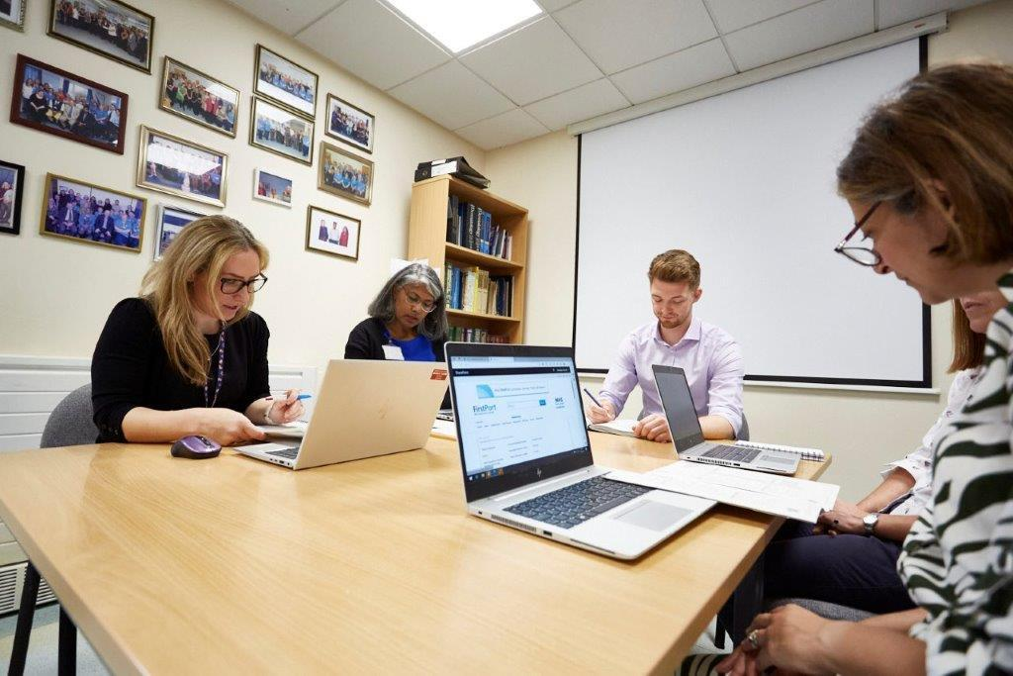

HR Medical & Dental

Kirkfield Cottage

Kirklands HQ

Bothwell

G71 8BB



|  |
| --- |
| **Contents** |

|  |  |  |
| --- | --- | --- |
| **Section** |  | **Page** |
| Section 1: | How to Apply | 3 |
| Section 2: | Contact Information | 4 |
| Section 3: | Person Specification | 5 |
| Section 4: | The Post | 6 |
| Section 5: | Department Resources | 6 |
| Section 6: | Working for Lanarkshire | 7 |
| Section 7: | Terms and Conditions of Employment | 7 |

|  |
| --- |
| **This post requires the post holder to have a PVG Scheme membership/record. If the successful applicant is not a current PVG member for the required regulatory group i.e. child and/or adult, then an application will need to be made to Disclosure Scotland and deemed satisfactory before the successful post holder can commence work.** |

|  |
| --- |
| **Section 1: HOW TO APPLY** |

**In order to apply:**

Applicants are required to complete an Application Form via the following link: https://apply.jobs.scot.nhs.uk/vacancies.aspx. Please note that you can upload your CV, however this will only be used to pre-populate part of the application form. CV`s are **not** accepted instead of a completed Application Form. Your CV **will not** be visible to the panel.

**Please complete applications by MIDNIGHT ON THE CLOSING DATE.**

**You will receive an email acknowledging receipt of your application once submitted.**

To find out more about the role and our recruitment process please visit NHS Scotland Recruitment Portal

Recruitment | NHS Lanarkshire (scot.nhs.uk)

**Application Process:**

The first part of the process is to complete the gateway questions applicable to the role you are applying for. Should you meet the requirements of the gateway questions you will then have the opportunity to complete the full application form, which asks you to complete your top three preferences of location and specialty.

**It is important that you demonstrate you meet the eligibility criteria detailed in the person specification on your application.**

**Shortlisting Process:**

**Stage 1**

Applications will be longlisted in line with the person specification for the job. If you are successful, you will receive an email from Jobtrain system advising you have been successful. Successful candidates from longlisting will be emailed a Clinical Situation and asked to provide feedback on this in the form of a one page document. If you are successful after this stage you will receive an invite to interview email.

**Stage 2**

Interview and Competency Assessment.

|  |
| --- |
| **Section 2: Contact Information** |

**Programme / Post Queries**

Prospective applicants are encouraged to make contact with:

Dr Freida Shaffrali, Clinical Lead for Dermatology

Email: freida.shaffrali@lanarkshire.scot.nhs.uk

**Application Queries**

If you have any queries regarding the application process please email Gill Swinburne at medical.dentalrecruitment@lanarkshire.scot.nhs.uk

**NHS Lanarkshire is committed to working towards equal opportunities for all.**

|  |
| --- |
| **Section 3: Person Specification** |

|  |  |  |  |  |
| --- | --- | --- | --- | --- |
| **PERSON PROFILE** | | | | |
| Attributes | **Essential** | | | **Desirable** |
| Qualifications | MBChB or equivalent.  Successful completion of UK Foundation Programme **OR CREST FORM** | | | MRCP Part 1 or 2  Diploma in Dermatology |
| Training | At least six months general medicine with exposure to acute medical problems | | | Some Dermatology experience  Skin Surgery |
| Experience | Eligible for full registration with the GMC at time of application and hold a current licence to practice * (\***Overseas Registration and Qualifications -**  In-patient management of medical patients  NHS Lanarkshire will check you have the necessary professional registration and qualifications for this role. You will need to provide an official translation of qualifications notarized by a solicitor of your overseas qualifications to be checked by the recruiting panel. Please ensure that this is available before applying for the post. | | | Out Patient experience |
| Audit/ Research/ Publications | Understanding of the principles of medical audit & willingness to participate. | | | Research based degree or experience in research post graduation  Audit or Quality improvement presentation or involvement in research projects |
| Presentations | Aware of process in preparing presentations for wider medical teams | | | Evidence of presentations to medical fraternity |
| Disposition | Team worker  Flexible | | | Evidence of organisational skills |
| Other | Satisfactory medical clearance by NHS Lanarkshire Occupational Health Service.  Satisfactory PVG Check.  Fluent in medical English and evidence of ability to communicate in stressful situations. | | | Computer literacy |
| If there is any reason why a disabled person should not be considered suitable for this post, please provide details: | | | **The post requires physical dexterity. Uncorrected visual or hearing defect would be incompatible with the nature of the work**. | |
|  | | **Prepared By:-** | | **Approved By:-** |
| Name | | Dr Freida Shaffrali | |  |
| Designation | | Consultant Dermatologist/Clinical Lead | |  |
| Date | | 29/11/24 | |  |

|  |
| --- |
| **Section 4: The Post** |

**ROLE SUMMARY:**

Three StR2(GP)s and one less than full time Registrar post comprise the junior staffing for the Lanarkshire Department of Dermatology. The Clinical Fellow will not attract training recognition by NHS Education for Scotland – West of Scotland.

**KEY DUTIES:**

Regular involvement in out-patient clinics at Monklands, and either Hairmyres or Wishaw Hospitals if appropriate, seeing both new and review patients under consultant supervision.

Attending consultant ward rounds for Dermatology patients admitted to Monklands hospital for intensive treatment. Supporting GPST2 with care of these inpatients.

Contributing, along with specialty doctors, to the unscheduled care of day patients, including those attending for phototherapy, laser, biopsy, patch testing or photodynamic therapy.

Training if desired in performing skin biopsies

Preparing and presenting cases for CME and CPC meetings held monthly.

Participation in audit projects undertaken by the Lanarkshire Dermatology Team.

Participation in the post-graduate training programmes arranged jointly by The Lanarkshire and Glasgow Royal Infirmary Departments of Dermatology, and in clinical symposia and other post-graduate activities of the West of Scotland Dermatologists.

This job description is not an exhaustive list of duties, but is intended to be a guide to the role of the postholder. Following discussion, the postholder may also be asked to undertake other appropriate duties necessary for the efficient running of the department.

|  |
| --- |
| **Section 5: Department Resources** |

Consultants Dr Freida Shaffrali

Dr Helen Dilworth

Specialist Doctor: Dr Rakhee Gupta

Specialty Doctors: Dr Rahul Dixit

Dr Anchal Goyal

Dr Rhea Ragobar

Specialist Registrars: West of Scotland Rotation – 1 (part-time, shared with Forth Valley)

GPST2 Trainees: 2

Hospital Practitioners: 0.35wte

Specialist Nurses: 6

Clinical Pharmacists: 1.3wte

|  |
| --- |
| **Section 6: Working for NHS Lanarkshire** |

For more information on the role please visit **NHS Lanarkshire Careers Website**

|  |
| --- |
| **Section 7: Terms and Conditions of Employment** |

|  |  |
| --- | --- |
| **TYPE OF CONTRACT** | Fixed Term (12 months) |
| **GRADE AND SALARY** | Clinical Fellow  £47,474 to £71,550 per annum (pro rata) |
| **HOURS OF WORK** | Full Time – 40 hours per week |
| **SUPERANNUATION** | New entrants to NHS Lanarkshire who are aged sixteen but under seventy five will be enrolled automatically into membership of the NHS Pension Scheme. Should you choose to "opt out" arrangements can be made to do this via: www.sppa.gov.uk |
| **REMOVAL EXPENSES** | Assistance with removal and associated expenses may be awarded |
| **EXPENSES OF CANDIDATES FOR APPOINTMENT** | NHS candidates who are requested to attend an interview will be given assistance with appropriate travelling expenses. Re-imbursement shall not normally be made to employees who withdraw their application, refuse an offer of appointment. Non NHS employees are not normally awarded travel expenses. |
| **DISCLOSURE SCOTLAND** | This post is considered to be in the category of “Regulated Work” and therefore requires a Disclosure Scotland Protection of Vulnerable Groups Scheme (PVG) Membership. |
| **CONFIRMATION OF ELIGIBILITY TO WORK IN THE UK** | NHS Lanarkshire are required to check the entitlement to work in the UK of all prospective employees, regardless of nationality or job category. UK Visas & Immigration rules are available at www.bia.homeoffice.gov.uk. Prospective applicants are encouraged to check eligibility in advance of applying for vacancies in NHS Lanarkshire. |
| **MEDICAL NEGLIGENCE** | In terms of NHS Circular 1989 (PCS) 32 dealing with Medical Negligence the Health Board does not require you to subscribe to a Medical Defence Organisation. Health Board indemnity will cover only Health Board responsibilities. It may, however, be in your interest to subscribe to a defence organisation in order to ensure you are covered for any work, which does not fall within the scope of the indemnity scheme. |
| **NOTICE** | Employment is subject to one month notice on either side. |
| **PRINCIPAL BASE OF WORK** | You may be required to work at any of NHS Lanarkshire sites as part of your role. Your base will be clarified for expenses purposes. |
| **REFERENCES** | All jobs are only offered subject to receiving two satisfactory references. At least one reference must be from your current/most recent employer or your course tutor if you are currently a student. If you have not been employed or have been out of employment for a considerable period of time, you may give the name of someone who knows you well enough to confirm information given and to comment on your ability to do the job. |

Author: Swinburne, Gillian (LH) HR Advisor

Label: Official Sensitive

Security Classification: Green

**R:\**

**HR Directorate –** *providing workforce support, solutions, advice and information*