JOB DESCRIPTION
1. JOB DETAILS
Job Title | Project Support Officer
Line Manager | Project Manager
Department | Programme Management Services (PgMS)
SBU | Strategy, Performance and Service Transformation
CAJE Reference

2. JOB PURPOSE
The post holder will manage the day-to-day running of the programme office for a number of NSS projects and programmes by providing high level project support and assisting in the delivery of advice and guidance on appropriate management methodologies. The Project Support Officer will be responsible for providing a full range of project support services to Programme Management Services (PgMS), assisting in the organisation and administration of all aspects of Projects, Programmes and Business As Usual.

3. DIMENSIONS
The post holder does not carry out any line manager function and will not be expected to control any set budget.
However, the post holder will be expected to work to defined budget targets and to assist in monitoring aspects of
these finances.

As more and more national Programmes and Projects are initiated, the need for a robust supporting framework for
the Programmes and Projects is required.

The Project Support Officer, as part of Programme Management Services (PgMS) will assist in providing a comprehensive project support function to all Programmes and Projects, covering areas such as:

- Project and Programme progress tracking
- Configuration management
- Risk assessment
- Maintenance of project issues/ risk logs
- Support for project exceptions
- Support for mid and end stage reviews
- Post implementation review
- Provision of management information
- Budget Tracking
Stakeholders include key staff such as Chief Executives, Directors, Project Board Chairpersons and other senior internal/external clients.

4. ORGANISATION CHART 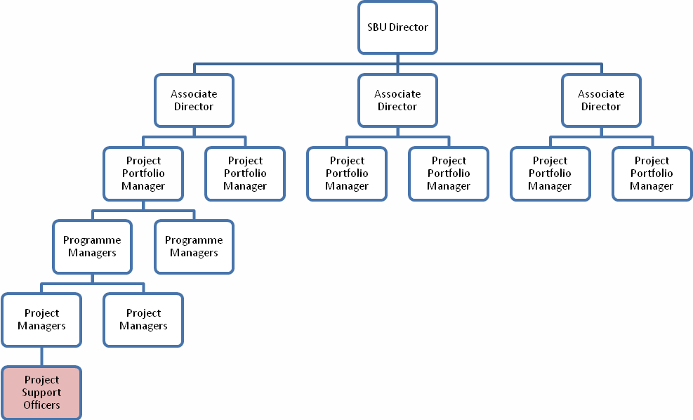

5. ROLE OF THE DEPARTMENT
NSS PgMs is accountable directly to the NSS Board and Executive Management Team with regard to ensuring NSS has in place policies and practices, and both financial and staff resources, that enable the effective management and control of all major corporate and SBU programmes and projects within NSS that deliver the corporate modernisation strategy in alignment with the annual business plans of NSS, ensuring ‘Best Value’ is achieved.
The wider remit of the Programme Management Services is to provide a suite of portfolio, programme and project management services [Planning; Delivery; Assurance] that can enable NSS, SG and Scottish Public Sector organisations to;
- deliver a significant Health and Public Sector Reform agenda in the most efficient and effective manner possible
- drive efficiency savings of between 5% - 8% for each programme or project undertaken
- achieve value for money in the approach taken and,
- maximise the required outcomes and benefits for patients and the wider public across Scotland.

6. KEY RESULT AREAS
- Assist the Project Manager in preparation, delivery, updating and monitoring all project plans, documentation and deliverables.
- The post holder is responsible for setting up, maintaining and developing a number of databases and information management system in order to develop and implement procedures to ensure efficiency of the project and programme administration. Maintenance of other databases developed by the jobholder to improve procedures. Regularly provide updates and guidance to NSS Project and Programme Managers as well as other internal/external stakeholders. Undertake the organisation of a large volume of meetings, workshops and presentations.
- Receive and respond to telephone calls/emails as appropriate, keeping the Project Manager/Project Support Manager informed of all relevant issues.
- Provide secretariat support to NSS Programme and Project Managers, associated staff and external stakeholders. Duties include diary co-ordination and arranging meetings together with all related duties. All work must be of a high standard, be completed within agreed timescales and meet PgMS expectations.
- From all systems, the post holder will generate reports for use by management and / or other appropriate individuals. A strong audit trail will be provided.
- Maintain all Programme Management Services documentation as appropriate. Liaise with internal departments to ensure all documentation is acted upon appropriately and meets PgMS/NSS expectations.
- Undertake full and accurate minute taking as and when required for NSS Project and Programme Managers and associated staff and boards which meets PgMS expectations.
- Contribute to preparation of documents which requires an understanding of forward planning and budget control.

7. ASSIGNMENT AND REVIEW OF WORK and DECISIONS AND JUDGEMENTS
Primarily the Project Manager assigns work and establishes a broad framework for the post holder, however the post holder will be expected to have autonomy and carry out work using his/her own discretion and initiative particularly in dealing with enquiries.

The post holder identifies the main areas requiring attention on a day-to-day basis and prioritises work accordingly, using their initiative whilst updating the Project Manager/Project Support Manager about all relevant issues. PgMS management as well as other internal/external contacts may generate additional tasks as appropriate.

The post-holder continuously reviews his/her own work to ensure satisfactory standards are maintained. Work is appraised and reviewed by the Project Manager on an on-going basis. The jobholder is expected to anticipate, resolve and take the decision to escalate problems arising from day to day work as appropriate. Advice and guidance from PgMS management is available as required. The line manager (by nature of his/her role) is often out of the office and therefore the post holder is expected to work unsupervised.

The Project Manager will review work in line with PgMS’s procedures.

8. COMMUNICATIONS AND RELATIONSHIPS

i) External:
Daily telephone and written communication with NHS Scotland Senior Managers and other external customers, e.g. other Boards/Groups/Stakeholders as required.

ii) Internal:
Face to face, information contact with all members of PgMS, other NSS Departments and SBUs around Programmes and Projects.

9. MOST CHALLENGING PARTS OF THE JOB
- Managing the varied and diverse workload and ensuring the provision of a high quality, confidential support service.

- Being able to prioritise workload to meet deadlines in a changing environment without the requirement for direct supervision.

- Communications and building mutually beneficial relationships with a variety of people at different levels.

10. SYSTEMS
- Excel
The post holder will maintain and input data into MS Excel spreadsheets to monitor Project and Programme budgets and provide reports as required.

- EProcurement / PECOS
The post holder will use appropriate processing and purchasing systems as determined by the agency.

- MSP/Prince 2
Programme/Project standards are constantly evolving and as revisions are released, guidance and application into NSS operational circumstances is required. Post holders may contribute to a larger Programme/Project to update guidance or may be asked to lead on an individual work stream.

The post holder must also be able to understand and use MS Project to support project planning.

- MS Outlook, MS Word/Excel, MS PowerPoint, MS Project
The post holder must be able to utilise MS Outlook for correspondence and diary management, MS Word for letters, mail merges and other correspondence. The creation of presentations using MS PowerPoint is required, with the post holder using the internet for research and be familiar with web-based applications.

The post holder will be able to organise conference calls and video conferences as and when required.

11. PHYSICAL, MENTAL, EMOTIONAL EFFORT

PHYSICAL EFFORT
Daily requirement for sitting/inputting/working at workstation for substantial periods of time, i.e. the majority of the work day, with appropriate breaks.

MENTAL EFFORT
The ability to think on one’s feet and offer support, either by email, face to face or telephone to a range of stakeholders on a host of Project and Programme queries and issues. Attendance and minute taking at frequently scheduled meetings is common with some meetings lasting a full day. There is a need for periods of concentration for meeting and workshop tasks as well as other daily duties. This is sometimes very difficult due to regular interruptions such as handling calls and general support requests. The location of some meetings requires travel and time spent away from home.

The generation and inputting of data into the various databases and information management systems requires absolute accuracy and attention to detail.

Unpredictable activities e.g. handling ad-hoc support requests from a wide range of people involved in the Projects and Programmes requires the ability to multi-task and give quick responses to a wide range of contact groups.

The ability to maintain momentum throughout lengthy sessions to fit with the requirements of the participants and PgMS colleagues.

EMOTIONAL EFFORT
Exposure to distressing or emotional circumstances is rare. However due to the nature and demands of the project, the jobholder may find that at certain times demands placed on them within tight timescales could cause a degree of pressure.

The post holder will require excellent planning and organisational skills to maintain the appropriate work/life balance.

12. ENVIRONMENTAL/WORKING CONDITIONS & MACHINERY AND EQUIPMENT
Standard Office conditions: Regular requirement to use laptop/PC

Requirement to travel throughout Scotland

The post holder will be required to use photocopiers, printers, scanners and fax machines in order to fulfil daily tasks including generating paperwork for meetings, distributing copies of mail etc.

13. KNOWLEDGE, TRAINING AND EXPERIENCE REQUIRED TO DO THE JOB

- Degree in Office Administration or related subject or equivalent experience gained over 5-7 years in a busy office environment.
- In-depth working knowledge of standard office software packages e.g. Microsoft Word, Excel, PowerPoint and MS Project.
- Knowledge of effective Project Management/trained in PRINCE 2 methodology.
- Team player with excellent interpersonal and communication skills and a well developed organisational ability.
- Experience in the delivery of training and confident in contributing to/with senior colleagues and stakeholders
- Minute taking skills.
- An understanding of NHS Scotland and a project management background would be advantageous.
- To have the ability to learn and gain knowledge of technical phrases to enable an increased efficiency and understanding in their role.
- Commitment to updating skills and life-long learning.

14. JOB DESCRIPTION AGREEMENT
Job Holder’s Signature: | Date:

